E
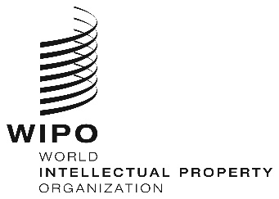
WEBINARS
ORIGINAL: eNGLISH
DATE: June 26, 2020
REGIONAL BUREAU FOR AFRICA CAPACITY BUILDING FOR SMEs, JULY 2020

organized by
the World Intellectual Property Organization (WIPO)

PROVISIONAL PROGRAM

prepared by the International Bureau of WIPO

Thursday, July 23, 2020
14.30 – 15.30 | Topic 4 | Working With IP In Your Business  - Different sources of IP in your business  - Protecting your business IP  - Case study of an entrepreneur
Speakers: Prof. Caroline Ncube
Dr. Mc Lean Sibanda
Ms. Rose Mboya

 |  | Discussions
 |  | [End of Webinar and the Series for SMEs]

