E
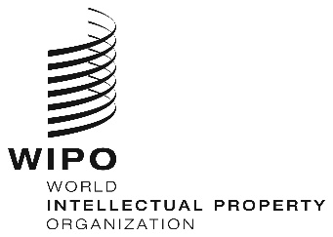
WEBINARS
ORIGINAL: eNGLISH
DATE: June 26, 2020
REGIONAL BUREAU FOR AFRICA CAPACITY BUILDING FOR SMEs, JULY 2020

organized by
the World Intellectual Property Organization (WIPO)

PROVISIONAL PROGRAM

prepared by the International Bureau of WIPO

Thursday, July 23, 2020
10.30 – 11.30 | Topic 3 | Access to IP  - Principle that you don’t have to own IP to use it  - Basics of patent searches
Speaker: Dr. Mc Lean Sibanda
Managing Director at Bigen Global Limited
International Consultant &IP Expert (South Africa)

 |  | Discussions
 |  | [End of Webinar]

