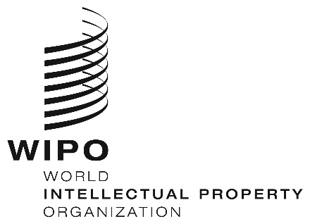
INFORMATION NOTICE NO. 7/2023

Madrid Protocol Concerning the International Registration of Marks

Withdrawal of the notification made under Rule 40(6) of the Regulations under the Madrid Protocol: Norway

- The Director General of the World Intellectual Property Organization (WIPO) has received a communication from the Office of Norway withdrawing the notification made by Norway under Rule 40(6) of the Regulations under the Madrid Protocol (“Regulations”).
- Such withdrawal became effective on March 1, 2023.
- Consequently, as from the above-mentioned date, the Office of Norway may present to the International Bureau of WIPO requests for the division of an international registration under Rule 27bis(1) of the Regulations and requests for the merger of international registrations resulting from division under Rule 27ter(2)(a) of the Regulations.

March 9, 2023

