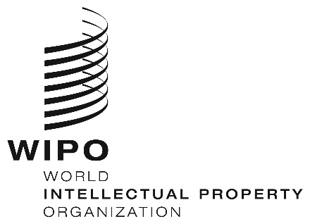
INFORMATION NOTICE NO. 37/2022
Madrid Protocol Concerning the International Registration of Marks
Change in the Amounts of the Individual Fee: Morocco
1. In accordance with Rule 35(2)(d) of the Regulations under the Madrid Protocol, the Director General of the World Intellectual Property Organization (WIPO) has established new amounts, in Swiss francs, of the individual fee that is payable when Morocco is designated in an international application, in a designation subsequent to an international registration and in respect of the renewal of an international registration in which Morocco has been designated.
2. As from January 6, 2023, the amounts of the individual fee payable in respect of Morocco will be the following:
ITEMS |  | Amounts  (in Swiss francs)
 |  | until  January 5, 2023 | as from  January 6, 2023
Application or Subsequent Designation | – for one class of goods or services  – for each additional class | 250  50 | 219  44
Renewal | – for one class of goods or services  – for each additional class | 250  50 | 219  44

3. These new amounts will be payable where Morocco
(a) is designated in an international application which is received by the Office of origin on or after January 6, 2023; or

(b) is the subject of a subsequent designation which is received by the Office of the Contracting Party of the holder on or after January 6, 2023, or is filed directly with the International Bureau of WIPO on or after that date; or
(c) has been designated in an international registration which is renewed on or after January 6, 2023.
December 6, 2022

