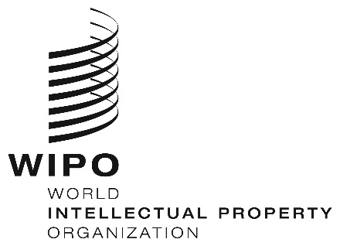
INFORMATION NOTICE NO. 20/2022
Madrid Protocol Concerning the International Registration of Marks
New Guide to the Madrid System
- The new Guide to the Madrid System (the Guide), which is a complete overhaul of the previous Guide, is now available on the Madrid System website.
- The purpose of the new Guide is to provide practical information and advice to brand owners wishing to protect their trademarks outside of their home market, as well as to inform Intellectual Property Offices (IP Offices) that are members of the Madrid System about their roles and responsibilities under the Madrid System.
- The Guide has four Chapters:
- Chapter I introduces the Madrid System and contains useful information for all its users, namely, applicants, holders of international registrations, their representatives and Officials of the IP Offices of its members. This chapter describes the main benefits of the Madrid System and includes information about procedural matters such as, the methods of communication, the calculation of time limits and the language regime.
- Chapter II contains practical information for applicants and holders on all aspects of the Madrid System throughout the life cycle of the international registration. This chapter guides applicants and holders through the application process and through the various procedures and processes that may occur during the lifetime of an international registration, for example, subsequent designation, change in ownership, changes in the holder’s details and renewal. This chapter also provides information on the various communications that Offices of designated members may issue.
- Chapter III delivers practical information for Officials of the IP Offices of the members of the Madrid System. This chapter provides information on the two roles of an IP Office, namely, as the Office of origin of international applications and as the Office of a designated member, and includes information on the certification of international applications, as well as on the various decisions those IP Offices could issue on the scope of protection.
- Chapter IV includes useful information for countries and intergovernmental organizations on how to prepare to become a member of the Madrid System, as well as the kind of support that WIPO could offer to potential new members.
- This Guide is available in portable document format (PDF) allowing readers to navigate between the relevant topics using bookmarks. The Guide in now available in English and will soon be available in Arabic, Chinese, French, Russian and Spanish.
May 31, 2022

Guide to the International Registration of Marks under the Madrid Protocol.

