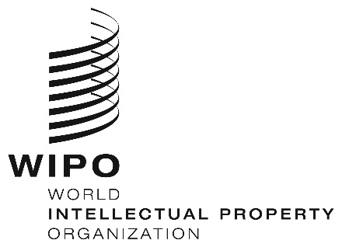
INFORMATION NOTICE NO. 2/2022
Madrid Protocol Concerning the International Registration of Marks
Change in the Amounts of the Individual Fee: Israel
- The Government of Israel has notified to the Director General of the World Intellectual Property Organization (WIPO) a declaration modifying the amounts of the individual fee payable with respect to Israel under Article 8(7) of the Madrid Protocol.
- As from March 14, 2022, the amounts of the individual fee payable in respect of Israel will be the following:
ITEMS |  | Amounts  (in Swiss francs)
 |  | until  March 13, 2022 | as from  March 14, 2022
Application or Subsequent Designation | – for one class of goods or services  – for each additional class | 442  332 | 483  363
Renewal | – for one class of goods or services  – for each additional class | 788  665 | 861  727

- These new amounts will be payable where Israel
(a) is designated in an international application which is received by the Office of origin on or after March 14, 2022; or
(b) is the subject of a subsequent designation which is received by the Office of the Contracting Party of the holder on or after March 14, 2022, or is filed directly with the International Bureau of WIPO on or after that date; or
(c) has been designated in an international registration which is renewed on or after March 14, 2022.
January 7, 2022

