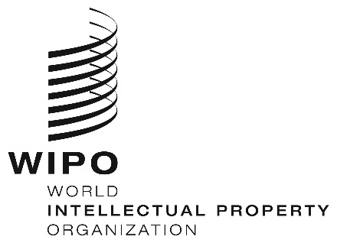
INFORMATION NOTICE NO. 10/2021
Madrid Protocol Concerning the International Registration of Marks
Madrid System for the International Registration of Marks: Closure of the International Bureau of the World Intellectual Property Organization (WIPO)
- Pursuant to Rule 32(2)(v) of the Regulations under the Protocol Relating to the Madrid Agreement Concerning the International Registration of Marks (the Regulations), the International Bureau of the World Intellectual Property Organization (WIPO) wishes to inform that it will be deemed not to be open to the public on Friday, July 9, 2021, due to a scheduled maintenance of its information technology systems and to safeguard users of the Madrid System online services from the possibility of missing time limits with the International Bureau of WIPO.
- Accordingly, under Rule 4(4) of the Regulations, all periods under the Madrid System that concern the International Bureau of WIPO and that expire on Friday, July 9, 2021, will expire on the first subsequent day on which the International Bureau of WIPO reopens. Therefore, those periods will expire on Monday, July 12, 2021.
- The International Bureau of WIPO also wishes to inform that the following Madrid System online services will be unavailable or may experience disruptions from Friday, July 9 to Sunday, July 11, 2021:
- Online Subsequent Designation;
- Online Limitation;
- Online Renewal;
- Online Management of Representative;
- Madrid Monitor;
- Madrid Portfolio Manager;
- Madrid Office Portal.
4. During the period specified in paragraph 3, applicants, holders and their representatives may continue to send communications and present requests under the Madrid System to the International Bureau of WIPO, but they must do so through Contact Madrid (https://www3.wipo.int/contact/en/madrid/).
July 7, 2021

