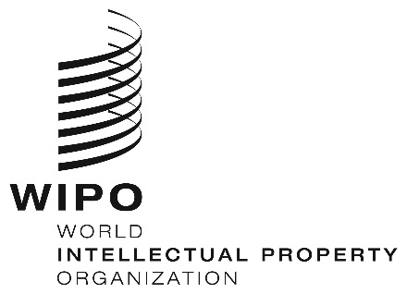
INFORMATION NOTICE NO. 73/2020
Madrid Protocol Concerning the International Registration of Marks
Change in the Amounts of the Individual Fee: United States of America
- The Government of the United States of America has notified to the Director General of the World Intellectual Property Organization (WIPO) a declaration modifying the amounts of the individual fee payable with respect to the United States of America under Article 8(7) of the Madrid Protocol.
- As from February 18, 2021, the amounts of the individual fee payable in respect of the United States of America will be the following:
ITEMS |  | Amounts  (in Swiss francs)
 |  | until  February 17, 2021 | as from  February 18, 2021
Application or Subsequent Designation | – for each class of goods or services | 388 | 460
Renewal | – for each class of goods or services | 291 | 276

- These new amounts will be payable where the United States of America
(a) is designated in an international application which is received by the Office of origin on or after February 18, 2021; or
(b) is the subject of a subsequent designation which is received by the Office of the Contracting Party of the holder on or after February 18, 2021, or is filed directly with the International Bureau of WIPO on or after that date; or
(c) has been designated in an international registration which is renewed on or after February 18, 2021.
November 30, 2020

