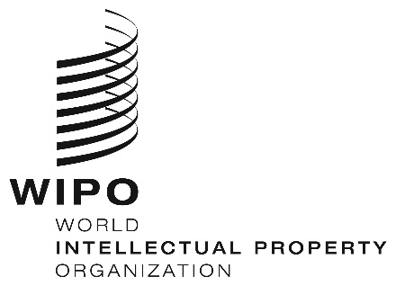
INFORMATION NOTICE NO. 48/2020

Madrid Protocol Concerning the International Registration of Marks

Change in the Amounts of the Individual Fee: Greece

- The Government of Greece has notified to the Director General of the World Intellectual Property Organization (WIPO) a declaration modifying the amounts of the individual fee payable with respect to Greece under Article 8(7) of the Madrid Protocol.
- In accordance with Rule 35(2)(b) of the Regulations under the Madrid Protocol, the Director General of WIPO has, after consultation with the Office of Greece, established the following new amounts, in Swiss francs, of the said individual fee:
ITEMS |  | Amounts  (in Swiss francs)
Application or Subsequent Designation | – for one class of goods or services | 127
 | – for each additional class | 21
 | Where the mark is a collective or certification mark:
 | – for one class of goods or services | 634
 | – for each additional class | 106
Renewal | – for one class of goods or services | 116
 | – for each additional class | 21
 | Where the mark is a collective or certification mark:
 | – for one class of goods or services  – for each additional class | 581  106

- This change shall have effect on August 22, 2020. Therefore, these amounts will be payable where Greece
(a) is designated in an international application which is received by the Office of origin on or after that date; or
(b) is the subject of a subsequent designation which is received by the Office of the Contracting Party of the holder on or after that date, or is filed directly with the International Bureau of WIPO on or after that date; or

(c) has been designated in an international registration which is renewed on or after that date.

June 18, 2020

