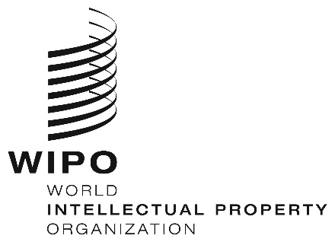
INFORMATION NOTICE NO. 2/2020

Madrid Protocol Concerning the International Registration of Marks

Agreement on the Withdrawal of the United Kingdom from the European Union: Implications for International Applications and Registrations Under the Madrid System

- The Agreement on the Withdrawal of the United Kingdom of Great Britain and Northern Ireland from the European Union and the European Atomic Energy Community (hereinafter referred to as “the Withdrawal Agreement”), provides for a transition period starting on February 1, 2020, the date on which the United Kingdom will leave the European Union, and ending on December 31, 2020.
- The International Bureau of the World Intellectual Property Organization (WIPO) wishes to inform users that international registrations under the Madrid System for the International Registration of Marks (the Madrid System) designating the European Union, including those designations made during the above-mentioned transition period, will continue to have effect in the United Kingdom during this period. Furthermore, nationals of the United Kingdom and those who are domiciled or have a real and effective industrial or commercial establishment in the United Kingdom and in whose name stands an application or registration with the Office of the European Union, may continue to file international applications with this Office, as Office of origin, during the transition period.
- Finally, under the Withdrawal Agreement, the United Kingdom will take measures to ensure that holders of international registrations under the Madrid System that have obtained protection for their marks in the European Union before the end of the transition period continue to enjoy protection for those marks in the United Kingdom after this period has ended. The International Bureau of WIPO will provide more information on the above-mentioned measures as soon as further details become available.

January 30, 2020

