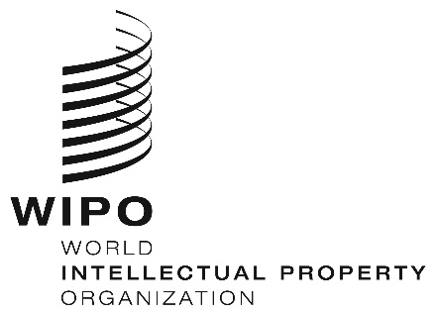
INFORMATION NOTICE NO. 51/2019

Madrid Protocol Concerning the International Registration of Marks

Withdrawal of the notification made under Rule 40(6) of the Common Regulations under the Madrid Agreement and the Madrid Protocol: New Zealand

- The Director General of the World Intellectual Property Organization (WIPO) received a communication from the Office of New Zealand withdrawing the notification made by New Zealand under Rule 40(6) of the Common Regulations under the Madrid Agreement and the Madrid Protocol (“Common Regulations”).
- Such withdrawal became effective on March 21, 2019.
- Consequently, as from March 21, 2019, the Office of New Zealand can present to the International Bureau of WIPO requests for the division of an international registration under Rule 27bis(1) of the Common Regulations and requests for the merger of international registrations resulting from division under Rule 27ter(2)(a) of the Common Regulations.

July 5, 2019

