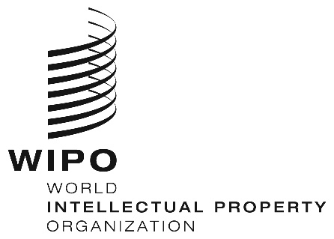
INFORMATION NOTICE NO. 38/2019

Madrid Protocol Concerning the International Registration of Marks

Notification under new Rules 27ter(2)(b) and 40(6) of the Common Regulations: Republic of Korea

- The Government of the Republic of Korea has notified the Director General of the World Intellectual Property Organization (WIPO) in accordance with new Rules 27ter(2)(b) and 40(6) of the Common Regulations under the Madrid Agreement Concerning the International Registration of Marks and the Protocol Relating to that Agreement (the Common Regulations), which entered into force on February 1, 2019.
- According to the said notification:
- new Rule 27bis(1) of the Common Regulations, providing for the possibility to file a request for division, is not compatible with the law of the Republic of Korea and does not apply in respect of the Republic of Korea; and,
- the law of the Republic of Korea does not provide for the merger of registrations of a mark.
- As a result, the Office of the Republic of Korea will not present to the International Bureau of WIPO requests for the division of an international registration under new Rule 27bis(1) nor requests for the merger of international registrations resulting from division under new Rule 27ter(2)(a).
- Further details on new Rules 27bis, 27ter and 40(6), which entered into force on February 1, 2019, can be found in Information Notice No. 21/2018.

March 28, 2019

