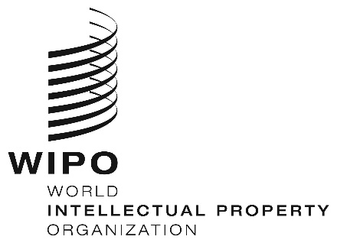
INFORMATION NOTICE NO. 35/2026

Madrid Protocol Concerning the International Registration of Marks

Accession to the Madrid Protocol: Saudi Arabia

- On July 8, 2026, the Government of Saudi Arabia deposited with the Director General of the World Intellectual Property Organization (WIPO) its instrument of accession to the Protocol Relating to the Madrid Agreement Concerning the International Registration of Marks (“the Madrid Protocol”). The Madrid Protocol will enter into force with respect to Saudi Arabia on October 8, 2026.
- The said instrument of accession was accompanied by:
– the declaration referred to in Article 5(2)(b) and (c) of the Madrid Protocol, whereby the time limit of one year to notify a provisional refusal of protection is replaced by 18 months, and a provisional refusal resulting from an opposition may be notified after the expiry of this time limit;
– the declaration referred to in Article 8(7)(a) of the Madrid Protocol, whereby Saudi Arabia wants to receive an individual fee when it is designated in an international application, in a designation subsequent to an international registration and in respect of the renewal of an international registration where Saudi Arabia has been designated, instead of a share in the revenue produced by the supplementary and complementary fees;
– the notification under Rule 27bis(6) of the Regulations under the Madrid Protocol, whereby the Office of Saudi Arabia will not present to the International Bureau of WIPO requests for the division of an international registration in respect of Saudi Arabia because its law does not provide for the division of registrations of a mark; and,
– the notification under Rule 27ter(2)(b) of the Regulations under the Madrid Protocol, whereby the Office of Saudi Arabia will not present to the International Bureau of WIPO requests for the merger of international registrations resulting from division because the law of Saudi Arabia does not provide for the merger of registrations of a mark.
- The amounts of the individual fee indicated by the Government of Saudi Arabia under Article 8(7)(a) of the Madrid Protocol will be the subject of a separate Information Notice.
- With the accession of Saudi Arabia to the Madrid Protocol, the number of Contracting Parties of this treaty and members of the Madrid Union is now 117. A list of the members of the Madrid Union, with information on the dates on which they became party to the Madrid Protocol, is available on WIPO’s website, at the following address: https://www.wipo.int/en/web/madrid-system/members/index.

July 23, 2026

