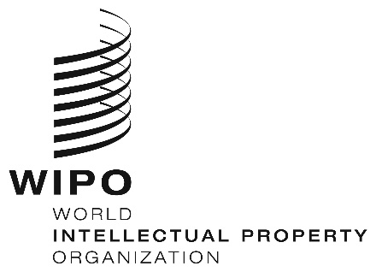
INFORMATION NOTICE NO. 41/2025

Madrid Protocol Concerning the International Registration of Marks

Withdrawal of the notification made under Rule 40(6) of the Regulations under the Madrid Protocol: Sweden

- The Director General of the World Intellectual Property Organization (WIPO) has received a communication from the Government of Sweden withdrawing the notification made by Sweden under Rule 40(6) of the Regulations under the Madrid Protocol (“Regulations”).
- Such withdrawal became effective on December 1, 2025.
- Consequently, as from the above-mentioned date, the Office of Sweden may present to the International Bureau of WIPO requests for the division of an international registration under Rule 27bis(1) of the Regulations.

December 9, 2025

