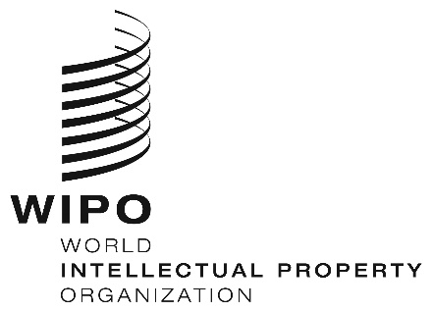
INFORMATION NOTICE NO. 10/2025
Madrid Protocol Concerning the International Registration of Marks
Change in the Amounts of the Individual Fee: Syrian Arab Republic
- The Government of the Syrian Arab Republic has notified the Director General of the World Intellectual Property Organization (WIPO) of a declaration modifying the amounts of the individual fee payable in respect of the Syrian Arab Republic under Article 8(7) of the Madrid Protocol.
- As from September 18, 2025, the amounts of the individual fee payable in respect of the Syrian Arab Republic will be the following:
ITEMS |  | Amounts  (in Swiss francs)
 |  | until  September 17, 2025 | as from  September 18, 2025
Application or Subsequent Designation | – for each class of goods or services | 134 | 215
Renewal | – for each class of goods or services | 134 | 215

- These new amounts will be payable where the Syrian Arab Republic
(a) is designated in an international application received by the Office of origin on or after September 18, 2025; or

(b) is the subject of a subsequent designation received by the Office of the Contracting Party of the holder or filed directly with the International Bureau of WIPO on or after that date; or
(c) has been designated in an international registration renewed on or after that date.
July 28, 2025

