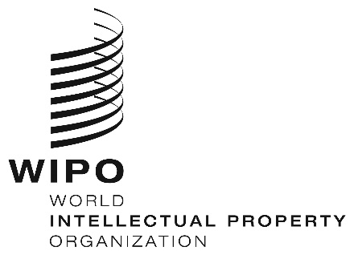
INFORMATION NOTICE NO. 17/2023
Madrid Protocol Concerning the International Registration of Marks
Change in the Amounts of the Individual Fee: Iceland
- The Government of Iceland has notified to the Director General of the World Intellectual Property Organization (WIPO) a declaration modifying the amounts of the individual fee payable with respect to Iceland under Article 8(7) of the Madrid Protocol.
- As from August 19, 2023, the amounts of the individual fee payable in respect of Iceland will be the following:
ITEMS |  | Amounts  (in Swiss francs)
 |  | until  August 18, 2023 | as from  August 19, 2023
Application or Subsequent Designation | – for one class of goods or services | 224 | 247
Application or Subsequent Designation | – for each additional class | 48 | 53
Application or Subsequent Designation | Where the mark is a collective mark:
Application or Subsequent Designation | – for one class of goods or services | 224 | 247
Application or Subsequent Designation | – for each additional class | 48 | 53

ITEMS |  | Amounts  (in Swiss francs)
 |  | until  August 18, 2023 | as from  August 19, 2023
Renewal | – for one class of goods or services | 224 | 247
Renewal | – for each additional class | 48 | 53
Renewal | Where the mark is a collective mark:
Renewal | – for one class of goods or services  – for each additional class | 224  48 | 247  53

- These new amounts will be payable where Iceland
(a) is designated in an international application which is received by the Office of origin on or after August 19, 2023; or
(b) is the subject of a subsequent designation which is received by the Office of the Contracting Party of the holder or is filed directly with the International Bureau of WIPO on or after that date; or
(c) has been designated in an international registration which is renewed on or after that date.
June 15, 2023

