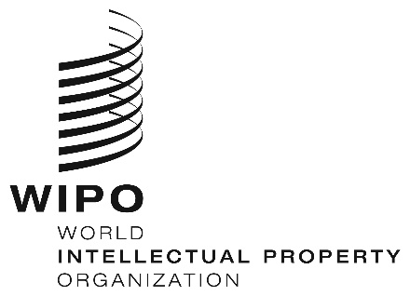
INFORMATION NOTICE NO. 9/2022

Madrid Protocol Concerning the International Registration of Marks

Withdrawal of the declaration made under Article 14(5) of the Madrid Protocol: Namibia

- The Director General of the World Intellectual Property Organization (WIPO) received a communication from the Government of Namibia withdrawing the declaration made by Namibia under Article 14(5) of the Protocol Relating to the Madrid Agreement Concerning the International Registration of Marks (“Madrid Protocol”).
- Such withdrawal became effective on February 16, 2022.
- Consequently, as from the above-mentioned date, Namibia may be the subject of a subsequent designation in respect of any international registration, including those effected before the date of entry into force of the Madrid Protocol in respect of Namibia, that is, including those international registrations effected before June 30, 2004.

March 7, 2022

