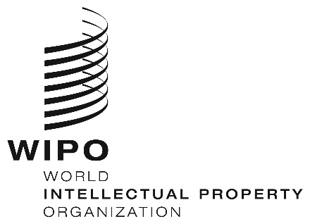
INFORMATION NOTICE NO. 5/2024
Madrid Protocol Concerning the International Registration of Marks
Change in the Amounts of the Individual Fee: Philippines
- In accordance with Rule 35(2)(d) of the Regulations under the Madrid Protocol, the Director General of the World Intellectual Property Organization (WIPO) has established new amounts, in Swiss francs, of the individual fee that is payable when the Philippines is designated in an international application, in a designation subsequent to an international registration and in respect of the renewal of an international registration in which the Philippines has been designated.
- As from April 28, 2024, the amounts of the individual fee payable in respect of the Philippines will be the following:
ITEMS |  | Amounts  (in Swiss francs)
 |  | until  April 27, 2024 | as from  April 28, 2024
Application or Subsequent Designation | – for each class of goods or services | 101 | 89
Renewal | – for each class of goods or services | 156 | 137

- These new amounts will be payable where the Philippines
(a) is designated in an international application which is received by the Office of origin on or after April 28, 2024; or

(b) is the subject of a subsequent designation which is received by the Office of the Contracting Party of the holder or is filed directly with the International Bureau of WIPO on or after that date; or
(c) has been designated in an international registration which is renewed on or after that date.
March 28, 2024

