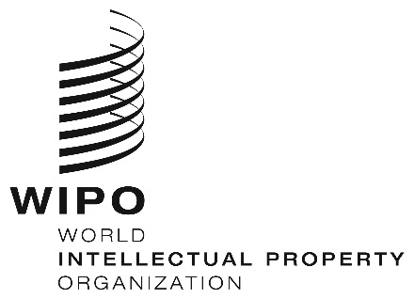
INFORMATION NOTICE NO. 7/2024
Madrid Protocol Concerning the International Registration of Marks
Change in the Amounts of the Individual Fee: Syrian Arab Republic
- The Government of the Syrian Arab Republic has notified to the Director General of the World Intellectual Property Organization (WIPO) a declaration modifying the amounts of the individual fee payable with respect to the Syrian Arab Republic under Article 8(7) of the Madrid Protocol.
- As from June 26, 2024, the amounts of the individual fee payable in respect of the Syrian Arab Republic will be the following:
ITEMS |  | Amounts  (in Swiss francs)
 |  | until  June 25, 2024 | as from  June 26, 2024
Application or Subsequent Designation | – for each class of goods or services | 41 | 134
Renewal | – for each class of goods or services | 41 | 134

- These new amounts will be payable where the Syrian Arab Republic
(a) is designated in an international application which is received by the Office of origin on or after June 26, 2024; or

(b) is the subject of a subsequent designation which is received by the Office of the Contracting Party of the holder or is filed directly with the International Bureau of WIPO on or after that date; or
(c) has been designated in an international registration which is renewed on or after that date.
May 15, 2024

