INFORMATION NOTICE NO. 17/2016

Madrid Agreement and Protocol Concerning the International Registration of Marks

Amendments to the Common Regulations under the Madrid Agreement and Protocol

- At its forty-ninth (21st ordinary) session, which took place in Geneva from October 5 to 14, 2015, the Assembly of the Madrid Union adopted amendments to the Common Regulations under the Madrid Agreement Concerning the International Registration of Marks and the Protocol Relating to that Agreement (the Common Regulations) that will enter into force on April 1, 2016.
Amendments to Rule 5 of the Common Regulations: Irregularities in Postal and Delivery Services and in Communications Sent Electronically
- Under the new text of paragraph (3) of Rule 5, failure of an interested party to meet a time limit for a communication addressed to WIPO will be excused where the communication was sent electronically and the interested party submits satisfactory evidence showing that the time limit was not met due to a failure in the electronic communication with WIPO or to one that affects the locality of the interested party due to extraordinary circumstances. In this case, a new communication should be effected no later than five days after the electronic services are resumed.
- The new provision is meant to cover communications sent to WIPO by an interested party (i.e., the applicant, holder, representative or Office of a Contracting Party) by electronic means (e.g., e-mail, fax, e-forms). An interested party may be excused for not meeting a time limit when an electronic communication is not received by WIPO due to any failure in the electronic communication systems. Moreover, the interested party will also be excused where extraordinary circumstances in its locality (e.g., prolonged Internet service disruptions, unanticipated power outages) prevent this party from effecting the communication.
- In order to be excused, the interested party must submit sufficient evidence to WIPO (e.g. an attestation from its Internet service provider confirming that the communication was sent or that service was not available, a letter from the power company informing of unanticipated outages, news articles of those events) and a new communication is received by WIPO within five days after services are resumed.
- In accordance with new paragraph (4) of Rule 5, the supporting evidence and the new communication shall be received by WIPO no later than six months from the expiry of the time-limit concerned.

- Under new paragraph (5) of Rule 5, when an Office is excused for not meeting the two-month time limit for WIPO to receive an international application or subsequent designation, as specified in Article 3(4) of the Madrid Protocol and Rule 24(6)(b), the date of the international registration or subsequent designation will be the date on which the Office received the said application or designation, as certified by that Office.
- Finally, users are reminded that failure to meet a time-limit for communications mailed through a postal service or sent through a delivery service may be excused under the conditions specified in paragraphs (1) or (2) of Rule 5.
Amendments to Rule 36 of the Common Regulations: Exemption From Fees
- An amendment to paragraph (ii) of Rule 36 clarifies that changes in the address for correspondence, e-mail address, telephone and fax numbers and in any other means of communication with the applicant or holder are exempt from the payment of a fee.
- Applicants and holders wishing to request any of the abovementioned changes to their contact information can do so by sending a communication to WIPO, signed by the applicant, holder or the recorded representative. In addition to the requested change, the communication must clearly indicate the name of the applicant or holder and, as the case may be, the basic application, basic registration or international registration number(s). Applicants and holders are encouraged to maintain their contact information up-to-date in order to receive communications from WIPO at their current addresses.
- When holders request the recording of a change in their name or address, by using form MM9, they need to confirm their address for correspondence. If this is not done, WIPO will send communications to their new address. Holders may also take advantage of this opportunity to opt for electronic communication or to request that their other contact information be updated by providing the relevant details in item 4 of the form.
How to Present Requests Under Rules 5 and 36(ii) of the Common Regulations

- A communication under Rules 5, requesting that an interested party be excused for having failed to meet a time limit, or 36(ii) of the Common Regulations, requesting a change in the contact details of the applicant or holder, may be presented to WIPO as follows:
By e-mail: intreg@wipo.int
indicating in the subject line, as the case may be,
“Request to be excused for having failed to meet a time limit under Rule 5”
“Request to change contact details under Rule 36(ii)”

By post: Madrid Registry
World Intellectual Property Organization
34, chemin des Colombettes
1211 Geneva 20, Switzerland

- The amended text of the Common Regulations and form MM9 are reproduced in Annexes I and II.

March 29, 2016

Common Regulations under
the Madrid Agreement Concerning
the International Registration of Marks
and the Protocol Relating to that Agreement

(as in force on April 1, 2016)

[…]

Chapter 1
General Provisions

[…]

Rule 5
Irregularities in Postal and Delivery Services
and in Communications Sent Electronically

[…]

(3) [Communication Sent Electronically] Failure by an interested party to meet a time limit for a communication addressed to the International Bureau and submitted by electronic means shall be excused if the interested party submits evidence showing, to the satisfaction of the International Bureau, that the time limit was not met because of failure in the electronic communication with the International Bureau, or which affects the locality of the interested party owing to extraordinary circumstances beyond the control of the interested party, and that the communication was effected not later than five days after the electronic communication service was resumed.

(4) [Limitation on Excuse] Failure to meet a time limit shall be excused under this Rule only if the evidence referred to in paragraph (1), (2) or (3) and the communication or, where applicable, a duplicate thereof are received by the International Bureau not later than six months after the expiry of the time limit.

(5) [International Application and Subsequent Designation] Where the International Bureau receives an international application or a subsequent designation beyond the two-month period referred to in Article 3(4) of the Agreement, in Article 3(4) of the Protocol and in Rule 24(6)(b), and the Office concerned indicates that the late receipt resulted from circumstances referred to in paragraph (1), (2) or (3), paragraph (1), (2) or (3) and paragraph (4) shall apply.

Chapter 8
Fees

[…]

Rule 36
Exemption From Fees

Recording of the following shall be exempt from fees:
(i) the appointment of a representative, any change concerning a representative and the cancellation of the recording of a representative,
(ii) any change concerning the telephone and telefacsimile numbers, address for correspondence, electronic mail address and any other means of communication with the applicant or holder, as specified in the Administrative Instructions,
(iii) the cancellation of the international registration,
(iv) any renunciation under Rule 25(1)(a)(iii),
(v) any limitation effected in the international application itself under Rule 9(4)(a)(xiii) or in a subsequent designation under Rule 24(3)(a)(iv),
(vi) any request by an Office under Article 6(4), first sentence, of the Agreement or Article 6(4), first sentence, of the Protocol,
(vii) the existence of a judicial proceeding or of a final decision affecting the basic application, or the registration resulting therefrom, or the basic registration,
(viii) any refusal under Rule 17, Rule 24(9) or Rule 28(3), any statement under Rules 18bis or 18ter or any declaration under Rule 20bis(5) or Rule 27(4) or (5),
(ix) the invalidation of the international registration,
(x) information communicated under Rule 20,
(xi) any notification under Rule 21 or Rule 23,
(xii) any correction in the International Register.

[Annex II follows]

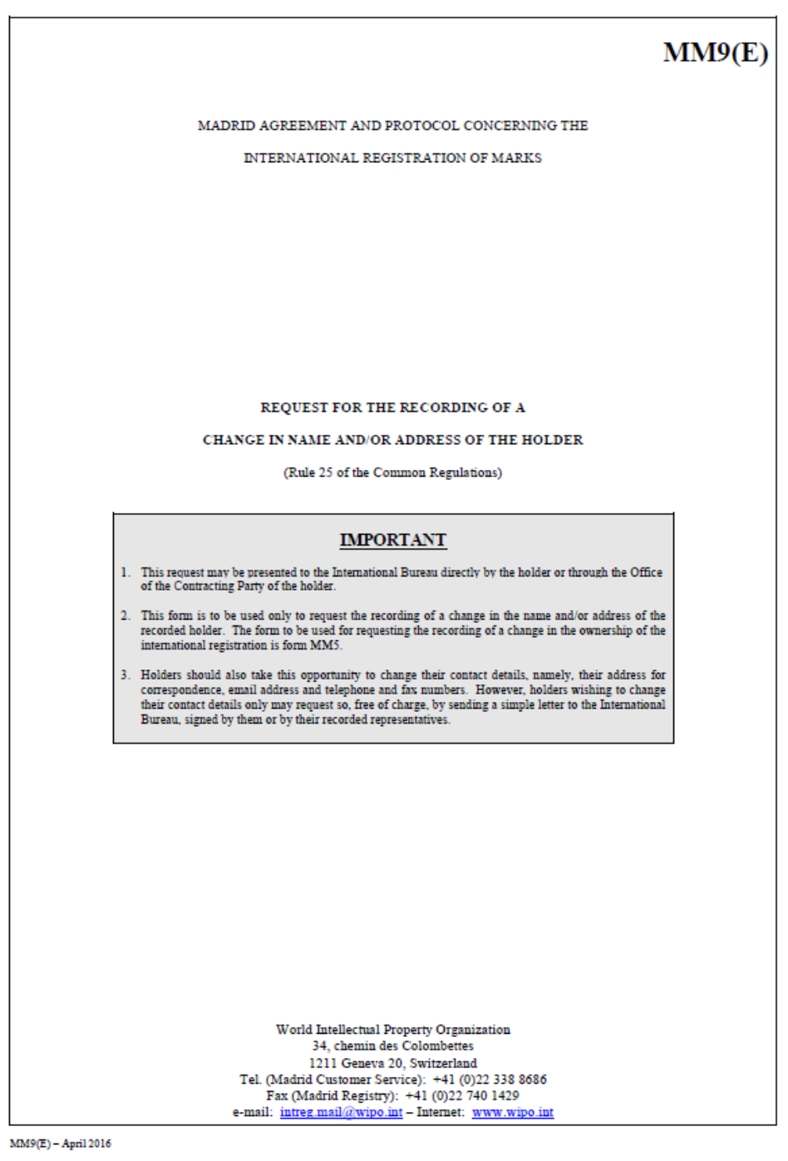

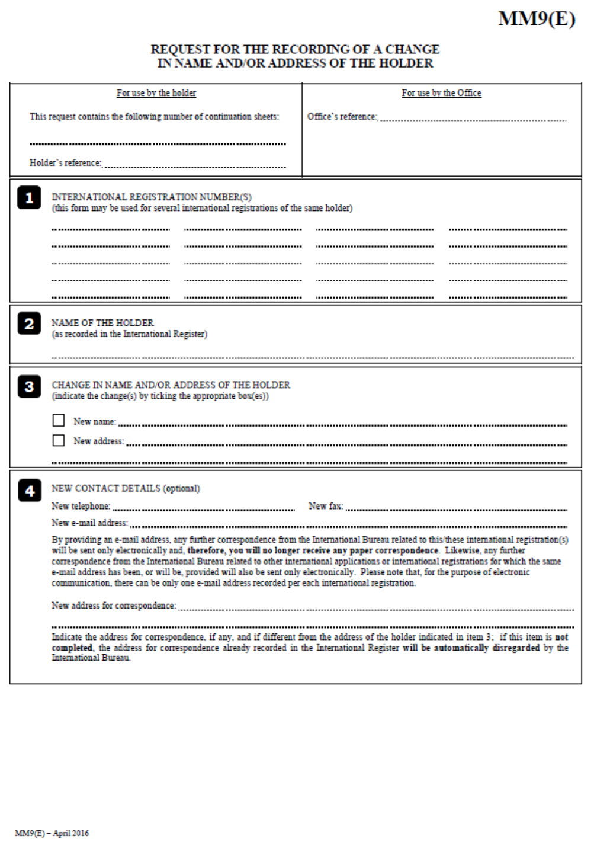

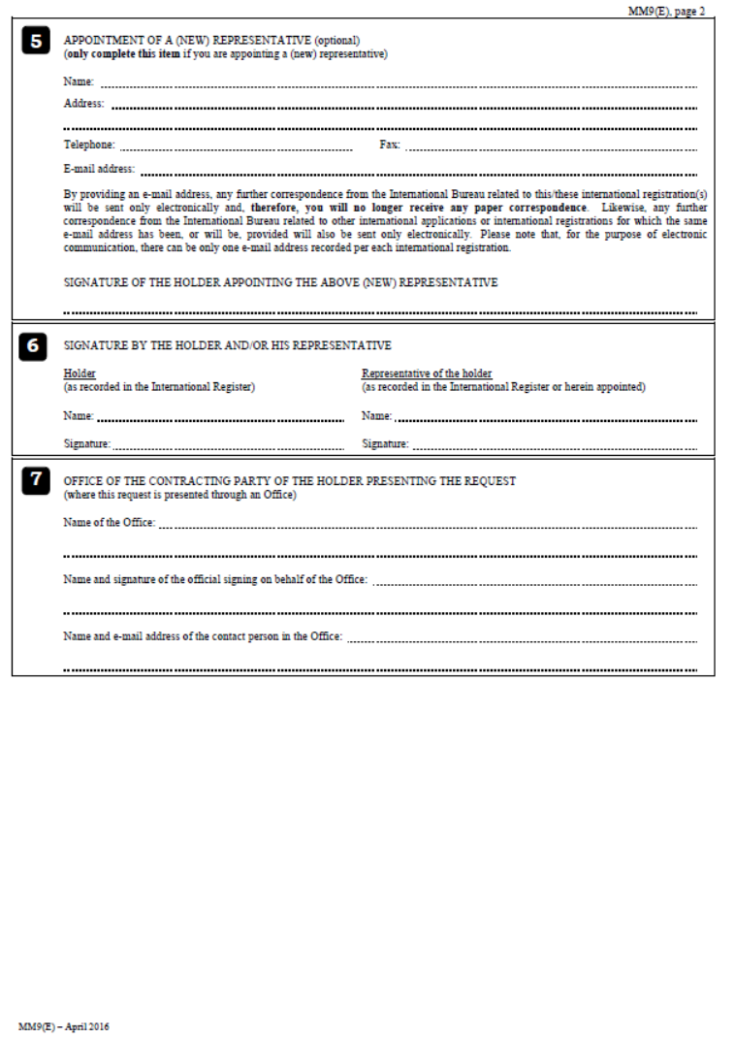
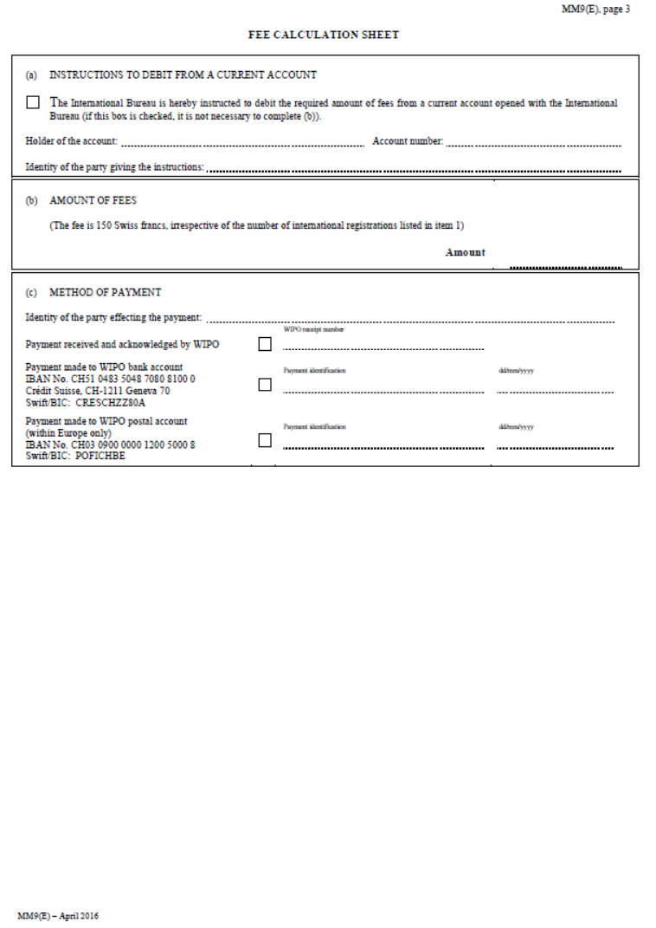

[End of Annex II]

