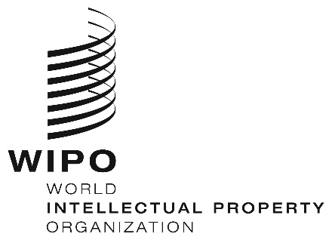
INFORMATION NOTICE NO. 13/2023
Madrid Protocol Concerning the International Registration of Marks
Change in the Amounts of the Individual Fee: Syrian Arab Republic
- In accordance with Rule 35(2)(d) of the Regulations under the Madrid Protocol, the Director General of the World Intellectual Property Organization (WIPO) has established new amounts, in Swiss francs, of the individual fee that is payable when the Syrian Arab Republic is designated in an international application, in a designation subsequent to an international registration and in respect of the renewal of an international registration in which the Syrian Arab Republic has been designated.
- As from June 9, 2023, the amounts of the individual fee payable in respect of the Syrian Arab Republic will be the following:
ITEMS |  | Amounts  (in Swiss francs)
 |  | until  June 8, 2023 | as from  June 9, 2023
Application or Subsequent Designation | – for each class of goods or services | 180 | 73
Renewal | – for each class of goods or services | 180 | 73

- These new amounts will be payable where the Syrian Arab Republic
(a) is designated in an international application which is received by the Office of origin on or after June 9, 2023; or
(b) is the subject of a subsequent designation which is received by the Office of the Contracting Party of the holder or is filed directly with the International Bureau of WIPO on or after that date; or
(c) has been designated in an international registration which is renewed on or after that date.
May 9, 2023

