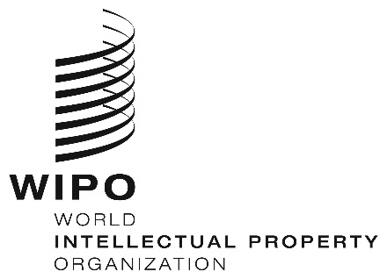
INFORMATION NOTICE NO. 15/2022

Madrid Protocol Concerning the International Registration of Marks

Accession to the Madrid Protocol: Cabo Verde

- On April 6, 2022, the Government of Cabo Verde deposited with the Director General of the World Intellectual Property Organization (WIPO) its instrument of accession to the Protocol Relating to the Madrid Agreement Concerning the International Registration of Marks (“the Madrid Protocol”). The Madrid Protocol will enter into force with respect to Cabo Verde on July 6, 2022.
- With the accession of Cabo Verde to the Madrid Protocol, the number of Contracting Parties of this treaty and members of the Madrid Union is now 112. A list of the members of the Madrid Union, with information on the dates on which they became party to the Madrid Protocol, is available on WIPO’s website, at the following address: www.wipo.int/madrid/en/members/.

April 27, 2022

