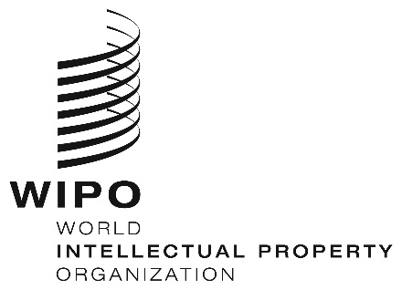
INFORMATION NOTICE NO. 4/2021

Madrid Protocol Concerning the International Registration of Marks

Accession to the Madrid Protocol: Pakistan

- On February 24, 2021, the Government of Pakistan deposited with the Director General of the World Intellectual Property Organization (WIPO) its instrument of accession to the Protocol Relating to the Madrid Agreement Concerning the International Registration of Marks (“the Madrid Protocol”). The Madrid Protocol will enter into force with respect to Pakistan on May 24, 2021.
- The said instrument of accession was accompanied by:
– the declaration referred to in Article 5(2)(b) and (c) of the Madrid Protocol, whereby the time limit of one year to notify a provisional refusal of protection is replaced by 18 months, and a provisional refusal resulting from an opposition may be notified after the expiry of the 18-month time limit;
– the declaration referred to in Article 8(7)(a) of the Madrid Protocol, whereby Pakistan wants to receive an individual fee when it is designated in an international application, in a designation subsequent to an international registration and in respect of the renewal of an international registration where it has been designated, instead of a share in the revenue produced by the supplementary and complementary fees;
– the notification under Rule 7(2) of the Regulations under the Madrid Protocol, whereby Pakistan requires, when it is designated under the Madrid Protocol, a declaration of intention to use the mark. The footnote b in item 11 of the official form MM2 and item 4 of the official form MM4 will be modified to indicate that, by designating Pakistan, applicants or holders declare that they have the intention of using the mark or that it will be used with their consent in Pakistan in connection with the goods and services identified in the international application or subsequent designation concerned;
– the notification under Rule 20bis(6)(b) of the Regulations under the Madrid Protocol, whereby the recording of licenses in the International Register shall have no effect in Pakistan. Consequently, a license relating to an international registration shall be recorded in the National Register of the Office of Pakistan in order to have effect in that Contracting Party. The formalities required for such recording must be completed directly with the Office of Pakistan and according to the conditions laid down by the legislation of that Contracting Party; and

– the notification under Rule 27ter(2)(b) of the Regulations under the Madrid Protocol, whereby the Office of Pakistan will not present to the International Bureau of WIPO requests for the merger of international registrations resulting from division because the law of Pakistan does not provide for the merger of registrations of a mark.
- The amounts of the individual fee indicated by the Government of Pakistan under Article 8(7)(a) of the Madrid Protocol will be the subject of a separate information notice.
- With the accession of Pakistan to the Madrid Protocol, the number of Contracting Parties of this treaty and members of the Madrid Union is now 108. A list of the members of the Madrid Union, with information on the dates on which they became party to the Madrid Protocol, is available on WIPO’s website, at the following address: www.wipo.int/madrid/en/members.

March 17, 2021

