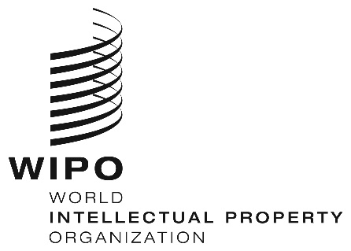
INFORMATION NOTICE NO. 19/2021

Madrid Protocol Concerning the International Registration of Marks

Non-Working Days in 2022

Pursuant to Rule 32(2)(v) of the Regulations under the Protocol Relating to the Madrid Agreement Concerning the International Registration of Marks, users are hereby informed that, in addition to Saturdays and Sundays, the days on which the International Bureau of the World Intellectual Property Organization (WIPO) is not scheduled to be open to the public during 2022, are the following:
NEW YEAR | Monday, January 3, 2022
EASTER | Friday, April 15, 2022  Monday, April 18, 2022
ASCENSION | Thursday, May 26, 2022
WHITSUN | Monday, June 6, 2022
JEÛNE GENEVOIS | Thursday, September 8, 2022
CHRISTMAS | Monday, December 26, 2022
NEW YEAR’S EVE | Friday, December 30, 2022

Furthermore, users are reminded that the International Bureau of WIPO is not scheduled to be open to the public on Friday, December 24, 2021, and Friday, December 31, 2021.

November 9, 2021

