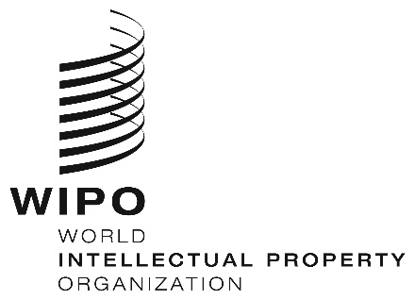
INFORMATION NOTICE NO. 15/2021

Madrid Protocol Concerning the International Registration of Marks

Accession to the Madrid Protocol: United Arab Emirates

- On September 28, 2021, the Government of the United Arab Emirates deposited with the Director General of the World Intellectual Property Organization (WIPO) its instrument of accession to the Protocol Relating to the Madrid Agreement Concerning the International Registration of Marks (“the Madrid Protocol”). The Madrid Protocol will enter into force with respect to the United Arab Emirates on December 28, 2021.
- The said instrument of accession was accompanied by:
– the declaration referred to in Article 5(2)(b) and (c) of the Madrid Protocol, whereby the time limit of one year to notify a provisional refusal of protection is replaced by 18 months, and a provisional refusal resulting from an opposition may be notified after the expiry of the 18-month time limit; and
– the declaration referred to in Article 8(7)(a) of the Madrid Protocol, whereby the United Arab Emirates want to receive an individual fee when they are designated in an international application, in a designation subsequent to an international registration and in respect of the renewal of an international registration where they have been designated, instead of a share in the revenue produced by the supplementary and complementary fees.
- The amounts of the individual fee indicated by the Government of the United Arab Emirates under Article 8(7)(a) of the Madrid Protocol will be the subject of a separate information notice.
- With the accession of the United Arab Emirates to the Madrid Protocol, the number of Contracting Parties of this treaty and members of the Madrid Union is now 109. A list of the members of the Madrid Union, with information on the dates on which they became party to the Madrid Protocol, is available on WIPO’s website, at the following address: www.wipo.int/madrid/en/members.

October 14, 2021

