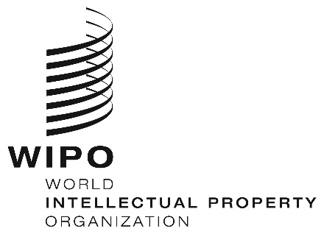
INFORMATION NOTICE NO. 64/2020

Madrid Protocol Concerning the International Registration of Marks

Withdrawal of the notification made under Rule 40(6) of the Regulations under the Madrid Protocol: Colombia

- The Director General of the World Intellectual Property Organization (WIPO) received a communication from the Office of Colombia withdrawing the notification made by Colombia under Rule 40(6) of the Regulations under the Madrid Protocol (“Regulations”).
- Such withdrawal will become effective on January 4, 2021.
- Consequently, as from January 4, 2021, the Office of Colombia will be able to present to the International Bureau of WIPO requests for the division of an international registration under Rule 27bis(1) of the Regulations.

November 13, 2020

