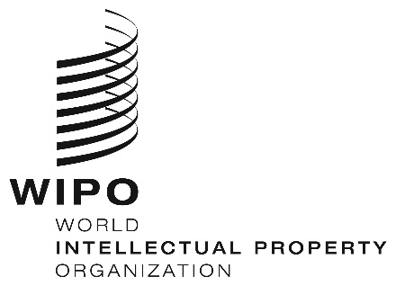
INFORMATION NOTICE NO. 59/2020

Madrid Protocol Concerning the International Registration of Marks

Withdrawal of the notification made under Rule 34(2)(b) of the Regulations under the Madrid Protocol: Viet Nam

- The Director General of the World Intellectual Property Organization (WIPO) received a communication from the Office of Viet Nam withdrawing the notification made by Viet Nam under Rule 34(2)(b) of the Regulations under the Madrid Protocol (“Regulations”).
- Such withdrawal became effective on September 1, 2020.
- Consequently, as from September 1, 2020, the Office of Viet Nam no longer collects and forwards to the International Bureau of WIPO the fees due under the Madrid Protocol and its Regulations.

September 30, 2020

