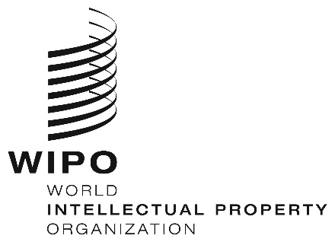
INFORMATION NOTICE NO. 40/2020
Madrid Protocol Concerning the International Registration of Marks
Philippines: Extension of the closure of the Office and of other measures
- The Intellectual Property Office of the Philippines (IPOPHL) has informed the International Bureau of the World Intellectual Property Organization (WIPO) the following:
- the IPOPHL, while remaining operational and providing services and support online, remained closed to the public until May 25, 2020 (see Information Notice No. 32/2020);
- IPOPHL Memorandum Circulars Nos. 2020-13 and 2020-13A, provide for an extension of deadlines for all papers, pleadings, documents and payments falling due between March 16 and June 30, 2020; and,
- all scheduled hearings before the IPOPHL, including hearings concerning mediation, remained suspended until May 25, 2020.
2. Accordingly, under Rule 4(4) of the Regulations under the Protocol Relating to the Madrid Agreement Concerning the International Registration of Marks, all periods under the Madrid System that concerned the IPOPHL, and that expired on a day on which this Office was not open to the public expired on the first subsequent day on which the IPOPHL reopened; that is, they expired on May 26, 2020.
3. For further information, users of the Madrid System may visit the IPOPHL’s website at the following address: https://www.ipophil.gov.ph/. Users may also consult the IPOPHL Memorandum Circulars Nos. 2020-13 and 2020-13A, at the following address: https://www.ipophil.gov.ph/news/advisories/.
May 28, 2020

