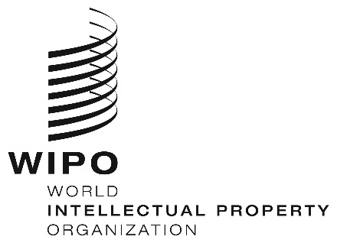
INFORMATION NOTICE NO. 32/2020
Madrid Protocol Concerning the International Registration of Marks
Philippines: Closure of the Office
- The Intellectual Property Office of the Philippines (IPOPHL) has informed the International Bureau of the World Intellectual Property Organization (WIPO) that it will not be open to the public, from March 16 to May 15, 2020. The IPOPHL is operational providing services and support online.
- Accordingly, under Rule 4(4) of the Regulations under the Protocol Relating to the Madrid Agreement Concerning the International Registration of Marks, all periods under the Madrid System that concern this Office and that expire on a day on which the IPOPHL is not open to the public will expire on the first subsequent day on which the IPOPHL reopens. Therefore, those periods will expire on May 18, 2020.
- The IPOPHL has also informed the International Bureau of WIPO that it has issued the IPOPHL Memorandum Circular No. 2020-011, which gives an extension of deadlines for all papers, pleadings, documents and payments thereof falling due between March 16 and May 15, 2020.
- Furthermore, the IPOPHL has informed the International Bureau of WIPO that all scheduled hearings before the IPOPHL, including mediation, shall remain suspended until May 15, 2020.
- For further information, users of the Madrid System may visit the IPOPHL’s website at the following address: https://www.ipophil.gov.ph/, or consult the IPOPHL Memorandum Circular No. 2020-011, at the following address: https://drive.google.com/file/d/1zE4qJtFVK8DwNibMHW-ceT4LK5m2TXtt/view.
May 5, 2020

