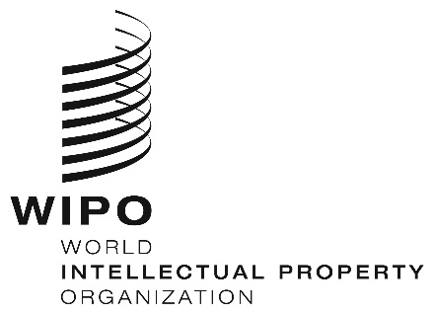
INFORMATION NOTICE NO. 29/2020
Madrid Protocol Concerning the International Registration of Marks
Spain: Closure of the Office
- The Spanish Patent and Trademark Office (OEPM) has informed the International Bureau of the World Intellectual Property Organization (WIPO) that, for the purposes of the Madrid System, it is not open to the public since March 14, 2020, and until further notice.
- Accordingly, under Rule 4(4) of the Regulations under the Protocol Relating to the Madrid Agreement Concerning the International Registration of Marks, all periods under the Madrid System that concern this Office and that expire on a day on which the OEPM is not open to the public will expire on the first subsequent day on which the OEPM reopens.
- For further information, users of the Madrid System may visit the OEPM’s website at the following address: https://www.oepm.es/es/index.html.
April 24, 2020

