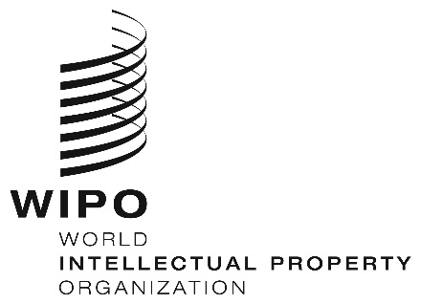
INFORMATION NOTICE NO. 23/2020
Madrid Protocol Concerning the International Registration of Marks
Spain: Suspension of time limits and abeyance of ongoing proceedings
- The Spanish Patent and Trademark Office (OEPM) has informed the International Bureau of the World Intellectual Property Organization (WIPO) that, by Royal Decree No. 463/2020 dated March 14, 2020, the Spanish Government has declared a state of emergency to manage the health crisis caused by the Coronavirus disease (COVID-19) outbreak.
- The Director General of the OEPM has accordingly decided, on March 16, 2020, that time limits for ongoing proceedings are held in abeyance and that time limits in administrative procedures pertaining to industrial property handled by the OEPM are suspended. The OEPM has further announced the suspension, pursuant to the aforementioned Royal Decree, of time limits for validity and lapse of any acts and rights enforceable before OEPM.
- For further information, users of the Madrid System may visit the OEPM’s website at the following address: https://www.oepm.es/es/index.html.
April 14, 2020

