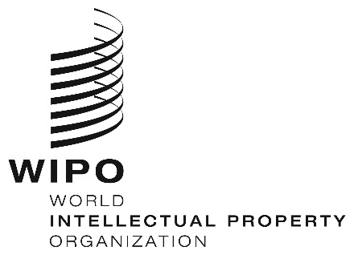
INFORMATION NOTICE NO. 21/2020
Madrid Protocol Concerning the International Registration of Marks
Viet Nam: Closure of the Office
- The Intellectual Property Office of Viet Nam (IP Viet Nam) has informed the International Bureau of the World Intellectual Property Organization (WIPO) that it is not open to the public since March 30, 2020, and until further notice.
- Accordingly, under Rule 4(4) of the Regulations under the Protocol Relating to the Madrid Agreement Concerning the International Registration of Marks, all periods under the Madrid System that concern this Office and that expire on a day on which IP Viet Nam is not open to the public will expire on the first subsequent day on which IP Viet Nam reopens.
- For further information, users of the Madrid System may visit IP Viet Nam’s website at the following address: http://www.noip.gov.vn/en/web/english/home.

April 14, 2020

