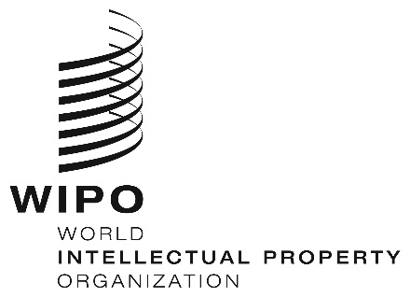
INFORMATION NOTICE NO. 20/2020
Madrid Protocol Concerning the International Registration of Marks
Greece: Closure of the Office
- The Greek Trade Mark Office has informed the International Bureau of the World Intellectual Property Organization (WIPO) that it is not open to the public since March 16, 2020, and until further notice.
- Accordingly, under Rule 4(4) of the Regulations under the Protocol Relating to the Madrid Agreement Concerning the International Registration of Marks, all periods under the Madrid System that concern this Office and that expire on a day on which the Greek Trade Mark Office is not open to the public will expire on the first subsequent day on which the Greek Trade Mark Office reopens.
- For further information, users of the Madrid System may visit the Greek Trade Mark Office’s website at the following address: http://www.mindev.gov.gr/.
April 10, 2020

