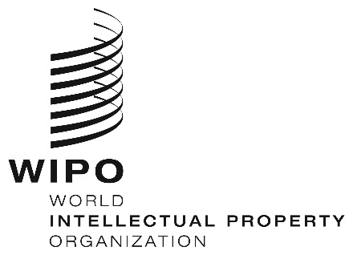
INFORMATION NOTICE NO. 19/2020

Madrid Protocol Concerning the International Registration of Marks

Change in the Amounts of the Individual Fee: Syrian Arab Republic

- In accordance with Rule 35(2)(d) of the Regulations under the Madrid Protocol, the Director General of the World Intellectual Property Organization (WIPO) has established the following new amounts, in Swiss francs, of the individual fee that is payable when the Syrian Arab Republic is designated in an international application, in a designation subsequent to an international registration and in respect of the renewal of an international registration in which the Syrian Arab Republic has been designated:
ITEMS |  | Amounts  (in Swiss francs)
Application or Subsequent Designation | - for each class of goods or services | 335
Renewal | - for each class of goods or services | 335

- This change shall have effect on May 8, 2020. Therefore, these amounts will be payable where the Syrian Arab Republic
(a) is designated in an international application which is received by the Office of origin on or after that date; or
(b) is the subject of a subsequent designation which is received by the Office of the Contracting Party of the holder on or after that date, or is filed directly with the International Bureau of WIPO on or after that date; or

(c) has been designated in an international registration which is renewed on or after that date.

April 8, 2020

