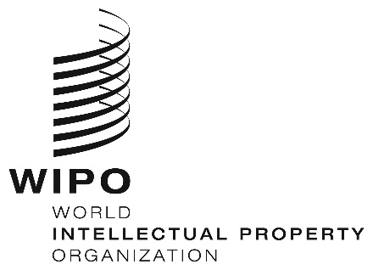
INFORMATION NOTICE NO. 18/2020
Madrid Protocol Concerning the International Registration of Marks
Antigua and Barbuda: Closure of the Office
- The Antigua and Barbuda Intellectual Property and Commerce Office (ABIPCO) has informed the International Bureau of the World Intellectual Property Organization (WIPO) that it is not open to the public since March 31, 2020, and until further notice.
- Accordingly, under Rule 4(4) of the Regulations under the Protocol Relating to the Madrid Agreement Concerning the International Registration of Marks, all periods under the Madrid System that concern this Office and that expire on a day on which ABIPCO is not open to the public will expire on the first subsequent day on which ABIPCO reopens.
- For further information, users of the Madrid System may visit ABIPCO’s website at the following address: https://abipco.gov.ag/.
April 7, 2020

