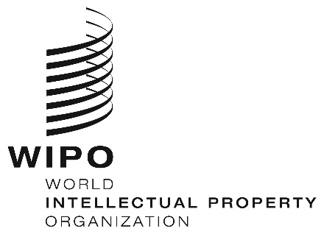
INFORMATION NOTICE NO. 15/2020
Madrid Protocol Concerning the International Registration of Marks
Mexico: Closure of the Office
- The Mexican Institute of Industrial Property (IMPI) has informed the International Bureau of the World Intellectual Property Organization (WIPO) that it will not be open to the public from March 27 to April 19, 2020.
- Accordingly, under Rule 4(4) of the Regulations under the Protocol Relating to the Madrid Agreement Concerning the International Registration of Marks, all periods under the Madrid System that concern this Office and that expire on a day on which IMPI is not open to the public will expire on the first subsequent day on which IMPI reopens. Therefore, those periods will expire on April 20, 2020.
- In addition, IMPI has informed the International Bureau of WIPO that periods in all proceedings before IMPI have been suspended from March 24 to April 19, 2020.
- For further information, users of the Madrid System may visit IMPI’s website at the following address: https://www.gob.mx/impi/.
April 7, 2020

