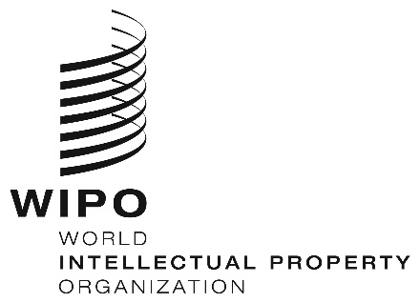
INFORMATION NOTICE NO. 10/2020
Madrid Protocol Concerning the International Registration of Marks
Colombia: Closure of the Office
- The Superintendence of Industry and Commerce (SIC) of Colombia has informed the International Bureau of the World Intellectual Property Organization (WIPO) that it will not be open to the public between March 17 and 31, 2020.
- Accordingly, under Rule 4(4) of the Regulations under the Protocol Relating to the Madrid Agreement Concerning the International Registration of Marks, all periods under the Madrid System that concern this Office and that expire on a day on which the SIC is not open to the public will expire on the first subsequent day on which the SIC reopens. Therefore, those periods will expire on April 1, 2020.
- In addition, the SIC has also informed the International Bureau of WIPO that periods in all administrative proceedings before the SIC have been suspended between March 17 and 31, 2020.
- For further information, users of the Madrid System may visit the SIC’s website at the following electronic address: https://www.sic.gov.co/.
March 27, 2020

