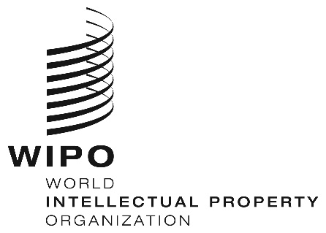
INFORMATION NOTICE NO. 63/2019

Madrid Agreement and Protocol Concerning the International Registration of Marks

Non-Working Days in 2020

Pursuant to Rule 32(2)(v) of the Common Regulations under the Madrid Agreement Concerning the International Registration of Marks and the Protocol Relating to that Agreement, users are hereby informed that, in addition to Saturdays and Sundays, the days on which the International Bureau of the World Intellectual Property Organization (WIPO) is not scheduled to be open to the public during 2020, are the following:
NEW YEAR | Wednesday, January 1, 2020
EASTER | Friday, April 10, 2020  Monday, April 13, 2020
WHITSUN | Monday, June 1, 2020
CHRISTMAS | Friday, December 25, 2020
NEW YEAR’S EVE | Thursday, December 31, 2020

Furthermore, users are reminded that the International Bureau is not scheduled to be open to the public on Wednesday, December 25, 2019, and Tuesday, December 31, 2019.

November 20, 2019

