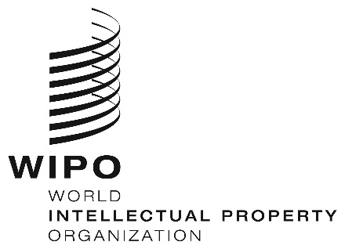
INFORMATION NOTICE NO. 62/2019

Madrid Protocol Concerning the International Registration of Marks

Declaration made under Article 8(7)(a) of the Madrid Protocol: Malaysia

- The Director General of the World Intellectual Property Organization (WIPO) has received from the Government of Malaysia the declaration referred to in Article 8(7)(a) of the Madrid Protocol, whereby Malaysia wishes to receive an individual fee where it is designated in an international application, in a designation subsequent to an international registration and in respect of the renewal of an international registration in which Malaysia has been designated (instead of a share in the revenue produced by the supplementary and complementary fees).
- In accordance with Rule 35(2)(b) of the Common Regulations under the Madrid Agreement and Protocol, the Director General of WIPO has, after consultation with the Office of Malaysia, established the following amounts, in Swiss francs, of the said individual fee:
ITEMS |  | Amounts  (in Swiss francs)
Application or Subsequent Designation | – for each class of goods or services | 259
Renewal | – for each class of goods or services | 236

3. This declaration shall have effect on December 27, 2019. Therefore, the above-mentioned amounts will be payable where Malaysia
(a) is designated in an international application which is received by the Office of origin on or after that date; or

(b) is the subject of a subsequent designation which is received by the Office of the Contracting Party of the holder on or after that date, or is filed directly with the International Bureau of WIPO on or after that date; or

(c) has been designated in an international registration which is renewed on or after that date.

November 15, 2019

