APPENDIX E

Version 1.1
ST.36 Compatibility Form
Revision adopted by the SDWG ST.66 Task Force
on December 3, 2007

Purpose
1 WIPO Standard ST.36, Recommendation for the Processing of Patent Information Using XML (Extensible Markup Language), was first promulgated in 2001. Since then, a number of Offices have adopted it extensively in their operations. Of those Offices, there are some that wish to achieve a degree of compatibility between WIPO Standards ST.36 and ST.66. The preferred method for doing so is specified in this Appendix.
2 Offices implementing WIPO Standard ST.66, that have not yet adopted WIPO Standard ST.36, are advised to NOT use the methods in this Appendix. Instead, they should use WIPO Standard ST.66 as described in the main body of this standard. In particular, name and address content models in WIPO Standard ST.66, based as they are on widely-used industry standards, are preferred over the corresponding models in WIPO Standard ST.36.

ST.36 Content Models
3 The content models below from among the international common elements (ICE) of WIPO Standard ST.36 are suggested as the primary candidates for inclusion in WIPO Standard ST.66 as replacements for their corresponding content models.
4 In the following section, an XML Schema fragment is provided for each content model for use in the import process.

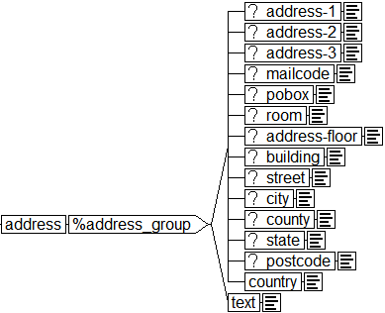

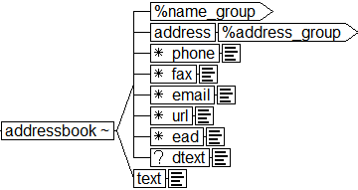

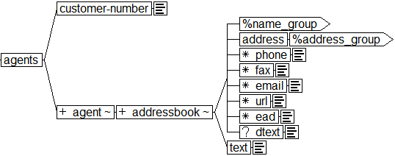

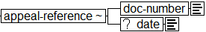

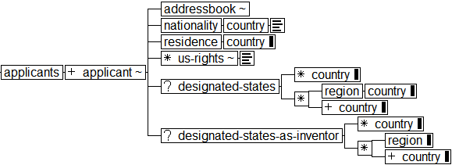

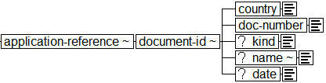

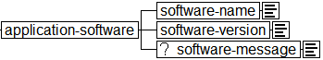

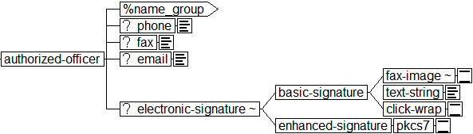

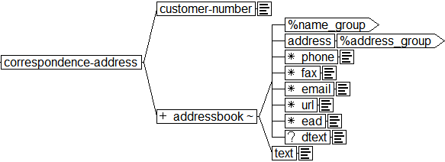

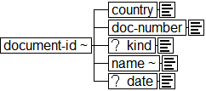

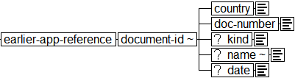

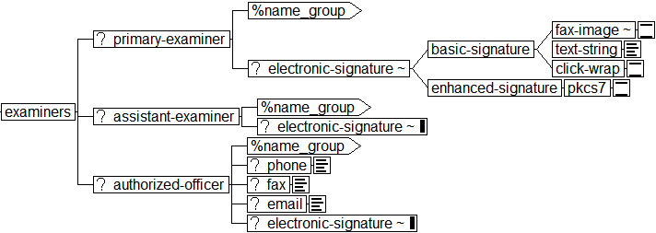

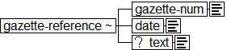

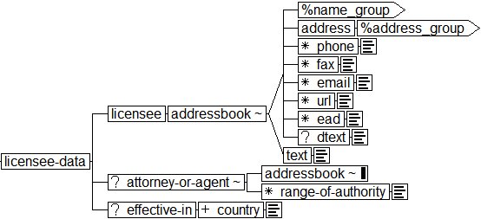

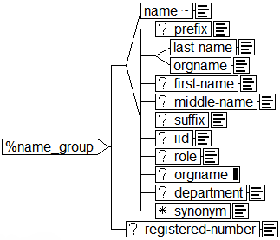

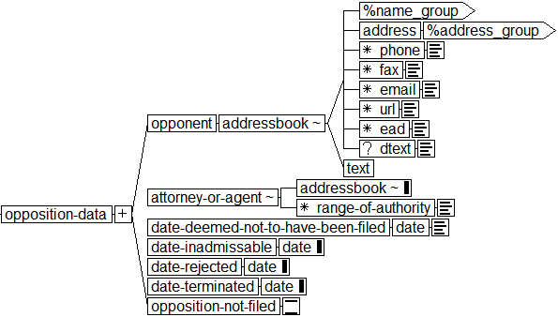

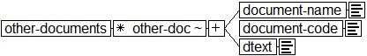

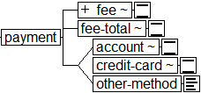

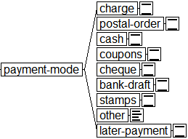

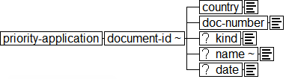

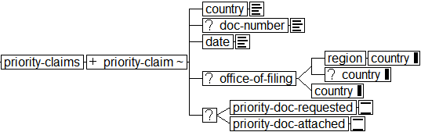

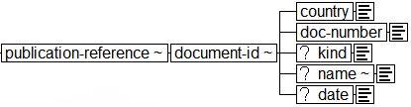

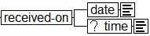

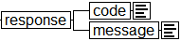

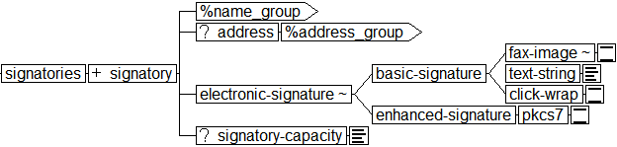

Import
5 Combine these ST.36 content models with ST.66 using the XML Schema import operation. For each content model you wish to use, create a separate file with the XML Schema fragment provided below, and import that file with a namespace, as in the simplified examples shown here.
Schema:
<?xml version="1.0" encoding="UTF-8"?>
<xs:schema xmlns:xs="http://www.w3.org/2001/XMLSchema"
xmlns="http://www.wipo.int/standards/XMLSchema/trademarks/sampledata"
xmlns:st36="http://www.wipo.int/standards/XMLSchema/trademarks/appendixE"
targetNamespace="http://www.wipo.int/standards/XMLSchema/trademarks/sampledata"
version="1.0"
elementFormDefault="qualified"
attributeFormDefault="unqualified">

<xs:import namespace="http://www.wipo.int/standards/XMLSchema/trademarks/appendixE" schemaLocation="http://www.wipo.int/standards/XMLSchema/trademarks/appendixE/st36for66-V1-0.xsd" />
<xs:element name="MyTransaction" type="MyTransactionType"/>
<xs:complexType name="MyTransactionType">
<xs:sequence>
<xs:element name="MyTransactionContentDetails">
<xs:complexType>
<xs:sequence>
<xs:element name="TransactionIdentifier" type="xs:string" minOccurs="0"/>
<xs:element ref="st36:amount-total"/>
<xs:element ref="st36:currency"/>
<xs:element ref="st36:date"/>
<xs:element ref="st36:addressbook"/>
</xs:sequence>
</xs:complexType>
</xs:element>
</xs:sequence>
</xs:complexType>
</xs:schema>

Instance:
<?xml version="1.0" encoding="UTF-8"?>
<MyTransaction xmlns="http://www.wipo.int/standards/XMLSchema/trademarks/sampledata"
xmlns:xsi="http://www.w3.org/2001/XMLSchema-instance"
xmlns:st36="http://www.wipo.int/standards/XMLSchema/trademarks/appendixE"
xsi:schemaLocation="http://www.wipo.int/standards/XMLSchema/trademarks/sampledata sampleSchema.xsd">
<MyTransactionContentDetails>
<TransactionIdentifier>0001</TransactionIdentifier>
<st36:amount-total>$123.45</st36:amount-total>
<st36:currency>US Dollar</st36:currency>
<st36:date>20070205</st36:date>
<st36:addressbook id="addr-01" lang="en">
<st36:last-name>Doe</st36:last-name>
<st36:first-name>John</st36:first-name>
<st36:address>
<st36:city>Alexandria</st36:city>
<st36:country>US</st36:country>
</st36:address>
</st36:addressbook>
</MyTransactionContentDetails>
</MyTransaction>

ST.36 XML Schema Fragments
6 The XML Schema fragments for each of the content models shown above are provided in a downloadable file, namely st36for66-V1-0.xsd from the WIPO Web site at the following URL: http://www.wipo.int/standards/en/xml_material/st66/. You can use this file as-is, or create a subset for just those elements you intend to import.

ST.36 – ST.66 Mapping

7 The tags relevant to applicant (agent) information

 | No | ST.36 Tag |  |  |  |  |  |  |  |  |  | Attribute | ST.36 Description | Refer to | ST.66 Tag
(1) applicants
 | 1 | applicants |  |  |  |  |  |  |  |  |  |  | Applicants information:  At least one of the applicants named must be a resident or national of a PCT Contracting State for which the receiving Office acts. |  | ApplicantDetails
 | 2 |  | applicant |  |  |  |  |  |  |  |  |  | Applicant information: (INID 71, ST.32:B710) | 1.(2) | Applicant  PreviousHolder  NewHolder
(2) applicant
 | 1 | applicant |  |  |  |  |  |  |  |  |  |  | Applicant information: (INID 71, ST.32:B710) |  | Applicant  PreviousHolder  NewHolder
 | 2 |  |  |  |  |  |  |  |  |  |  | sequence | sequence number of each applicant; e.g, sequence="1" |  | ApplicantSequenceNumber
 | 3 |  |  |  |  |  |  |  |  |  |  | app-type | applicant type:  app-type="applicant":  the applicant is only applicant.  app-type="applicant-inventor":  the applicant is also inventor.
 | 4 |  |  |  |  |  |  |  |  |  |  | designation | This person is applicant for the purpose of:  designation="all": all designated states  designation="all-except-us": all designated states except US  designation="us-only": US only  designation="as-indicated": the states indicated in designated-states element under applicant element
 | 5 |  | addressbook |  |  |  |  |  |  |  |  |  | ADDRESSBOOK GROUP: Holds name and contact information for individuals/organizations.  The LANG attribute is REQUIRED for certain document types; e.g., the JPO PCT Request where names and addresses may be repeated in two different languages. If no structure possible use text. | 1.(11) | ApplicantAddressBook  ClaimantAddressBook  CorrespondenceAddressBook  EntitlementEstablishmentAddressBook  EntitlementDomiciledAddressBook  LicenseeAddressBook  OpponentAddressBook  RepresentativeAddressBook
 | 6 |  | nationality |  |  |  |  |  |  |  |  |  | Country of nationality | 1.(15) | ApplicantNationalityCode  ClaimantNationalityCode  EntitlementNationalityCode  EntitlementEstablishmentCode  EntitlementDomiciledCode  LicenseeNationalityCode  OpponentNationalityCode  RepresentativeNationalityCode
 | 7 |  | residence |  |  |  |  |  |  |  |  |  | Country of residence
 |  |  |  |  | country |  |  |  |  |  |  |  | Country: use ST.3 country code; e.g., DE, FR, GB, NL, etc. Also includes EP, WO.
 | 8 |  | us-rights |  |  |  |  |  |  |  |  |  | This person is successor to the rights of an inventor who is deceased, insane, or legally incapacitated, for the purposes of the designation of the United States of America.
 | 9 |  |  |  |  |  |  |  |  |  |  | to-dead-inventor
 | 10 |  |  |  |  |  |  |  |  |  |  | kind
 | 11 |  | designated-states |  |  |  |  |  |  |  |  |  | Indication of specific Contracting States in or for which the applicant is seeking protection for his invention (Rule 4.9(a)). | 1.(16) | RecordInterestedOfficeCode  RecordDesignatedCountryCode  RecordUseIntentCountryCode  DesignatedCountryCode  DesignatedUnderCode  LimitationCountryCode
 | 12 |  | designated-states-as-inventor |  |  |  |  |  |  |  |  |  | Rule 4.6(c): "The request may, for different designated states, indicate different persons as inventors where, in this respect, the requirements of the national laws of the designated States are not the same. In such a case, the request shall contain a separate statement for each designated State or group of States in which a particular person, or the same person, is to be considered the inventor, or in which particular persons, or the same persons, are to be considered the inventors."
 | 13 |  |  |  | country |  |  |  |  |  |  |  | Country: use ST.3 country code; e.g., DE, FR, GB, NL, etc. Also includes EP, WO.
 | 14 |  |  |  | region |  |  |  |  |  |  |  | The region for which protection or exclusion (depending upon context) is desired.
 | 15 |  |  |  |  |  |  |  | country |  |  |  | Country: use ST.3 country code; e.g., DE, FR, GB, NL, etc. Also includes EP, WO.
 | 16 |  |  |  | country |  |  |  |  |  |  |  | Country: use ST.3 country code; e.g., DE, FR, GB, NL, etc. Also includes EP, WO.
(3) agents
 | 1 | agents |  |  |  |  |  |  |  |  |  |  | Information regarding Agents or common representatives |  | RepresentativeDetails
 | 2 |  | customer-number |  |  |  |  |  |  |  |  |  | Customer number for agents by office |  | RepresentativeKey
 | 3 |  | agent |  |  |  |  |  |  |  |  |  | Agent or common representative (Rules 90.1, 90.2) | 1.(4) | Representative
(4) agent
 | 1 | agent |  |  |  |  |  |  |  |  |  |  | Agent or common representative (Rules 90.1, 90.2) |  | Representative
 | 2 |  |  |  |  |  |  |  |  |  |  | sequence |  |  | RepresentativeSequenceNumber
 | 3 |  |  |  |  |  |  |  |  |  |  | rep-type |  |  | RepresentativeKindCode
 | 4 |  | addressbook |  |  |  |  |  |  |  |  |  | ADDRESSBOOK GROUP: Holds name and contact information for individuals/organizations  The LANG attribute is REQUIRED for certain document types; e.g., the JPO PCT Request where names and addresses may be repeated in two different languages. If no structure possible use text. | 1.(11)
(5) correspondence-address
 | 1 | correspondence-address |  |  |  |  |  |  |  |  |  |  | Address used for general correspondence |  | CorrespondenceAddress
 | 2 |  | customer-number |  |  |  |  |  |  |  |  |  | Customer number for agents by office
 | 3 |  | addressbook |  |  |  |  |  |  |  |  |  | ADDRESSBOOK GROUP: Holds name and contact information for individuals/organizations  The LANG attribute is REQUIRED for certain document types; e.g., the JPO PCT Request where names and addresses may be repeated in two different languages. If no structure possible use text. | 1.(11)
(6) licensee-data
 | 1 | licensee-data |  |  |  |  |  |  |  |  |  |  | Licensee Data: (ST.32:B790) |  | LicenseeDetails
 | 2 |  | licensee |  |  |  |  |  |  |  |  |  | Licensee name and address: (ST.32:B791) | 1.(7) | Licensee
 | 3 |  | attorney-or-agent |  |  |  |  |  |  |  |  |  | Applicant's legal representative: (INID 74, ST.32:B740) | 1.(10) | Representative
 | 4 |  | effective-in |  |  |  |  |  |  |  |  |  | Designated countries for license: (INID 67, ST.32:B670)
 | 5 |  |  |  |  |  | country |  |  |  |  |  | Country: use ST.3 country code; e.g., DE, FR, GB, NL, etc. Also includes EP, WO.
(7) licensee
 | 1 | licensee |  |  |  |  |  |  |  |  |  |  | Licensee name and address: (ST.32:B791) |  | Licensee
 | 2 |  | addressbook |  |  |  |  |  |  |  |  |  | ADDRESSBOOK GROUP: Holds name and contact information for individuals/organizations.  The LANG attribute is REQUIRED for certain document types; e.g., the JPO PCT Request where names and addresses may be repeated in two different languages. If no structure possible use text. | 1.(11)
(8) opposition-data
 | 1 | opposition-data |  |  |  |  |  |  |  |  |  |  | Opposition data: (ST.32:B780) |  | OpponentDetails
 | 2 |  | opponent |  |  |  |  |  |  |  |  |  | Opponent data, name and address: (ST.32:B781) | 1.(9) | Opponent
 | 3 |  | attorney-or-agent |  |  |  |  |  |  |  |  |  | Applicant's legal representative: (INID 74, ST.32:B740) | 1.(10)
 | 4 |  | date-deemed-not-to-have-been-filed |  |  |  |  |  |  |  |  |  | Opposition deemed not to have been filed: (ST.32:B785)
 | 5 |  |  |  |  | date |  |  |  |  |  |  | Date: components of a date  Format: YYYYMMDD
 | 6 |  | date-inadmissable |  |  |  |  |  |  |  |  |  | Opposition inadmissable: (ST.32:B786)
 | 7 |  |  |  |  | date |  |  |  |  |  |  | Date: components of a date  Format: YYYYMMDD
 | 8 |  | date-rejected |  |  |  |  |  |  |  |  |  | Date of rejection of opposition: (ST.32:B787)
 | 9 |  |  |  |  | date |  |  |  |  |  |  | Date: components of a date  Format: YYYYMMDD
 | 10 |  | date-terminated |  |  |  |  |  |  |  |  |  | Date of termination of opposition: (ST.32:B788)
 | 11 |  |  |  |  | date |  |  |  |  |  |  | Date: components of a date  Format: YYYYMMDD
 | 12 |  |  |  |  |  |  |  |  |  |  |  | No opposition filed: (ST.32:B789)
(9) opponent
 | 1 | opponent |  |  |  |  |  |  |  |  |  |  | Opponent data, name and address: (ST.32:B781) |  | Opponent
 | 2 |  | addressbook |  |  |  |  |  |  |  |  |  | ADDRESSBOOK GROUP: Holds name and contact information for individuals/organizations.  The LANG attribute is REQUIRED for certain document types; e.g., the JPO PCT Request where names and addresses may be repeated in two different languages. If no structure possible use text. | 1.(11)
(10) attorney-or-agent
 | 1 | attorney-or-agent |  |  |  |  |  |  |  |  |  |  | Applicant's legal representative: (INID 74, ST.32:B740) |  | Representative
 | 2 |  |  |  |  |  |  |  |  |  |  | rep-type |  |  | RepresentativeKindCode
 | 3 |  | addressbook |  |  |  |  |  |  |  |  |  | ADDRESSBOOK GROUP: Holds name and contact information for individuals/organizations  The LANG attribute is REQUIRED for certain document types; e.g., the JPO PCT Request where names and addresses may be repeated in two different languages. If no structure possible use text. | 1.(11)
 | 4 |  | range-of-authority |  |  |  |  |  |  |  |  |  | The type of authority held by the attorney or agent
(11) addressbook
 | 1 | addressbook |  |  |  |  |  |  |  |  |  |  | ADDRESSBOOK GROUP: Holds name and contact information for individuals/organizations  The LANG attribute is REQUIRED for certain document types; e.g., the JPO PCT Request where names and addresses may be repeated in two different languages. If no structure possible use text. |  | ApplicantAddressBook  ClaimantAddressBook  CorrespondenceAddressBook  EntitlementEstablishmentAddressBook  EntitlementDomiciledAddressBook  LicenseeAddressBook  OpponentAddressBook  RepresentativeAddressBook
 | 2 |  |  |  |  |  |  |  |  |  |  | id
 | 3 |  |  |  |  |  |  |  |  |  |  | lang |  |  | AddressLanguageCode
 | 4 |  |  | %name_group; |  |  |  |  |  |  |  |  |  | 1.(12) | Name  PayerName  PayeeName  SignatoryName
 | 5 |  |  | address |  |  |  |  |  |  |  |  | Address components: Address formats differ from country to country  If no structure possible use text. | 1.(13) | Address  SignatoryAddress
 | 6 |  |  | phone |  |  |  |  |  |  |  |  | Telephone number |  | Phone
 | 7 |  |  | fax |  |  |  |  |  |  |  |  | Fax number |  | Fax
 | 8 |  |  | email |  |  |  |  |  |  |  |  | Email address |  | Email
 | 9 |  |  | url |  |  |  |  |  |  |  |  | Universal Resource Locator: e.g., www.wipo.int |  | URL
 | 10 |  |  | ead |  |  |  |  |  |  |  |  | Electronic address use for other than email |  | OtherElectronicAddress
 | 11 |  |  | dtext |  |  |  |  |  |  |  |  | Descriptive text
 | 12 |  |  | text |  |  |  |  |  |  |  |  | If no structure is possible, enter text (without markup).
(12) %name_group;
 | 1 | %name_group; |  |  |  |  |  |  |  |  |  |  |  |  | Name  PayerName  PayeeName  SignatoryName
 | 2 |  |  | name |  |  |  |  |  |  |  |  | Name:  If no distinction or detail can be given.  Also to be used for:  personal (natural person)  and corporate (legal entity) names |  | FreeFormatNameLine
 | 3 |  |  |  |  |  |  |  |  |  |  | name-type |  |  | NameKind
 | 4 |  |  | Prefix |  |  |  |  |  |  |  |  | Title: e.g., Mr., Mrs., Dr. etc. |  | NamePrefix
 | 5 |  |  | last-name |  |  |  |  |  |  |  |  | Last, family, surname |  | LastName
 | 6 |  |  | orgname |  |  |  |  |  |  |  |  | Organization name or company name |  | OrganizationName
 | 7 |  |  | first-name |  |  |  |  |  |  |  |  | First or given name(s), initial(s) |  | FirstName
 | 8 |  |  | middle-name |  |  |  |  |  |  |  |  | Middle name(s) or initial(s) |  | MiddleName
 | 9 |  |  | suffix |  |  |  |  |  |  |  |  | Name suffix (e.g., II, Jr., Dip., Ing., BA, etc.) |  | NameSuffix
 | 10 |  |  | Iid |  |  |  |  |  |  |  |  | SDOBI: Individual id
 | 11 |  |  | role |  |  |  |  |  |  |  |  | Role; e.g., President, Chairman, etc. |  | PersonRole
 | 12 |  |  | orgname |  |  |  |  |  |  |  |  | Organization name or company name |  | OrganizationName
 | 13 |  |  | department |  |  |  |  |  |  |  |  | Department, division, section, etc. name |  | OrganizationDepartment
 | 14 |  |  | synonym |  |  |  |  |  |  |  |  | Synonym |  | NameSynonym
 | 15 |  |  | registered-number |  |  |  |  |  |  |  |  | Registered number |  | ApplicantKey/Identifier  RepresentativeKey/Identifier  ClaimantKey/Identifier
(13) address
 | 1 | address |  |  |  |  |  |  |  |  |  |  | Address components: Address formats differ from country to country  If no structure possible use text. |  | Address  SignatoryAddress
 | 2 |  | %address_group; |  |  |  |  |  |  |  |  |  |  | 1.(14)
(14) %address_group;
 | 1 | %address_group;
 | 2 |  | address-1 |  |  |  |  |  |  |  |  |  | Address, first line |  | AddressLine
 | 3 |  | address-2 |  |  |  |  |  |  |  |  |  | Address, second line |  | AddressLine
 | 4 |  | address-3 |  |  |  |  |  |  |  |  |  | Address, third line |  | AddressLine
 | 5 |  | mailcode |  |  |  |  |  |  |  |  |  | Organizational mail code |  | AddressMailCode
 | 6 |  | pobox |  |  |  |  |  |  |  |  |  | Post Office Box number |  | AddressPostOfficeBox
 | 7 |  | room |  |  |  |  |  |  |  |  |  | Address room; e.g., Room 55B |  | AddressRoom
 | 8 |  | address-floor |  |  |  |  |  |  |  |  |  | Address floor; e.g., 10th |  | AddressFloor
 | 9 |  | building |  |  |  |  |  |  |  |  |  | Building information in address; e.g., Hoffman building |  | AddressBuilding
 | 10 |  | street |  |  |  |  |  |  |  |  |  | Street may contain house number or name |  | AddressStreet
 | 11 |  | city |  |  |  |  |  |  |  |  |  | City or town name |  | AddressCity
 | 12 |  | county |  |  |  |  |  |  |  |  |  | County, parish, department, etc. (mainly UK, USA) |  | AddressCounty
 | 13 |  | state |  |  |  |  |  |  |  |  |  | Region of country; e.g., state, province, etc. |  | AddressState
 | 14 |  | postcode |  |  |  |  |  |  |  |  |  | Postal code or zip code |  | AddressPostcode
 | 15 |  | country |  |  |  |  |  |  |  |  |  | Country: use ST.3 country code; e.g., DE, FR, GB, NL, etc. Also includes EP, WO. |  | AddressCountryCode
 | 16 |  | text |  |  |  |  |  |  |  |  |  | If no structure is possible, enter text (without markup). |  | FreeFormatAddressLine
(15) nationality
 | 1 | nationality |  |  |  |  |  |  |  |  |  |  | Country of nationality |  | ApplicantNationalityCode  ClaimantNationalityCode  EntitlementNationalityCode  EntitlementEstablishmentCode  EntitlementDomiciledCode  LicenseeNationalityCode  OpponentNationalityCode  RepresentativeNationalityCode
 | 2 |  | country |  |  |  |  |  |  |  |  |  | Country: use ST.3 country code; e.g., DE, FR, GB, NL, etc.  Also includes EP, WO.
(16) designated-states
 | 1 | designated-states |  |  |  |  |  |  |  |  |  |  | Indication of specific Contracting States in or for which the applicant is seeking protection for his invention (Rule 4.9(a)). |  | RecordInterestedOfficeCode  RecordDesignatedCountryCode  RecordUseIntentCountryCode  DesignatedCountryCode  LimitationCountryCode
 | 2 |  | country |  |  |  |  |  |  |  |  |  | Country: use ST.3 country code; e.g., DE, FR, GB, NL, etc. Also includes EP, WO.
 | 3 |  | region |  |  |  |  |  |  |  |  |  | The region for which protection or exclusion (depending upon context) is desired.
 | 4 |  |  |  |  |  | country |  |  |  |  |  | Country: use ST.3 country code; e.g., DE, FR, GB, NL, etc. Also includes EP, WO.
 | 5 |  | country |  |  |  |  |  |  |  |  |  | Country: use ST.3 country code; e.g., DE, FR, GB, NL, etc. Also includes EP, WO.
(17) phone
 | 1 | phone |  |  |  |  |  |  |  |  |  |  | Telephone number |  | Phone
(18) fax
 | 1 | fax |  |  |  |  |  |  |  |  |  |  | Fax number |  | Fax
(19) email
 | 1 | email |  |  |  |  |  |  |  |  |  |  | Email address |  | Email
(20) url
 | 1 | url |  |  |  |  |  |  |  |  |  |  | Universal Resource Locator: e.g., www.wipo.int |  | URL
(21) ead
 | 1 | ead |  |  |  |  |  |  |  |  |  |  | Electronic address use for other than email |  | OtherElectronicAddress
(22) name
 | 1 | name |  |  |  |  |  |  |  |  |  |  | Name:  If no distinction or detail can be given  Also to be used for:  personal (natural person) and  corporate (legal entity) names |  | FreeFormatNameLine
 | 2 |  |  |  |  |  |  |  |  |  |  | name-type |  |  | NameKind
(23) prefix
 | 1 | prefix |  |  |  |  |  |  |  |  |  |  | Title: e.g., Mr., Mrs., Dr. etc. |  | NamePrefix
(24) last-name
 | 1 | last-name |  |  |  |  |  |  |  |  |  |  | Last, family, surname |  | LastName
(25) orgname
 | 1 | orgname |  |  |  |  |  |  |  |  |  |  | Organization name or company name |  | OrganizationName
(26) first-name
 | 1 | first-name |  |  |  |  |  |  |  |  |  |  | First or given name(s), initial(s) |  | FirstName
(27) middle-name
 | 1 | middle-name |  |  |  |  |  |  |  |  |  |  | Middle name(s) or initial(s) |  | MiddleName
(28) suffix
 | 1 | suffix |  |  |  |  |  |  |  |  |  |  | Name suffix (e.g., II, Jr., Dip., Ing., BA, etc.) |  | NameSuffix
(29) role
 | 1 | role |  |  |  |  |  |  |  |  |  |  | Role; e.g., President, Chairman, etc. |  | PersonRole
(30) department
 | 1 | department |  |  |  |  |  |  |  |  |  |  | Department, division, section, etc. name |  | OrganizationDepartment
(31) synonym
 | 1 | synonym |  |  |  |  |  |  |  |  |  |  | Synonym |  | NameSynonym
(32) registered-number
 | 1 | registered-number |  |  |  |  |  |  |  |  |  |  | Registered number |  | ApplicantKey/Identifier  RepresentativeKey/Identifier  ClaimantKey/Identifier
(33) address-1
 | 1 | address-1 |  |  |  |  |  |  |  |  |  |  | Address, first line |  | AddressLine
(34) address-2
 | 1 | address-2 |  |  |  |  |  |  |  |  |  |  | Address, second line |  | AddressLine
(35) address-3
 | 1 | address-3 |  |  |  |  |  |  |  |  |  |  | Address, third line |  | AddressLine
(36) mailcode
 | 1 | Mailcode |  |  |  |  |  |  |  |  |  |  | Organizational mail code |  | AddressMailCode
(37) pobox
 | 1 | Pobox |  |  |  |  |  |  |  |  |  |  | Post Office Box number |  | AddressPostOfficeBox
(38) room
 | 1 | Room |  |  |  |  |  |  |  |  |  |  | Address room; e.g., Room 55B |  | AddressRoom
(39) address-floor
 | 1 | address-floor |  |  |  |  |  |  |  |  |  |  | Address floor; e.g., 10th |  | AddressFloor
(40) building
 | 1 | Building |  |  |  |  |  |  |  |  |  |  | Building information in address; e.g., Hoffman building |  | AddressBuilding
(41) street
 | 1 | Street |  |  |  |  |  |  |  |  |  |  | Street may contain house number or name |  | AddressStreet
(42) city
 | 1 | City |  |  |  |  |  |  |  |  |  |  | City or town name |  | AddressCity
(43) county
 | 1 | County |  |  |  |  |  |  |  |  |  |  | County, parish, department, etc. (mainly UK, USA) |  | AddressCounty
(44) state
 | 1 | State |  |  |  |  |  |  |  |  |  |  | Region of country; e.g., state, province, etc. |  | AddressState
(45) postcode
 | 1 | Postcode |  |  |  |  |  |  |  |  |  |  | Postal code or zip code |  | AddressPostcode
(46) country
 | 1 | country |  |  |  |  |  |  |  |  |  |  | Country: use ST.3 country code; e.g., DE, FR, GB, NL, etc. Also includes EP, WO. |  | AddressCountryCode
(47) text
 | 1 | text |  |  |  |  |  |  |  |  |  |  | If no structure is possible, enter text (without markup). |  | FreeFormatAddressLine
(48) dtext
 | 1 | dtext |  |  |  |  |  |  |  |  |  |  | Descriptive text

8 The tags relevant to signature

 | No | ST.36 Tag |  |  |  |  |  | Attribute |  | ST.36 Description |  |  | Refer to |  |  | ST.66 Tag
(1) signatories
 | 1 | signatories |  |  |  |  |  |  |  | Signatories |  |  |  |  |  |  | SignatoryDetails
 | 2 |  |  | signatory |  |  |  |  |  | PCT/RO/101 Box No. X:  The signature must be that of the applicant (if there are several applicants, all must sign); however, the signature may be that of the agent, or the common representative, where a separate power of attorney appointing the agent or the common representative, respectively, or a copy of a general power of attorney is already in possession of the receiving Office, is furnished...(PCT Rules 4.1(d), 4.15, and 90).  Indicate the capacity of the signer with ”signatory-capacity”. |  | 2.(2) |  |  |  |  | Signatory
(2) signatory
 | 1 | signatory |  |  |  |  |  |  |  | PCT/RO/101 Box No. X:  The signature must be that of the applicant (if there are several applicants, all must sign); however, the signature may be that of the agent, or the common representative, where a separate power of attorney appointing the agent or the common representative, respectively, or a copy of a general power of attorney is already in possession of the receiving Office, is furnished...(PCT Rules 4.1(d), 4.15, and 90).  Indicate the capacity of the signer with ”signatory-capacity”. |  |  |  |  |  | Signatory
 | 2 |  | %name_group; |  |  |  |  |  |  |  |  | 1.(12)
 | 3 |  | address |  |  |  |  |  |  | Address components: Address formats differ from country to country  If no structure possible use text. |  | 1.(13)
 | 4 |  | electronic-signature |  |  |  |  |  |  | A signature represented by electronic means |  | 2.(3)
 | 5 |  | signatory-capacity |  |  |  |  |  |  | The capacity in which the person signs |  |  |  |  |  | SignatoryCapacityCode
(3) electronic-signature
 | 1 | electronic-signature |  |  |  |  |  |  |  | A signature represented by electronic means
 | 2 |  |  |  |  |  |  | date |  |  |  |  |  |  |  | SignatureDate
 | 3 |  |  |  |  |  |  | place-signed |  |  |  |  |  |  |  | SignaturePlace
 | 4 |  | basic-signature |  |  |  |  |  |  | A non-PKI electronic signature |  | 2.(4) |  |  |  | SignatureManner
 | 5 |  | enhanced-signature |  |  |  |  |  |  | A PKI / PKCS #7 digital signature data type |  | 2.(5) |  |  |  | SignatureManner
(4) basic-signature
 | 1 | basic-signature |  |  |  |  |  |  |  | A non-PKI electronic signature |  |  |  |  |  | SignatureManner
 | 2 |  | fax-image |  |  |  |  |  |  | A TIFF image of a signature
 | 3 |  |  |  |  |  |  |  | file |  |  |  |  |  |  | SignatureAssociatedText
 | 4 |  | text-string |  |  |  |  |  |  | A simple text string is to be used as the basic electronic signature; e.g., John Doe <text-string>/jd/</text-string> |  |  |  |  |  | SignatureAssociatedText
 | 5 |  | Click-wrap |  |  |  |  |  |  | A simple ”signature”; e.g., clicking a button labeled “accept” or “I agree”
(5) enhanced-signature
 | 1 | enhanced-signature |  |  |  |  |  |  |  |  | A PKI / PKCS #7 digital signature data type |  |  |  |  | SignatureManner
 | 2 |  | Pkcs7 |  |  |  |  |  |  |  | PKCS7 digital signature
(6) signatory-capacity
 | 1 | signatory-capacity |  |  |  |  |  |  |  | The capacity in which the person signs |  |  |  |  | SignatoryCapacityCode

9 The tags relevant to fee

 | No | ST.36 Tag |  |  |  |  |  | Attribute |  | ST.36 Description | Refer to |  | ST.66 Tag
(1) payment-mode
 | 1 | payment-mode |  |  |  |  |  |  |  | Mode of payment |  |  | PaymentMethod  ReimbursementMethod
 | 2 |  |  | charge |  |  |  |  |  | Authorization to charge deposit account |  |  | Account
 | 3 |  |  | postal-order |  |  |  |  |  | Postal money order used as mode of payment
 | 4 |  |  | cash |  |  |  |  |  | Cash used as payment method
 | 5 |  |  | coupons |  |  |  |  |  | Coupons used as mode of payment
 | 6 |  |  | cheque |  |  |  |  |  | Cheque used as payment method |  |  | Cheque
 | 7 |  |  | bank-draft |  |  |  |  |  | Bank draft to be used as mode of payment |  |  | BankTransfer
 | 8 |  |  | stamps |  |  |  |  |  | Revenue stamps used as mode of payment
 | 9 |  |  | other |  |  |  |  |  | Other method by which prior art was disclosed to the public |  |  | OtherPaymentMethod
 | 10 |  |  | later-payment |  |  |  |  |  | Authorization to later payment
(2) payment
 | 1 | payment |  |  |  |  |  |  | Payment method |  |  |  | PaymentMethod  ReimbursementMethod
 | 2 |  | fee |  |  |  |  |  | Amount due
 | 3 |  |  |  |  |  |  | fee-code
 | 4 |  |  |  |  |  |  | amount
 | 5 |  |  |  |  |  |  | quantity
 | 6 |  |  |  |  |  |  | currency
 | 7 |  | fee-total |  |  |  |  |  | Total amount of fees due
 | 8 |  |  |  |  |  |  | amount
 | 9 |  | account |  |  |  |  |  | Deposit account information |  |  |  | Account
 | 10 |  |  |  |  |  |  | number |  |  |  |  | AccountIdentifier
 | 11 |  |  |  |  |  |  | account-type |  |  |  |  | AccountKind
 | 12 |  |  |  |  |  |  | name |  |  |  |  | AccountHolderName
 | 13 |  | credit-card |  |  |  |  |  | Credit card used as payment method |  |  |  | CardAccount
 | 14 |  |  |  |  |  |  | number |  |  |  |  | CardPrimaryAccountNumber
 | 15 |  |  |  |  |  |  | expires |  |  |  |  | CardExpiryDate
 | 16 |  |  |  |  |  |  | name |  |  |  |  | CardHolderName
 | 17 |  |  |  |  |  |  | postal-code
 | 18 |  | other-method |  |  |  |  |  | Other payment method. Specify |  |  |  | OtherPaymentMethod
(3) fee
 | 1 | fee |  |  |  |  |  |  | Amount due |  |  |  | FeeAmount  FeeUnitAmount
 | 2 |  |  |  |  |  |  | fee-code
 | 3 |  |  |  |  |  |  | amount
 | 4 |  |  |  |  |  |  | quantity
 | 5 |  |  |  |  |  |  | currency |  |  |  |  | currencyCode
(4) account-no
 | 1 | account-no |  |  |  |  |  |  | Deposit account number |  |  |  | AccountIdentifier
(5) amount-each
 | 1 | amount-each |  |  |  |  |  |  | The amount of each of the fees |  |  |  | FeeAmount
(6) amount-total
 | 1 | amount-total |  |  |  |  |  |  | The total amount due for each fee group; e.g., search fees, transmittal fees, etc. |  |  |  | FeeUnitAmount
(7) amount-grand-total
 | 1 | amount-grand-total |  |  |  |  |  |  | The total amount of all fees. Note that more than one grand total amount may be permitted, as there may be multiple currencies in which payment is due. |  |  |  | FeeUnitAmount
 | 2 |  |  |  |  |  |  | currency |  |  |  |  | currencyCode
(8) charge
 | 1 | charge |  |  |  |  |  |  | Authorization to charge deposit account |  |  |  | Account
(9) cheque
 | 1 | cheque |  |  |  |  |  |  | Cheque used as payment method |  |  |  | Cheque
(10) bank-draft
 | 1 | bank-draft |  |  |  |  |  |  | Bank draft to be used as mode of payment |  |  |  | BankTransfer
(11) other
 | 1 | other |  |  |  |  |  |  | Other method by which prior art was disclosed to the public |  |  |  | OtherPaymentMethod
(12) account
 | 1 | account |  |  |  |  |  |  | Deposit account information |  |  |  | Account
 | 2 |  |  |  |  |  |  | number |  |  |  |  | AccountIdentifier
 | 3 |  |  |  |  |  |  | account-type |  |  |  |  | AccountKind
 | 4 |  |  |  |  |  |  | name |  |  |  |  | AccountHolderName
(13) credit-card
 | 1 | credit-card |  |  |  |  |  |  | Credit card used as payment method |  |  |  | CardAccount
 | 2 |  |  |  |  |  | number |  |  |  |  |  | CardPrimaryAccountNumber
 | 3 |  |  |  |  |  | expires |  |  |  |  |  | CardExpiryDate
 | 4 |  |  |  |  |  | name |  |  |  |  |  | CardHolderName
 | 5 |  |  |  |  |  | postal-code
(14) other-method
 | 1 | other-method |  |  |  |  |  |  | Other payment method: Specify |  |  |  | OtherPaymentMethod

10 The tags relevant to application reference information

 | No | ST.36 Tag |  |  |  |  |  |  |  | Attribute | ST.36 Description |  |  | Refer to | ST.66 Tag
(1) application-reference
 | 1 | application-reference |  |  |  |  |  |  |  |  | Application reference information: application number, country (INID 21, ST.32:B210) |  |  |  | BasicApplicationDetails  BasicRegistrationDetails
 | 2 |  |  |  |  |  |  |  |  | id
 | 3 |  |  |  |  |  |  |  |  | appl-type
 | 4 |  | document-id |  |  |  |  |  |  |  | Document identification refers to patents (and patent applications) only. See WIPO ST.14. |  |  | 4.(3)
(2) publication-reference
 | 1 | publication-reference |  |  |  |  |  |  |  |  | Publication reference information: publication number, date, etc (INID 11, ST.32:B110) |  |  |  | Publication  RecordPublication
 | 2 |  |  |  |  |  |  |  |  | id
 | 3 |  | document-id |  |  |  |  |  |  |  | Document identification refers to patents (and patent applications) only. See WIPO ST.14. |  |  | 4.(3)
(3) document-id
 | 1 | document-id |  |  |  |  |  |  |  |  | Document identification refers to patents (and patent applications) only. See WIPO ST.14.
 | 2 |  |  |  |  |  |  |  |  | lang
 | 3 |  |  | country |  |  |  |  |  |  | Country: use ST.3 country code; e.g., DE, FR, GB, NL, etc. Also includes EP, WO. |  |  |  | RegistrationOfficeCode
 | 4 |  |  | doc-number |  |  |  |  |  |  | The number of the referenced patent (or application) document |  |  |  | BasicApplicationNumber  BasicRegistrationNumber  PublicationIdentifier
 | 5 |  |  | kind |  |  |  |  |  |  | Document kind code; e.g., A1 (INID 13, ST.32:B130) |  |  |  | PublicationSection
 | 6 |  |  | name |  |  |  |  |  |  | Name:  If no distinction or detail can be given.  Also to be used for:  personal (natural person) and  corporate (legal entity) names.
 | 7 |  |  |  |  |  |  |  |  | name-type
 | 8 |  |  | date |  |  |  |  |  |  | Date: components of a date  Format: YYYYMMDD |  |  |  | BasicApplicationDate  BasicRegistrationDate  PublicationDate
(4) priority-application
 | 1 | priority-application |  |  |  |  |  |  |  |  | Priority application number: (INID 31, ST.32:B310)
 | 2 |  |  | document-id
 | 3 |  |  |  |  |  |  |  |  | lang
 | 4 |  |  |  |  | country |  |  |  |  | Country: use ST.3 country code; e.g., DE, FR, GB, NL, etc. Also includes EP, WO. |  |  |  | PriorityCountryCode
 | 5 |  |  |  |  | doc-number |  |  |  |  | The number of the referenced patent (or application) document |  |  |  | PriorityNumber
 | 6 |  |  |  |  | kind |  |  |  |  | Document kind code; e.g., A1 (INID 13, ST.32:B130)
 | 7 |  |  |  |  | name |  |  |  |  | Name: If no distinction or detail can be given  Also to be used for:  personal (natural person) and  corporate (legal entity) names.
 | 8 |  |  |  |  |  |  |  |  | name-type
 | 9 |  |  |  |  | date |  |  |  |  | Date: components of a date  Format: YYYYMMDD |  |  |  | PriorityDate
(5) priority-claims
 | 1 | priority-claims |  |  |  |  |  |  |  |  | PCT/RO/101 BOX No.VI Priority Claim (PCT Rule 4.10) (INID 30, ST.32:B300) |  |  |  | Priority
 | 2 |  |  | priority-claim |  |  |  |  |  |  | Priority claim (PCT Rule 4.10) (INID 32/33/34, ST.32:B320/B330/B340) |  |  | 4.(6)
(6) priority-claim
 | 1 | priority-claim |  |  |  |  |  |  |  |  | Priority claim (PCT Rule 4.10) (INID 32/33/34, ST.32:B320/B330/B340)
 | 2 |  |  |  |  |  |  |  |  | id
 | 3 |  |  |  |  |  |  |  |  | sequence
 | 4 |  |  |  |  |  |  |  |  | kind
 | 5 |  |  | country |  |  |  |  |  |  | Country: use ST.3 country code; e.g., DE, FR, GB, NL, etc. Also includes EP, WO |  |  |  | PriorityCountryCode
 | 6 |  |  | doc-number |  |  |  |  |  |  | The number of the referenced patent (or application) document |  |  |  | PriorityNumber
 | 7 |  |  | date |  |  |  |  |  |  | Date: components of a date  Format: YYYYMMDD |  |  |  | PriorityDate
 | 8 |  |  | office-of-filing |  |  |  |  |  |  | Where the earlier application is an ARIPO application, indicate at least one country party to the PARIS convention for the protection of industrial property or one member of the WTO for which that earlier application was filed.
 | 9 |  |  |  |  | region |  |  |  |  | The region for which protection or exclusion (depending upon context) is desired. |  |  | #REF!
 | 10 |  |  |  |  |  | country |  |  |  | Country: use ST.3 country code; e.g., DE, FR, GB, NL, etc. Also includes EP, WO.
 | 11 |  |  |  |  | country |  |  |  |  | Country: use ST.3 country code; e.g., DE, FR, GB, NL, etc. Also includes EP, WO.
 | 12 |  |  |  |  | country |  |  |  |  | Country: use ST.3 country code; e.g., DE, FR, GB, NL, etc. Also includes EP, WO.
 | 13 |  |  | priority-doc-requested |  |  |  |  |  |  | The receiving office is requested to prepare and transmit to the IB a certified copy of the earlier application.
 | 14 |  |  | priority-doc-attached |  |  |  |  |  |  | The priority document is attached to the application.
(7) file-reference-id
 | 1 | file-reference-id |  |  |  |  |  |  |  |  | Applicant's or agent's file reference, if desired, 12 characters maximum
(8) document-code
 | 1 | document-code |  |  |  |  |  |  |  |  | For reference to non-PCT document from national office; code defined by national office |  |  |  | ApplicationFormName
(9) document-name
 | 1 | document-name |  |  |  |  |  |  |  |  | The name of the other-doc(ument) referenced |  |  |  | DocumentName
(10) appeal-reference
 | 1 | appeal-reference |  |  |  |  |  |  |  |  | Reference to an appealed application
 | 2 |  |  |  |  |  |  |  |  | appeal-type
 | 3 |  |  |  | doc-number |  |  |  |  |  | The number of the referenced patent (or application) document
 | 4 |  |  |  | date |  |  |  |  |  | Date: components of a date  Format: YYYYMMDD
(11) doc-number
 | 1 | doc-number |  |  |  |  |  |  |  |  | The number of the referenced patent (or application) document |  |  |  | BasicApplicationNumber  BasicRegistrationNumber  PublicationIdentifier  PriorityNumber
(12) kind
 | 1 | kind |  |  |  |  |  |  |  |  | Document kind code; e.g., A1 (INID 13, ST.32:B130) |  |  |  | PublicationSection
(13) date
 | 1 | date |  |  |  |  |  |  |  |  | Date: components of a date  Format: YYYYMMDD |  |  |  | BasicApplicationDate  BasicRegistrationDate  PublicationDate  PriorityDate
(14) country
 | 1 | Country |  |  |  |  |  |  |  |  | Country: use ST.3 country code; e.g., DE, FR, GB, NL, etc. Also includes EP, WO. |  |  |  | PriorityCountryCode

11 The tags relevant to document page and image data

 | No | ST.36 Tag |  |  |  |  |  |  | Attribute | ST.36 Description |  |  |  | Refer to | ST.66 Tag
(1) img
 | 1 | img |  |  |  |  |  |  |  | Image data  Image is used for any kind of image: art work, figures, complex work units (math, tables, chemistry), etc. |  |  |  |  | MarkImage
 | 2 |  |  |  |  |  |  |  | id | i0001, i0002, etc.
 | 3 |  |  |  |  |  |  |  | he | "11" - milimeters - height, width |  |  |  |  | MarkImageRepresentationSize/Height
 | 4 |  |  |  |  |  |  |  | wi | "11" - milimeters - height, width |  |  |  |  | MarkImageRepresentationSize/Width
 | 5 |  |  |  |  |  |  |  | file | file name,location: label - not used |  |  |  |  | MarkImageFilename
 | 6 |  |  |  |  |  |  |  | alt | alternate text if image not shown
 | 7 |  |  |  |  |  |  |  | img-content | drawing is the default
 | 8 |  |  |  |  |  |  |  | img-format | common will be tiff, ST.33 and ST.35 in for backward compatibilty and, later, publication |  |  |  |  | MarkImageFileFormat
 | 9 |  |  |  |  |  |  |  | orientation | orientation of the image (portrait | landscape). Default is portrait.
 | 10 |  |  |  |  |  |  |  | inline | inline= (yes | no).  Whether the image is to be presented inline or separated by line breaks. Default is no.
(2) doc-page
 | 1 | doc-page |  |  |  |  |  |  |  | doc-page - DOCument or PAGE  This is primarily to be used when data for the whole or major sections of an application are in image format OR other formats such as pdf.  Page range attributes are given when required:  pp - page range  ppf - first page  ppl - last page (for pdf).  The “img” may also be used for complete pages; e.g., in drawings.
 | 2 |  |  |  |  |  |  |  | id | Recommended id = docp0001, docp0002, etc.
 | 3 |  |  |  |  |  |  |  | he
 | 4 |  |  |  |  |  |  |  | wi
 | 5 |  |  |  |  |  |  |  | type
 | 6 |  |  |  |  |  |  |  | alt
 | 7 |  |  |  |  |  |  |  | pp
 | 8 |  |  |  |  |  |  |  | ppf
 | 9 |  |  |  |  |  |  |  | ppl
 | 10 |  |  |  |  |  |  |  | file
 | 11 |  |  |  |  |  |  |  | ocr
 | 12 |  |  |  |  |  |  |  | color
 | 13 |  |  |  |  |  |  |  | orientation
(3) filelist
 | 1 | filelist
 | 2 |  | file-content |  |  |  |  |  |  | Contents of the file received. See Section 704(a):  “and may, at the option of the Office, also indicate or contain such information as (v) the names and sizes of the electronic files received; (vi) the dates of creation of the electronic files received;..."
 | 3 |  |  |  |  |  |  | doc-name |  | name of the document
 | 4 |  |  |  |  |  |  | file-name |  | name of the electronic file
 | 5 |  |  |  |  |  |  | size |  | size of the file
 | 6 |  |  |  |  |  |  | date-produced |  | date of creation of the file
 | 7 |  |  |  |  |  |  | number-of-notification
(4) application-request
 | 1 | application-request |  |  |  |  |  |  |  | PCT request form (PCT/RO/101)
 | 2 |  |  |  |  |  |  |  | id
 | 3 |  |  |  |  |  |  |  | file
 | 4 |  |  |  |  |  |  |  | lang
 | 5 |  |  |  |  |  |  |  | status
 | 6 |  |  |  |  |  |  |  | carriers
(5) priority-document
 | 1 | priority-document |  |  |  |  |  |  |  | A copy of the earlier application for which priority is being claimed (Rule 17)
 | 2 |  |  |  |  |  |  |  | id
 | 3 |  |  |  |  |  |  |  | file
 | 4 |  |  |  |  |  |  |  | lang
 | 5 |  |  |  |  |  |  |  | carriers
 | 6 |  |  |  |  |  |  |  | status
(6) other-documents
 | 1 | other-documents |  |  |  |  |  |  |  | Holder for other documents that do not conform to one of the DTDs published in Appendix I of Annex F.
 | 2 |  |  | other-doc |  |  |  |  |  | Other documents; specify with sub-elements.
 | 3 |  |  |  |  |  |  |  | id
 |  |  |  |  |  |  |  |  | file
 |  |  |  |  |  |  |  |  | lang
 |  |  |  |  |  |  |  |  | carriers
 |  |  |  |  |  |  |  |  | file-type
 |  |  |  |  |  |  |  |  | status
 | 4 |  |  |  | document-name |  |  |  |  | The name of the other-doc(ument) referenced
 | 5 |  |  |  | document-code |  |  |  |  | Notification to the applicant of the document code of the object to draft
 | 6 |  |  |  | dtext |  |  |  |  | Descriptive text

12 Others

 | No |  | ST.36 Tag |  |  |  | Attribute | ST.36 Description | Refer to | ST.66 Tag
(1) language-of-filing
 |  | 1 |  | language-of-filing |  |  |  | Filing language, ISO639 language code, e.g, en,de,ja, etc. (INID 25, ST.32:B250) |  | DocumentLanguageCode  RequestLanguageCode
(2) ro
 |  | 1 |  | ro |  |  |  | Receiving Office |  | ReceivingOfficeCode  RequestReceivingOfficeCode
 |  | 3 |  |  | country |  |  | Country: use ST.3 country code; e.g., DE, FR, GB, NL, etc. Also includes EP, WO.
(3) application-software
 |  | 1 |  | application-software |  |  |  | The software used to generate the XML document instance |  | RequestSoftware
 |  | 2 |  |  | software-name |  |  | The name of the software used to create the document |  | RequestSoftwareName
 |  | 3 |  |  | software-version |  |  | The version of the software used to create the document |  | RequestSoftwareVersion
 |  | 4 |  |  | software-message |  |  | Any message (e.g., parser response text) returned by the software used to create the document
(4) received-on
 |  | 1 |  | received-on |  |  |  | Date, time package was received  The date of receipt will be determined according to the usual principles applicable to the filing of applications on paper, including filing by electronic means (such as by facsimile transmission), that is, based on the date prevailing at the location of the Office at the time when the complete transmission of the application has been received.
 |  | 2 |  |  | date |  |  | Date: components of a date  Format: YYYYMMDD |  | ApplicationDate
 |  | 3 |  |  | time |  |  | Time: format HHMM |  | ApplicationDateTime
(5) response
 |  | 1 |  | response |  |  |  | Response from server |  | TransactionError
 |  | 2 |  |  | code |  |  | Response code from server |  | TransactionErrorCode
 |  | 3 |  |  | message |  |  | Response message from server |  | TransactionErrorText

