WORLD INTELLECTUAL PROPERTY ORGANIZATION

SPECIAL UNION FOR THE INTERNATIONAL PATENT CLASSIFICATION
(IPC UNION)

IPCA6TransDef - Installation manual

Date | By | Version | Status | Modification
June 16, 2009 | Collioud | 1.0 | Final | Creation
March 30, 2012 | Collioud | 1.1 | Final | Removal of serverless mode

Contact: WIPO: Patrick FIÉVET (patrick.fievet@wipo.int)

Table of Contents
IPCA6TransDef - Installation manual 1
1. Introduction 5
Prerequisites 6
1.1. Windows 6
1.2. Apache 6
1.3. Python 6
1.4. LXML 7
1.5. mod_wsgi 7
2. Server installation 9
2.1. Install Apache 9
2.1.1. Prerequisites 9
2.1.2. Install 9
2.1.3. Test 15
2.2. Install Python 18
2.2.1. Prerequisites 18
2.2.2. Install 18
2.3. Install LXML 18
2.3.1. Prerequisites 18
2.3.2. Install 18
2.4. Install mod_wsgi 18
2.4.1. Prerequisites 18
2.4.2. Install 18
2.5. Install IPCA6TransDef 18
2.5.1. Prerequisites 18
2.5.2. Install 19

Introduction
This is the guide to install all the software needed for using the IPCA6TransDef toolkit. IPCA6Trans is a web-based application hosted in an Apache web-server with Python.
In section 2 - Server installation, the guide describes how to install and configure Apache web-server with Python on a Windows XP machine. If you have already all these prerequisites installed, you can go directly to section “Install IPCA6TransDef”.
The client machines only need Internet Explorer 7 or FireFox 5 to be installed.

Prerequisites
Before we get started, we need to download all the appropriate components.
Versions used:
Application | Version
Windows | XP SP3
Apache | 2.2
Python | 2.6.2
LXML | 2.2.1
Mod_wsgi | 3.3

For easier use of the documentation, before the installation, make sure file extensions are visible.
Use exactly software version indicated in this documentation as other were not tested but incompatibilities were experimented.

Windows
Version: Windows XP SP3
This guide is written for Windows XP. However, it should work fine with Windows 2000. Under Windows 2000, remember to replace C:\WINDOWS with C:\WINNT wherever you see it in this document.

Apache
From the Apache HTTPD download page, download the latest Win32 Binary (MSI Installer). The latest version should be under a section titled "the best available version".
- Version: 2.2
- File Name: apache_2.2.3-win32-x86-no_ssl.msi
- Download Location: http://httpd.apache.org/download.cgi

Python
On the Python download page, click on the MSI package under the Windows section.
- Version: 2.6.2
- File Name: python-2.6.2.msi
Download Location: http://www.python.org/download/releases/2.6.2/

LXML
On the Python LXML package download page, click on the “lxml-2.2.1.win32-py2.6.exe” package.
- Version: 2.2
- File Name: lxml-2.2.1.win32-py2.6.exe
- Download Location: http://pypi.python.org/pypi/lxml/2.2.1

mod_wsgi
On the mod_wsgi download page, click on the “mod_wsgi-win32-ap22py26-3.3.so” link.
- Version: 3.3
- File Name: mod_wsgi-win32-ap22py26-3.3.so
- Download Location: http://code.google.com/p/modwsgi/downloads/detail?name=mod_wsgi-win32-ap22py26-3.3.so

Server installation

Install Apache
For all the installation proceed as described in this document. For installation you need administrator privileges on the machine.

Prerequisites
- Version: 2.2.3
- File Name: apache_2.2.3-win32-x86-no_ssl.msi

Install
Download apache_2.2.3-win32-x86-no_ssl.msi
From http://archive.apache.org/dist/httpd/binaries/win32/
Run apache_2.2.3-win32-x86-no_ssl.msi
Click Next> in the first screen.

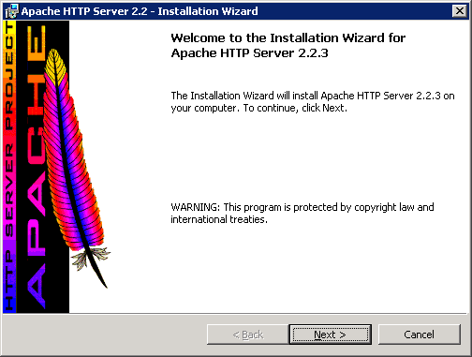
Choose "I accept the terms in the license agreement", and then click Next >.
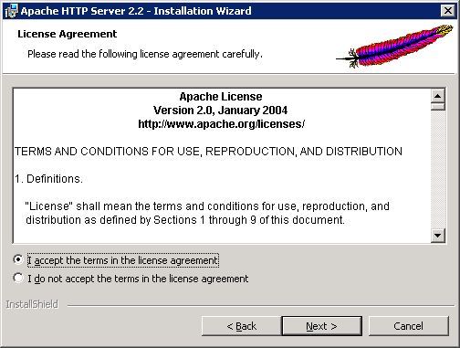
3. Click Next >.
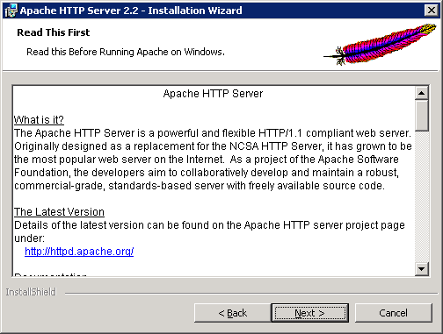
4. Fill in the appropriate information. If you do not know what to enter, you can put in localhost for the network domain and server name. Write the administrator’s email address and select "for All Users, on Port 80, as a Service", and then click Next >.

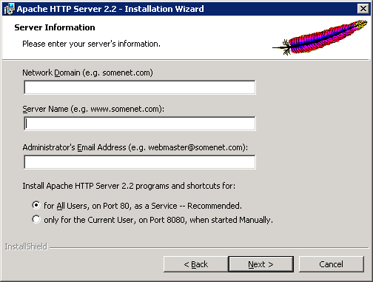

5. Choose "Typical", and then click Next >.
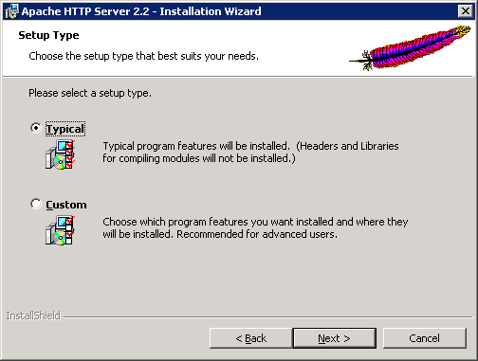

6. Click Next >.
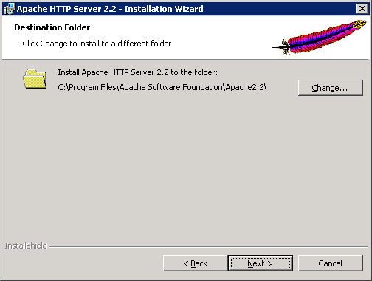
7. Click Install.
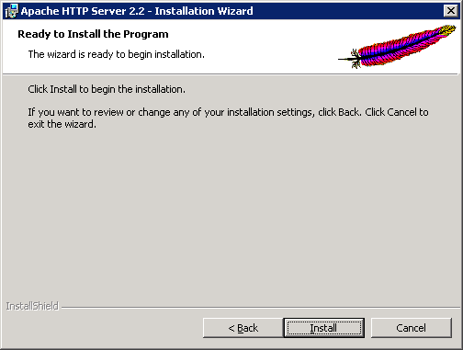
8. Click Finish.
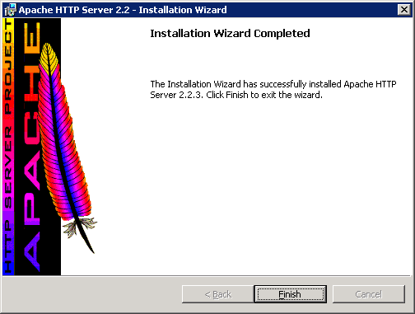

Open http://localhost/ in a web browser. If you see something like the image above, then the Apache installation is working properly.
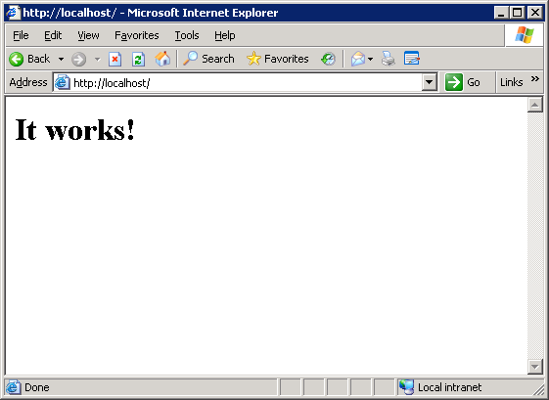

Test
Open http://localhost/ in a web browser. If you see something like in the previous screen, then the Apache installation is working properly.

If you have Windows Firewall enabled (check it in Start → Control Panel → Network and Internet Connections → Change Windows Firewall settings), the first time you access to the Apache welcome page, it will appear the screen shown in Figure 1. Select Unblock on the Windows Security Alert. For other firewalls, make sure port 80 is open.
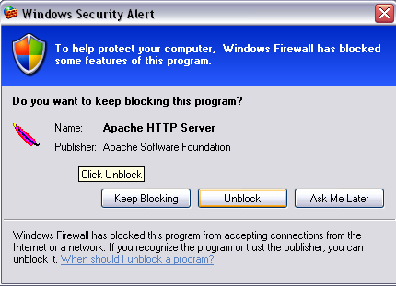
Figure 1 Windows Security Alert window

In the system tray there is a new icon (Figure 2). Single left-click on it to get a menu (Figure 3) that allows Apache HTTPD service management (to start, stop or restart it).

Figure 2 Apache management icon

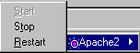
Figure 3 After single click on Apache management icon

Install Python

Prerequisites
- Version: 2.6.2
- File Name: python-2.6.2.msi

Install
Execute python-2.6.2.msi and follow instructions keeping default values.
NB: Install as an Administrator and make python available to all users.

Install LXML

Prerequisites
- Version: 2.2.1
- File Name: lxml-2.2.1.win32-py2.4.exe

Install
Execute lxml-2.2.1.win32-py2.4.exe and follow instructions keeping default values.

Install mod_wsgi

Prerequisites
- Version: 3.3
- File Name: mod_wsgi-win32-ap22py26-3.3.so

Install
- copy mod_wsgi-win32-ap22py26-3.3.so to mod_wsgi.so into the modules directory under Apache installation directory.
- edit httpd.conf in conf directory under Apache installation directory and add the following line after the last one beginning with “LoadM;odule …”:
LoadModule wsgi_module modules/mod_wsgi.so
- restart Apache

Install IPCA6TransDef

Prerequisites
- Version: 1.1
- File Name: ipca6transdef.zip

For each edition to translate, the definitions masterfiles in Authentic Languages must be inside a Data Folder. Example:
C:\IPC\data\20090101\ipcr_elayer_definitions\ipcr_elayer_definitions_20090101.xml

Install
- extract ipca6transdef.zip to c:\
- edit httpd.conf in conf directory under Apache installation directory and add the following lines after the comments section with “# Aliases: …”:
WSGIPythonPath C:/ipca6transdef/defedit;C:/python24

WSGIScriptAlias /definitionsEditor C:/ipca6transdef/defedit/defedit.py
<Directory "C:/ipca6transdef/defedit">
Order allow,deny
Allow from all
ExpiresActive Off
FileETag None
</Directory>

Alias /ipca6transdef "C:/ipca6transdef/"
<Directory "C:/ipca6transdef/">
Options Indexes Multiviews
AllowOverride None
Order allow,deny
Allow from all
</Directory>

Alias /ipcdata "C:/ipc/data"
<Directory "C:/ipc/data/">
Options Indexes Multiviews
AllowOverride None
Order allow,deny
Allow from all
ExpiresActive Off
FileETag None
</Directory>

Uncomment the following line:
LoadModule expires_module modules/mod_expires.so

- edit C:/ipca6transdef/defedit/config.cfg and modify it as necessary.
- restart Apache
- start a web browser and go to :
http://localhost/ipca6transdef/manager.html
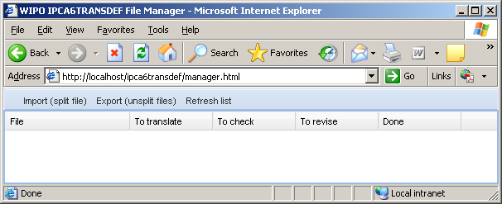
- start a web browser and go to :
http://localhost/ipca6transdef/index.html
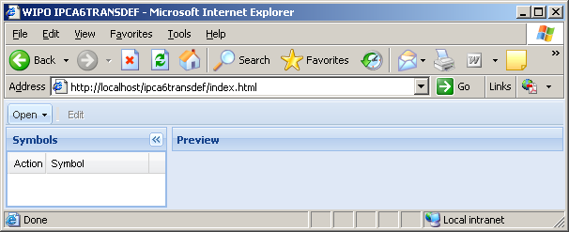
Note: to access the application from a remote PC you have to replace localhost by your web server root location.

