Minimal Specifications for Electronic PCT Document Exchange

Version Number 3.0
May 2, 2007

Document Information
Document title: | Minimal Specifications for Electronic PCT Document Exchange
Document file name: | input.doc
Issued by: | Peter Waring, Christophe Mazenc, Jim Fullton
Issue Date: | May 02, 2007
Status: | Approved

Table of Contents
1. Executive summary 3
2. Format Specification 3
Rule 1 – Supported Document Formats 4
Rule 2 – Supported Document Types 5
Rule 3 – Document Wrapper Format 6
Rule 3.1 Document wrapper format 6
Rule 3.2 Document wrapper format (enhanced) 7
Rule 3.3 Document Packaging for Scanned record copies 9
Rule 4 – Document Wrapper Naming Convention 10
Rule 5 – Document Index Data 11
Rule 5.1 Document index data 11
Rule 5.2 Document index data (enhanced) 11
Rule 6 – Exceptional Document Uploads 13
Rule 7 – Package transfer failures 14
3. ANNEX 15

Executive summary
This minimal specification provides an easily implemented, temporary yet upward-extensible solution to the problem of electronic document exchange between the International Bureau, Patent Cooperation Treaty (PCT) member state intellectual property offices and PCT international authorities.
The use of this minimal specification will quickly provide benefits to the implementing PCT member state office or international authority and to the International Bureau both in terms of cost (through reductions in document printing, shipping, storage and disposal) and quality (fewer manual operations for the staff).
Electronic document exchange between PCT member states and the International Bureau is now a reality. The International Bureau has established the PCT-EDI Service to encourage member states to take immediate advantage of the cost savings and improved operational efficiencies potentially available through electronic data exchange with the International Bureau.
The following simple requirements were considered during the development of this minimal specification:

- The specification should be sufficiently simple to both permit and encourage its implementation by any PCT member state office or international authority at a minimum cost.
- The specification should be sufficiently flexible to allow the transmission of both scanned documents and electronically authored documents.
- The specification should be “exchange media neutral”, e.g. it should make no assumptions as to the media used for electronic exchange.
- The specification should be upward compatible with the new WIPO Standard ST.36 standard by using similar document structures.
- The specification should facilitate efficient processing by the PCT Operations division at the International Bureau, reducing the administrative overhead and facilitating the creation of the electronic publication working copy.
Offices are strongly encouraged to transfer documents in the WIPO Standard ST.36 format to the International Bureau as a first choice, using unstructured formats only when their internal systems are not yet capable of processing documents fully compliant with WIPO Standard ST.36.

Format Specification

The format specification is designed for simplicity and ease of implementation at the lowest possible cost. It consists of five basic rules, based primarily upon existing WIPO standards and guidelines.

Rule 1 – Supported Document Formats
Each document is represented by a single file. The following file formats and types are supported by the International Bureau (listed in order of preference):

Format | Description
WIPO Standard ST.36 | WIPO Standard ST.36 documents stored as Wrapped Application Documents (WAD)s or Wrapped and Signed Packages (WASP)s as per Annex F of the PCT Administrative Instructions
Record Copies | Record copies as defined in Annex F of the PCT Administrative Instructions.
Adobe PDF Format | Adobe PDF representations of documents, without encryption or other security protections. PDF-format documents should be in accordance with Annex F of the PCT Administrative Instructions. Fonts should be embedded where possible because where they are not embedded the documents may not be correctly rendered to images (screen, paper, tiff).
Machine Readable Character-coded data as per Bilateral Agreement | Other electronically authored documents: in certain cases, a specific format may be transmitted under bilateral agreement with the International Bureau (e.g. Microsoft Word 97 and up, non Annex F compliant PDF formats, RTF, etc). These formats are not desirable and can lead to problems for both parties (the IB and the sending RO).
Scanned Documents | A set of black and white (ONE BIT PER PIXEL, not greyscale) TIFF V6, single strip, Intel encoded (little-endian) single A4 pages. Each page is represented by a single file, scanned at 300 dpi resolution and so identified in the TIFF header. Multi-page TIFF files are not supported. The set of document page files is transferred either:  a) zipped into a wrapper file, the order of the pages being obtained by applying an alphabetic sort operation of the single page filenames, (e.g. TIFF page images, numbered 000001.tif – nnnnnn.tif) or  b) wrapped in a PDF format file (TIFF images embedded in PDF)
Sequence Listings | Sequence listings stored in ST.25 format.

Rule 2 – Supported Document Types
The document types defined in detail in the Annex are supported.
Any document not exactly corresponding to one of those document types shall be sent with the document type designation of “other”. This means that the International Bureau will visually check the document and determine the associated PCT document type, potentially splitting the document into several sub documents or merging it with others, before examining it. The use of the “other” document type should be avoided whenever possible.
The document types were originally directly obtained from the set of electronic filing DTDs published on the WIPO web site (http://www.wipo.int/), and have subsequently been added to as required. This permits electronic documents sent to the International Bureau to be easily transferred later to other parties (Designated Offices, etc.) using WIPO Standard ST.36 data encoding, and allows the offices a migration path to full WIPO Standard ST.36 support.

Rule 3 – Document Wrapper Format

Document wrapper format 3.1 - For offices where we have agreed transfers prior to 2007, we have used a packaging scheme where relationships between documents in a given batch are not retained and thus it is more difficult to create business transaction work items in the IB system. This scheme remains valid and supported by the IB. No date as been set for the deprecation of the use of this scheme, however it should be noted that, at the time of writing, the IB encourages offices following this scheme to consider migrating to the revised scheme 3.2.

Document wrapper format (enhanced) 3.2 - For offices where we have agreed transfers after 2006, we have encouraged the use of a packaging scheme where relationships (e.g. priority document plus accompanying letter) between documents in a given batch are retained.

Document Packaging for Scanned record copies 3.3 - For scanned record copies the collection of sub-documents are gathered together in a single zipfile.

Rule 3.1 Document wrapper format

The documents are transmitted and stored in a hierarchical directory structure consisting of 2 “levels”:
Level 1: WIPO Standard ST.3 code of the transmitting office, date of transmission in local office time, sequential number of the transmission in the day. e.g. US-20041102-000001, JP-20041025-000001 or KR-20041119-000001.
Level 2: PCT Number, or the string PCTXXXXXXXXXXXX (“PCT” followed by twelve ASCII 88/0x130 characters) if the PCT number is not known or not applicable.
This hierarchical structure is preserved in transmission by storing the Level 1 directory in either a “zip” or “tar” file, as shown in the example below:
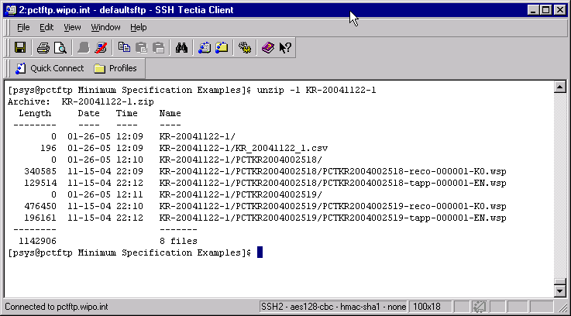

Rule 3.2 Document wrapper format (enhanced)

The image below shows a screen-shot of a package received from US.
Documents for each IA are contained in folders for each IA. These folders are named as follows:
<ia_number>[-<series-number>] Series number is optional
The naming structure allows for the grouping of documents into business transactions – where a letter is attached to another document etc. Thus in the case where the RO has one or more documents for an IA that has no known grouping they should be sent in a folder simply using the IA number (i.e pctKR2006123456); in the case where there are groups of documents for an IA they should be sent in a folder with the IA Number and a series number (i.e. pctKR2006123456-000001) – if there are 2 groups for an IA then a second folder would be expected (i.e. pctKR2006123456-000002) and if there is a single grouping plus some ‘other’ unrelated documents then we would expect folders pctKR2006123456 and pctKR2006123456-000001
A CSV file is in the root directory of the zipfile (with the same name as the zipfile (csv replacing zip).

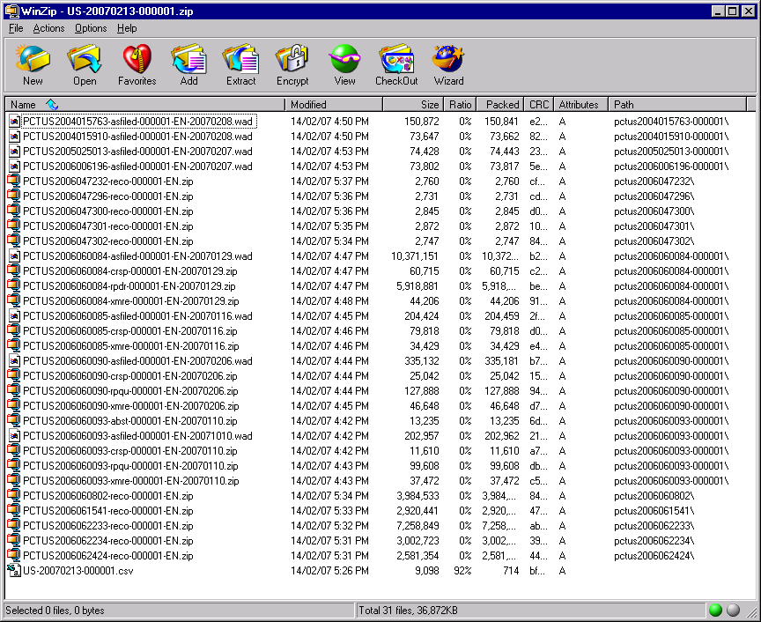

The zip file is named as follows:
RO-yyyymmdd-nnnnnn.zip

Where
RO is the 2 letter office code (in this case US)
Yyyymmdd is the date of sending, not the date that the package was put together (in this case 20070213)
And nnnnnn is a sequential counter incremented with each wrapper file sent by the office in a given year

Rule 3.3 Document Packaging for Scanned record copies
For scanned record copies the collection of sub-documents are gathered together in a single zipfile that is inserted into the batch transfer package to be sent by an office.

All the contained documents are named according to the minimum-specification [this document] and are placed in the zipfile at the root directory level (there should be no sub-folders). See screenshot below:

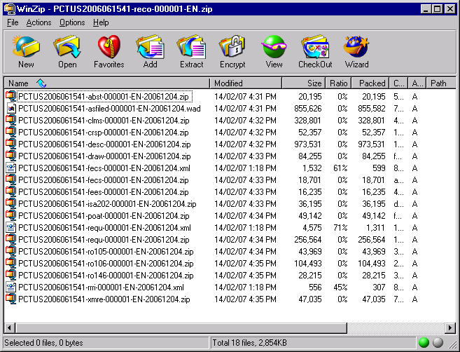

Rule 4 – Document Wrapper Naming Convention
The name of a wrapper file is composed of either five or six consecutive parts separated by dashes (using an extended version of the Annex F File Naming Conventions):
- The PCT Number, or the string PCTXXXXXXXXXXXX if the number is not known.
- The document type code in lower case (see the annex for the document types)
- A numeric string NNNNNN to make the filename unique within its directory NNNNNN is a number right justified and padded with leading zeros
- The upper case ISO639 code representing the language of the document or XX if unknown
- Any optional additional bibliographic data information (format depending on the document type, see Annex)
- The “wad”, “wsp”, “.pdf”, “.doc” or the “.zip” extension.

Note that for characters uppercase is preferred for readability, but the EDI service is character case independent for file and folder names.

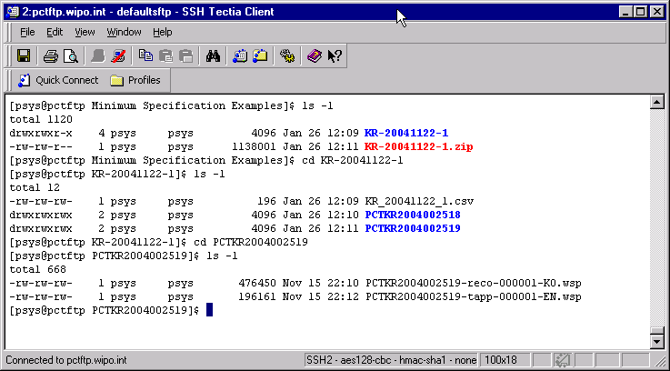

Rule 5 – Document Index Data
Rule 5.1 Document index data - For offices where we have agreed transfers prior to 2007 we have used a packaging scheme where relationships between documents in a given batch are not retained and thus it is more difficult to create business transaction work items in the IB system. This scheme remains valid and supported by the IB. No date as been set for the deprecation of the use of this scheme, however it should be noted that, at the time of writing, the IB encourages offices following this scheme to consider migrating to the revised scheme 5.2.

Rule 5.2 Document index data (enhanced) - For offices where we have agreed transfers after 2006, we have encouraged the use of a packaging scheme where relationships (e.g. priority document plus accompanying letter) between documents in a given batch are retained.

Rule 5.1 Document index data
The transmitted documents are accompanied by an index file in Comma Separated Value (csv) format. This index file is saved under the level 1 directory. Its name is composed of the level 1 directory name with the extension .csv. The CSV file contains an entry for each transmitted document, with the first column containing the PCT number and the second column the name of the document file. This index allows confirmation that no documents were lost in the transmission.
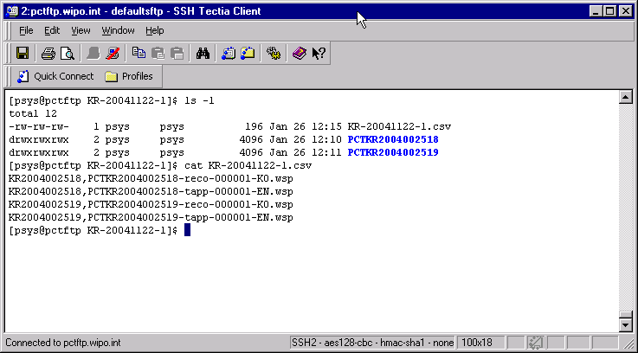

Rule 5.2 Document index data (enhanced)
The CSV file contains 2 columns (one row per document file):
A Folder name
B The document file name

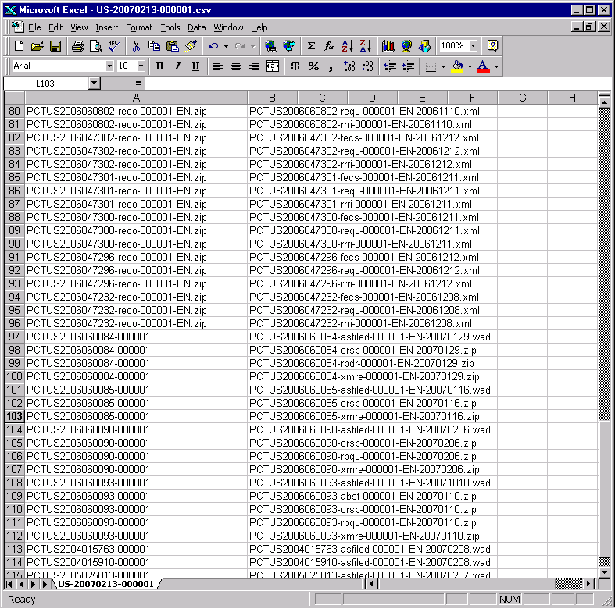
It should be noted that, in the example above, the reco document entries have been expanded to additionally list their contents to enable validation of their reception as though they were folders.

Rule 6 – Exceptional Document Uploads
This rule is applicable for documents satisfying the conditions below:
- Rule 19.4 record copy filings
- Record copy filings subject to national security concerns
- Very large documents (e.g 1 gigabyte in size)

These document uploads require special handling and the provisions for their handling are as follows:

(a) Rule 19.4 record copy filings
either
package the record copies in the normal office package, with the exception that the document type is ‘reco194’ (as per the Annex) instead of ‘reco’ (this is the preferred of the two options),
or
name each record copy in accordance with Rule 2 as normal and upload files to the directory: ‘upload-roib194’.

(b) Record copy filings subject to national security concerns
The security statement should be uploaded as part of a normal package with the document type ‘secu’ as specified in the Annex.

(c) Very large documents
either
Upload files INDIVIDUALLY to the directory: upload-vld
or
Send individual files to the IB on DVD with an appropriate covering letter.
Name each file in accordance with Rule 2
Do not package the documents in accordance with Rule 3

Rule 7 – Package transfer failures
Where an entire batch transmission has failed the entire package file should be resent using the original name.

ANNEX

Please note that all dates follow the YYYYMMDD format.
Document Type | Code | Description (E-Filing Tag name) | Allowed file formats | Wrapper file naming convention
abstract | abst | Abstract of the application (part of the application body) | .pdf  .doc  .zip | Additional Biblio Data:  Date of receipt at transmitting office  e.g.:  PCTUS2004005602-abst-000001-EN-20050531.doc
amend-claims | amcl | Amended claims under Article 19 (ST36 document). Normally expected from the Applicant. | .wad  .wsp | Additional Biblio Data:  Date of receipt at transmitting office  e.g.:  PCTUS2004005602-amcl-000001-EN-20050531.wad
amend-statement | amst | Statement describing the amendment of the claims (PCT Article 19.1, PCT Rule 46.4). Normally expected from the Applicant. | .pdf  .doc  .zip | Additional Biblio Data:  Date of receipt at transmitting office  e.g.:  PCTUS2004005602-amst-000001-EN-20050531.zip
Applicants-request-for-publication-of-late-correction | rlpc | Applicant’s Request for publication of late furnished correction/addition p.claim (Rule 26bis.2(e)) | .pdf  .doc  .zip | Additional Biblio Data:  Date of receipt at transmitting office  e.g.:  PCTUS2004005602-rlpc-000001-EN-20050531.zip
Applicants-request-for-publication-relating-to-pdoc-discrepancy-or-void | rppc | Applicant’s request for publication of info relating to p.claim declared void, discrepancy with priority document etc (Rule 26bis.2(d)) | .pdf  .doc  .zip | Additional Biblio Data:  Date of receipt at transmitting office  e.g.:  PCTUS2004005602-rppc-000001-EN-20050531.zip
applicants-statement-of-reasons | stpr | Applicant’s “Statement of Reasons” (may include Applicant’s request for restoration of priority rights) (Rule 26bis.3) | .pdf  .doc  .zip | Additional Biblio Data:  Date of receipt at transmitting office  e.g.:  PCTUS2004005602-stpr-000001-EN-20050531.zip
as-filed-document | asfiled | As filed document with no transformations (from the applicants submission) applied.  Note such documnts should ALWAYS be wrapped in a zip file. | .zip | Additional Biblio Data:  Date of receipt at transmitting office  e.g.:  PCTUS2004005602-asfiled-000001-EN-20050531.zip
claims | clms | Claims of the application (part of the application body) | .pdf  .doc  .zip | Additional Biblio Data:  Date of receipt at transmitting office  e.g.:  PCTUS2004005602-clms-000001-EN-20050531.pdf
conf-r20.6-incorp-by-ref | incr | Applicant’s confirmation of request for incorporation by reference (Rule 20.6) | .pdf  .doc  .zip | Additional Biblio Data:  Date of receipt at transmitting office  e.g.:  PCTUS2004005602-incr-000001-EN-20050531.pdf
Copy-of-earlier-filed-application | eapp | Copy of earlier application (for incorporation by reference) | .pdf  .doc  .zip | Additional Biblio Data:  Date of receipt at transmitting office  e.g.:  PCTUS2004005602-eapp-000001-EN-20050531.zip
declaration | decl | Declaration where the specific declaration type is not known (Rule 4.17) | .pdf  .doc  .zip | Additional Biblio Data:  Date of receipt at transmitting office  e.g.:  PCTUS2004005602-decl-000001-EN-20050212.pdf
Declaration-in-support-of-request-for-restoration-of-priority-claim | rspr | Declaration/Evidence  Filed in support of request for restoration of priority rights (Rule 26bis.3) | .pdf  .doc  .zip | Additional Biblio Data:  Date of receipt at transmitting office  e.g.:  PCTUS2004005602-rspr-000001-EN-20050531.zip
demand | dmnd | Chapter II demand | .pdf  .doc  .zip | Additional Biblio Data:  Date of receipt at the IPEA: YYYYMMDD or XXXXXXXX if not known  e.g.:  PCTUS2004005602-dmnd-000001-EN-20040202.zip
description | desc | Description of the application (part of the application body) | .pdf  .doc  .zip | Additional Biblio Data:  Date of receipt at transmitting office  e.g.:  PCTUS2004005602-desc-000001-EN-20050531.zip
drawings | draw | Drawings of the application (part of the application body) | .pdf  .doc  .zip | Additional Biblio Data:  Date of receipt at transmitting office  e.g.:  PCTUS2004005602-draw-000001-EN-20050531.zip
easy-file | easy | The bibliographic data file from the easy diskette | .zip | Additional Biblio Data:  PCTUS2004005602-easy-000001-EN.zip
english-translation-of- iper | ipet | English translation of International Preliminary Examination Report | .pdf  .doc  .zip | Additional Biblio Data:  IPEA  Date of establishment of the IPER (XXXXXXXX if unknown)  e.g.:  PCTUS2003000102-ipet-000001-EN-US-20031205.zip
english-translation-of-iprp2 | iprt | English translation of International Preliminary Report on Patentability (chapter 2) | .pdf  .doc  .zip | Additional Biblio Data:  IPEA (e.g. EP)  Date of establishment of the IPRP2(XXXXXXXX if unknown)  e.g.:  PCTUS2004000052-iprt-000001-EN-US-20041001.zip
english-translation-of-non-establishment-of –international-search-report | a17t | English translation of non establishment of international search report from the ISA under Article 17.2(a) | .pdf  .doc  .zip | Additional Biblio Data:  ISA (country code)  Date of mailing of the Article 17.2a to the Applicant  e.g.:  PCTUS2004005602-a17t-000001-EN-US-20040810.zip
english-translation-of-international-application | tapp | English translation of the international application (ST36 document) | wad  .wsp | Additional Biblio Data:  Date of receipt at transmitting office  PCTKR2004000602-tapp-000001-EN-20040808.wsp
english-translation-of-search-report | isrt | English translation of the International Search Report | .pdf  .doc  .zip | Additional Biblio Data:  ISA (country code)  Date of mailing of the search report to the Applicant  e.g.:  PCTUS2004005602-isrt-000001-EN-US-20040810.zip
english-translation-of-wosa | ewos | English translation of the Written Opinion by International Search Authority | .pdf  .doc  .zip | Additional Biblio Data:  ISA (country code)  Date of mailing of the wosa to the Applicant  Date of completion of the WOSA  e.g.:  PCTUS2004005602-ewos-000001-EN-US-20041008-20040401.zip
entitlement-to-be-granted-patent | ebgp | Declaration of entitlement-to-be-granted-patent under Rule 4.17(ii) | .pdf  .doc  .zip | Additional Biblio Data:  Date of receipt at transmitting office  e.g.:  PCTUS2004005602-ebgp-000001-EN-20040808.zip
entitlement-to-claim-priority | etcp | Declaration of entitlement-to-claim-priority under Rule 4.17(iii) | .pdf  .doc  .zip | Additional Biblio Data:  Date of receipt at transmitting office  e.g.:  PCTUS2004005602-etcp-000001-EN-20040808.zip
fee-calculation-sheet | fecs | PCT fee calculation sheet | .pdf  .doc  .zip | Additional Biblio Data:  Date of receipt at transmitting office  e.g.:  PCTUS2004005602-fecs-000001-EN-20040808.zip
fee-office-info | feei | Additional fee information in an office specific format | .pdf  .doc  .zip | Additional Biblio Data:  Date of receipt at transmitting office  e.g.:  PCTUS2004005602-feei-000001-EN-20040808.zip
fee-xml | fees | fee data in XML format. | .xml | Additional Biblio Data:  Date of receipt at transmitting office  e.g.:  PCTUS2004005602-feei-000001-EN-20040808.zip
general-correspondence | crsp | general-correspondence | .pdf  .doc  .zip | Additional Biblio Data:  Date of receipt at transmitting office  e.g.:  PCTUS2004005602-crsp-000001-EN-20040808.zip
Identity-and-entitlement-to-be-granted-patent | ideb | Combined declaration of identity-of-inventor under rule 4.17(i) and Declaration of entitlement-to-be-granted-patent under Rule 4.17(ii) | .pdf  .doc  .zip | Additional Biblio Data:  Date of receipt at transmitting office  e.g.:  PCTUS2004005602-ideb-000001-EN-20040808.zip
identity-of-inventor | idty | Declaration of identity-of-inventor under Rule 4.17(i) | .pdf  .doc  .zip | Additional Biblio Data:  Date of receipt at transmitting office  e.g.:  PCTUS2004005602-idty-000001-EN-20050212.pdf
indication-bio-deposit | biod | Indications relating to the deposit of biological material. | .pdf  .doc  .zip | Additional Biblio Data:  Date of receipt at transmitting office  e.g.:  PCTUS2004005602-biod-000001-EN-20050212.zip
inventorship | invp | Declaration of inventorship under Rule 4.17(iv) | .pdf  .doc  .zip | Additional Biblio Data:  Date of receipt at transmitting office  e.g.:  PCTUS2004005602-invp-000001-EN-20050212.zip
ipea-forms | ipeaNNN | IPEA forms. Where general correspondence is machine generated the IPEA may use the form number to generate the type code e.g. for IPEA404 use ipea form 404. Note these codes must only be used for forms not listed elsewhere in this document such as the iprp. | .pdf  .doc  .zip | Additional Biblio Data:  Date of mailing of the form  e.g.:  PCTUS2004005602-ipea203-000001-EN-20050212.zip
iper | iper | International Preliminary Examination Report (for IAs with an international filing date before 2004) | .pdf  .doc  .zip | Additional Biblio Data:  IPEA  Date of establishment (XXXXXXXX if unknown)  e.g.:  PCTUS2003000102-iper-000001-EN-US-20031205.zip
iprp2 | iprp | International Preliminary Report on Patentability (chapter 2) | .pdf  .doc  .zip | Additional Biblio Data:  IPEA (e.g. EP)  Date of completion (XXXXXXXX if unknown)  e.g.:  PCTUS2004000052-iprp-000001-EN-US-20041001.zip
isa-forms | isaNNN | ISA forms. Where general correspondence is machine generated the ISA may use the form number to generate the type code e.g for ISA form 203 use isa203. Note these codes must only be used for forms not listed elsewhere in this document such as the search report (isre). | .pdf  .doc  .zip | Additional Biblio Data:  Date of mailing of the form  e.g.:  PCTUS2004005602-isa203-000001-EN-20031205.zip
lack-of-novelty | lnov | declaration of lack of novelty under Rule 4.17(v) | .pdf  .doc  .zip | Additional Biblio Data:  Date of receipt at transmitting office  e.g.:  PCTUS2004005602-lnov-000001-EN-20031205.zip
Letter | Lett | Specific correspondence in the form of a letter | .pdf  .doc  .zip | Additional Biblio Data:  Date of receipt at transmitting office  e.g.:  PCTUS2004005602-crsp-000001-EN-20040808.zip
non-establishment-of –international-search-report | a17e | Non establishment of international search report from the ISA under Article 17.2(a) | .pdf  .doc  .zip | Additional Biblio Data:  ISA (country code)  Date of mailing of the Article 17.2a to the Applicant  e.g.:  PCTUS2004005602-a17e-000001-EN-US-20040810.zip
pdoc | pdoc | Priority document (including certification sheet) | .pdf  .doc  .zip | Additional Biblio Data:  Country of the Priority Document  Date of filing of the Priority Document  (XXXXXXXX if unknown)  Serial number of the Priority document  (XXXXX if unknown) if it contains “/” characters, replace by @, if it contains “\” characters replace by #, if it contains “-“ characters, replace by “^”  Date of Receipt from applicant if under Rule 17.1(a) otherwise XXXXXXXX  e.g.:  PCTUS2004005602-pdoc-000001-EN-US-20040104-60@127,333-XXXXXXXX.zip
power-of-attorney | poat | Power of attorney document, including general power of attorney. | .pdf  .doc  .zip | Additional Biblio Data:  Date of receipt at transmitting office  e.g.:  PCTUS2004005602-poat-000001-EN-20040131.pdf
record-copy | reco | Record copy (ST36 document) | .wad  .wsp | Additional Biblio Data:  Optional filing method for Paper and Easy scanned record copies (for E-Filings this entry should not be present)  e.g.:  PCTUS2004005602-reco-000001-EN.wsp (E-Filing)  PCTUS2004005602-reco-000001-EN-EASYF.wad (Easy)  PCTUS2004005602-reco-000001-EN-PAPER.wad (Paper filing)
record-copy-19.4 | reco194 | Record copy (ST36 document) being transmitted to RO IB as a 19.4 case. | .wad  .wsp | Additional Biblio Data:  Optional filing method for Paper and Easy scanned record copies (for E-Filings this entry should not be present)  e.g.:  PCTUS2004005602-reco194-000001-EN.wsp (E-Filing)  PCTUS2004005602-reco194-000001-EN-EASYF.wad (Easy)  PCTUS2004005602-reco194-000001-EN-PAPER.wad (Paper filing)
rectified-sequence-list | rcql | Rectified versions of the sequence listing part of the application under Rule 91 (from the ISA) | .pdf  .doc  .zip | Additional Biblio Data:  Date of receipt at transmitting office  e.g.:  PCTUS2004005602-rcql-000001-EN-20050624.zip
rectified-sheets-abstract | rcab | Rectified sheets for the abstract under Rule 91 (from the ISA) | .pdf  .doc  .zip | Additional Biblio Data:  Date of receipt at transmitting office  e.g.:  PCTUS2004005602-rcab-000001-EN-20050624.zip
rectified-sheets-claims | rccl | Rectified sheets for the claims under Rule 91 (from the ISA) | .pdf  .doc  .zip | Additional Biblio Data:  Date of receipt at transmitting office  e.g.:  PCTUS2004005602-rccl-000001-EN-20050624.zip
rectified-sheets-description | rcde | Rectified sheets for the description under Rule 91 (from the ISA) | .pdf  .doc  .zip | Additional Biblio Data:  Date of receipt at transmitting office  e.g.:  US2004005602-rcde-000001-EN-20050624.zip
rectified-sheets-drawings | rcdr | Rectified sheets for the drawings under Rule 91 (from the ISA) | .pdf  .doc  .zip | Additional Biblio Data:  Date of receipt at transmitting office  e.g.:  PCTUS2004005602-rcdr-000001-EN-20050624.zip
rectified-sheets-request | rcqu | Rectified sheets for the request under Rule 91 (from the RO) | .pdf  .doc  .zip | Additional Biblio Data:  Date of receipt at transmitting office  e.g.:  PCTUS2004005602-rcqu-000001-EN-20050624.zip
rectified-sheets-other | rcot | Rectified sheets of indeterminate type under Rule 91 (from the RO or ISA) | .pdf  .doc  .zip | Additional Biblio Data:  Date of receipt at transmitting office  e.g.:  PCTUS2004005602-rcot-000001-EN-20050624.zip
replacement sheets-abstract | rpab | Replacement sheets for the abstract under Rule 26 (from the RO) | .pdf  .doc  .zip | Additional Biblio Data:  Date of receipt at transmitting office  e.g.:  PCTUS2004005602-rpab-000001-EN-20040120.zip
replacement sheets-claims | rpcl | Replacement sheets for the claims under Rule 26 (from the RO) | .pdf  .doc  .zip | Additional Biblio Data:  Date of receipt at transmitting office  e.g.:  PCTUS2004005602-rpcl-000001-EN-20050624.zip
replacement sheets-description | rpde | Replacement sheets for the description under Rule 26 (from the RO) | .pdf  .doc  .zip | Additional Biblio Data:  Date of receipt at transmitting office  e.g.:  PCTUS2004005602-rpde-000001-EN-20050624.zip
replacement sheets-drawings | rpdr | Replacement sheets for the drawings under Rule 26 (from the RO) | .pdf  .doc  .zip | Additional Biblio Data:  Date of receipt at transmitting office  e.g.:  PCTUS2004005602-rpdr-000001-EN-20050624.zip
replacement sheets-other | rpot | Replacement sheets of indeterminate type under Rule 26 (from the RO) | .pdf  .doc  .zip | Additional Biblio Data:  Date of receipt at transmitting office  e.g.:  PCTUS2004005602-rpot-000001-EN-20050624.zip
replacement sheets-request | rpqu | Replacement sheets for the request under Rule 26 (from the RO) | .pdf  .doc  .zip | Additional Biblio Data:  Date of receipt at transmitting office  e.g.:  PCTUS2004005602-rpqu-000001-EN-20050624.zip
replacement-sequence-list | rpql | Replacement sequence listing part of the application under Rule 26 (from the RO) | .pdf  .doc  .zip | Additional Biblio Data:  Date of receipt at transmitting office  e.g.:  PCTUS2004005602-rpql-000001-EN-20050624.zip
request | requ | RO 101 request form | .pdf  .doc  .zip | Additional Biblio Data:  Date of receipt at transmitting office  e.g.:  PCTUS2004005602-requ-000001-EN-20050624.zip
ro-forms | roNNN | RO Forms. Where general correspondence is machine generated the RO may use the form number to generate the type code e.g for RO form 106 use ro106. Note these codes must only be used for forms not listed elsewhere in this document such as the record copy. | .pdf  .doc  .zip | Additional Biblio Data:  Date of mailing of the form  e.g.:  PCTUS2004005602-ro106-000001-EN-20050624.zip
Rule-92-bis-changes | r92b | Rule 92 bis changes | .pdf  .doc  .zip | Additional Biblio Data:  Date of receipt at transmitting office  e.g.:  PCTUS2004005602-r92b-000001-EN-20050624.zip
search-report | isre | International search report | .pdf  .doc  .zip | Additional Biblio Data:  ISA (country code)  Date of mailing of the search report to the Applicant  e.g.:  PCTUS2004005602-isre-000001-EN-US-20040810.zip
security-statement | secu | Statement from RO indicating that the International Application is pending security clearance | pdf  .doc  .zip | Additional Biblio Data:  None  e.g.:  PCTUS2004005602-secu-000001-en.zip
sequence-list | seql | Sequence listing part of the application | .pdf  .doc  .zip | Additional Biblio Data:  Date of receipt at transmitting office  e.g.:  PCTUS2004005602-seql-000001-en-20040810.zip
sequence-list-information-sheet | seqi | Information sheet relating to the sequence listing part of the application. | .pdf  .doc  .zip | Additional Biblio Data:  Date of receipt at transmitting office  e.g.:  PCTUS2004005602-seqi-000001-en-20040810.zip
translated-earlier-filed-application | teap | Copy of translation of earlier application (for incorporation by reference) | .pdf  .doc  .zip | Additional Biblio Data:  Date of receipt at transmitting office  e.g.:  PCTUS2004005602-teap-000001-EN-20050531.zip
translated-national-phase-document | tnap | Document that has been translated into the national language for a national application | .pdf  .doc  .zip | Additional Biblio Data: none  e.g.:  PCTUS2004005602-tnap-000001-ES.zip
translated-priority-document | tpdc | Translated priority document (Rule 20.6) | .pdf  .doc  .zip | Additional Biblio Data:  Country of the Priority Document  Date of filing of the Priority Document  (XXXXXXXX if unknown)  Serial number of the Priority document  (XXXXX if unknown) if it contains “/” characters, replace by @, if it contains “\” characters replace by #, if it contains “-“ characters, replace by “^”  Date of Receipt from applicant if under Rule 17.1(a) otherwise XXXXXXXX  e.g.:  PCTUS2004005602-tpdc-000001-EN-US-20040104-60@127,333-XXXXXXXX.zip
withdrawal | wdra | Withdrawal of application under Rule 90bis, or withdrawal of priority claim, or withdrawal of designation, or withdrawal of election. | . pdf  .doc  .zip | Additional Biblio Data:  Date of receipt at transmitting office  e.g.:  PCTUS2004005602-wdra-000001-ES-20041008.zip
wosa | wosa | Written Opinion by International Search Authority | .pdf  .doc  .zip | Additional Biblio Data:  ISA (country code)  Date of mailing of the wosa to the Applicant  Date of completion of WOSA  e.g.:  PCTUS2004005602-wosa-000001-EN-US-20041008-20041008.zip
wosa-comment | wosc | Applicant’s comments on the written opinion. Normally expected from the Applicant. | .pdf  .doc  .zip | Additional Biblio Data:  Date of receipt at transmitting office  e.g.:  PCTUS2004005602-wosc-000001-EN-20041008.zip
xml-reciept | xmre | XML receipt issued for transmission evidence | .xml | Additional Biblio Data:  Date of receipt at transmitting office  e.g.:  PCTUS2004005602-xmre-000001-EN.xml

