General Policies Regarding the
Intellectual Property Rights of the Traditional knowledge and Traditional Cultural Expressions (Intangible Cultural Heritage) in Republic of Macedonia

by Ivona Opetcheska Tatarchevska ethnochoreologist
Ministry of Culture, Cultural Heritage Protection Office
WIPO INTER-REGIONAL EXPERTS MEETING,
Warsaw, Poland, 8-9 July 2010

The intellectual property system in Macedonia aims at protecting the results of the human brain work and creativeness. The intellectual property system of protection of these results includes two basic categories: The Ministry of Culture has the responsibility for protecting of artistic property and State office of Industrial property; Ministry of Economy and Ministry of Local Self-Government have the responsibility for protecting the artistic craftsmanship from the aspect of industrial property. http://www.ippo.gov.mk/dzzis/dzzis1.nsf

The protection of the artistic property is ensured by the following 11 legislative acts:
National legislation
- Law on Copyright and other Related Rights (1996); link:Закон за авторското право и сродните права („Сл. Весник на Република Македонија“ бр.47/96, 3/98; 98/02; 4/05 и 23/05 - пречистен текст);
- Law on establishing the Film Library (1974) link: Закон за основање на Кинотека на СРМ („Сл. Весник на Република Македонија“ бр. 20/74);
- Law on audiovisual cultural heritage (2008) link ?
- Law of culture (1998),(2003),(2005) link: Закон за културата („Сл. Весник на Република Македонија“ бр.66/03 - пречистен текст, 82/05);
- Law on the Macedonian Language Use (1998); link:Закон за употребата на македонскиот јазик („Сл. Весник на Република Македонија“ бр.5/98, 82/05);
- Law on libraries September(2004) link: Закон за библиотеките („Сл. Весник на Република Македонија“ бр.66/04);
- Law for archival materials and documents (1990 and 1995) link: Закон за архивската граѓа („Сл. Весник на Република Македонија“ бр. 36/90 и 36/95)
- Law on Cultural Heritage Protection enacted March 19th 2004, entering into force on 1st of January (2005) link: Закон за заштита на културното наследство („Сл. Весник на Република Македонија“ бр. 20/04)
- Law on museums (2004) link: Закон за музеите („Сл. Весник на Република Македонија“ бр. 66/04);
- Law on Film Fund (2006); link: ?
- Law on obligatory example of edition (1994) link: Закон за задолжителен примерок („Сл. Весник на Република Македонија“ бр. 11/94);

International conventions, agreements in the field of intelectual property, ratified by Macedonia:
- 18 International Treaties in the Field of Copyright and Related Rights; http://www.wipo.int/members/en/details.jsp?country_id=114&country_code=MK
Like:
1. International Treaties in the Field of Copyright and Related Rights
2. Convention Establishing the World Intellectual Proprty Oorganization (1993 on the base of succession from the former SFRY);
3. Berne Convention for Protection of Literature and Artistic Work 1971;
4. Universal Convention on Copyright (1952 and 1971);
5. International Convention for the protection of performers, phonogram producers and broadcasting organizations (Rome Convention from 1961);
6. Convention on the Distribution of Program-carry Signals via satellites (Satellite Convention);
7. Convention for the Protection of the Phonogram Producers Against Unauthorized Duplication of Their Phronograms (Phonogram Convention); ratified 1997;
8. Treaty (WIPO Treaty)
9. WIPO Performances and Phonograms Tretaty
- 1 - Agreement of Trade Related Aspects of the Intellectual Property Rights - TRIPS Agreement of WTO (April 2003); http://www.wto.org/English/docs_e/27-truips.pdf. („Сл. В.РМ“-МД бр. 7/03)
- 7 EU (Council of Europe) directives; CELEX: http://europa.eu.int/celex/htm/celex.en.htm
1. Council Directive 91/250/EEC on the Legal Protection of Computer Programs;
2. Coincil Directive 92/100/EEC on Rental Right and Lending Right and on Certain Rights related to Copyright in the Field of Intellectual Property;
3.Coincil directive 93/83/EEC on the Coordination of Certain Rules Concerning Copyright and Rights Related to Copyright Applicable to Satellite Boradcasting and Cable Retransmission;
4. Coincil Directive 93/98/EEC Harmonizing the Term of Protection of Copyright and Certain Related Rights;
5. Directive 96/9/EC on the Legal Protection of Databases;
6. Directive 2001/29/EC on the Harmonisation of Certain aspects of Copyright and related Rights in the Information Society;
7. Directive 2001/84/EC on the Resale Right for the Benefit of the Author of an Original Work of Art.

Protection on Intangible Cultural Heritage (TK and TCE’s ) in Republic of Macedonia
I would like to briefly mention that the Republic of Macedonia legally ratified the
1. Convention for the Safeguarding of the Intangible Cultural Heritage (Paris 2003) on the 28th April, 2006.
2. Convention on the Protection and Promotion of the Diversity of Cultural Expressions (Paris 2005) ratified on 22/05/2007

Institutional structure of the Ministry of Culture concerning ICH (TK and TCE’s)

Ministry
of
culture

Cultural Heritage
Protection Office
Department for
Cultural activities,
Perform. arts and
Cultural heritage
Department for
Copyright and
Other Related
Rights
UNESCO
Macedonian
National
Commission

National Council for
cultural heritage
Board for protection
of
intangible heritage

Structure of the Cultural Heritage Protection Office

Cultural Heritage
Protection Office

Department for
Prevention and
Supervision

Department for
Identification,
Protection and Use
of Cultural heritage

Department for
Documentation and
Internat. cooperation

Section for
Intangible
heritage

Section for
Movable
heritage

Section for
Immovable
heritage

Authorized institutions/protectors for Intangible heritage (TK and TCE’s):
1. Institute of folklore “Marko Cepenkov”- Skopje;
2. Institute of Macedonian language “Krste Misirkov”- Skopje;

The audio/video heritage in R.Macedonia, according the Law on Cultural Heritage Protection, is defined as movable heritage.
Authorized institutions for audiovisual cultural heritage are:

1. National University Library “Kliment Ohridski” - Skopje

2. National Film Laboratory - Skopje

The Macedonian Law for protection of Cultural heritage, provides two main categories of values of cultural heritage

1. Cultural heritage of exceptional value, divide into two subcategories:

1.1. Cultural heritage of extraordinary value;

1.2. Cultural heritage of great value;

2. Important Cultural heritage

National Registry of Cultural heritage in Macedonia is define as National inventory of protected goods.

Three types of registries

1. National inventory for Immovable
2. National inventory for Moveable
3. National inventory for Spiritual heritage

Actual activities

1. Parallel processes of Identification and Valorization of ICH or TK and TCE’s:

With Cultural Heritage Protection Law and four years since the enactment of the Law on Ratifying the Convention for the Safeguarding of the Intangible Cultural Heritage, analyses of identifying and validating 69 intangible goods have been processed:

- 39 folk creations
- 19 dialects of Macedonian and
- 10 dialects of the ethnic minority languages in Macedonia,
On September 15th 2009 the Government of the Republic of Macedonia declared all these dialects a significant cultural heritage, a decision published in the September 2009 issue of the Government Gazette. The legal protection of the other minority dialects is in procedure.

The linguistic diversity of Macedonia is to be part of other specific projects. For instance, the 2010 Annual Programme for Financing National Interest Projects has supported the digitalization of 9 archives from the Krste Petkov Misirkov Macedonian Language Institute from Skopje which in early 2010 were declared protected cultural heritage by law.

- 1 good in the category of toponyms. The toponyms were registered in the Global Mapping database – 613 toponyms were transcribed: 291 localities, 84 municipalities, 19 lakes, 219 rivers. In order to execute the abovementioned project, the identification and validation of the toponymic system for the whole country was required, a process legally carried out in the period between 2007 and 2009. Also, 30 toponyms were reviewed in the topographical maps at the State Survey Office as part of the project of making a basic map of the GIS data of the Republic of Macedonia;
Notation: It is important to note that the Republic of Macedonia is the first country in Europe to supply data for this base.

2. Due to the increased activity of the institutions responsible for the intangible cultural heritage, the Ministry of Culture has been preparing special applications in the last 3 years, through which institutions may petition for funds for safeguarding the intangible cultural heritage. Among the state projects involving the intangible cultural heritage as a factor in the sustainable development of Macedonian culture, we would like to single out two strategies of the Ministry of Culture:
- the Strategy for Digitalizing the Cultural Heritage, promoted on 25th January 2010, and
- the Strategy for Reviving the Old Bazaar in Skopje, promoted on 17th February 2010.

3. There have also been several media actions to raise the awareness for safeguarding the intangible culture resulting in the following projects presented to the Macedonian public:
- The Cyrillic Alphabet Song: www.mojatakirilica.com.mk;
- Digital archives of the Macedonian language,
http://damj.manu.edu.mk/materijali_en.html, as well as the recently promoted first Macedonian dialectal atlas at the Macedonian Academy of Arts and Sciences;
- Macedonia Timeless: http://www.macedonia-timeless.com/;
- Macedonian Cultural Heritage: http://soros.org.mk/konkurs/038/Kultura.htm;
- Macedonian folk songs: http://pesna.org/;
- The Living Heritage Network: http://www.zivonasledstvo.org.mk/default_en.asp.

These are all attempts to present Macedonian culture. The intangible cultural heritage may not always be properly represented in these projects, but there is still a lot of work to be done in order to achieve greater awareness and respect for this sort of heritage.
4. One of the new projects of identification of the ICH or TK and TCE’s in R. Macedonia is the common project of Ministry of Culture and British Council in Skopje, for mapping of cultural industries. The intangible heritage was recognized as very important for this project.
The first step in creating the map is registration of all traditional and cultural events that can be determinate as intangible heritage like:

a. Mapping in sphere of Performing arts as Living heritage;

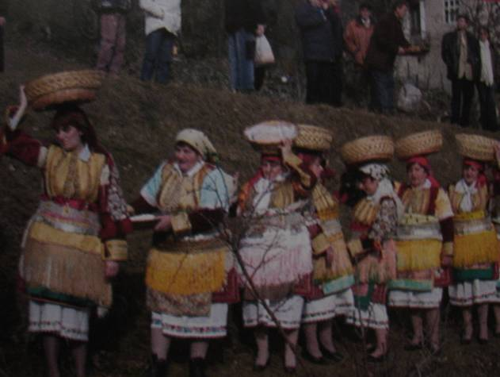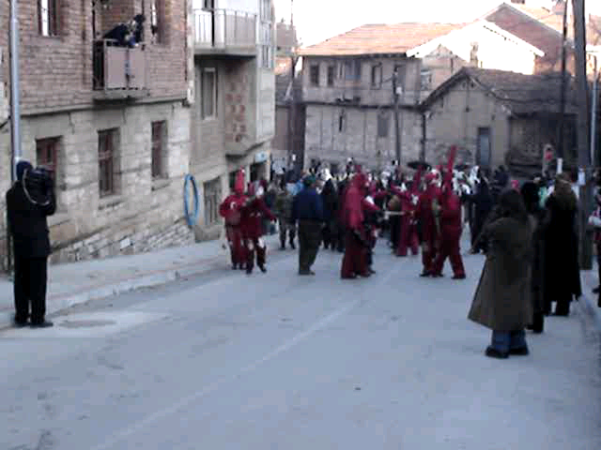

b. Reconstruction of traditional dancing and singing on state level
within “Tanec” – state dance ensemble;

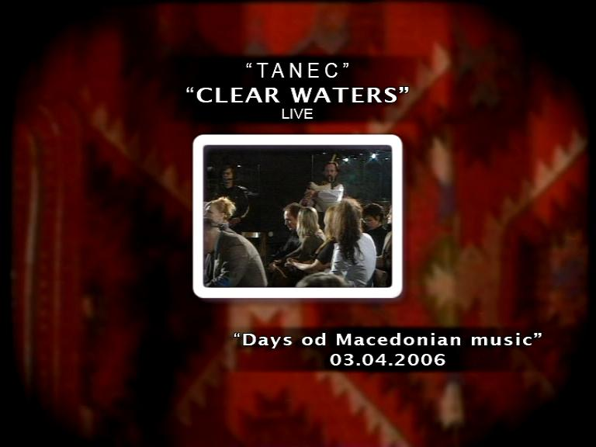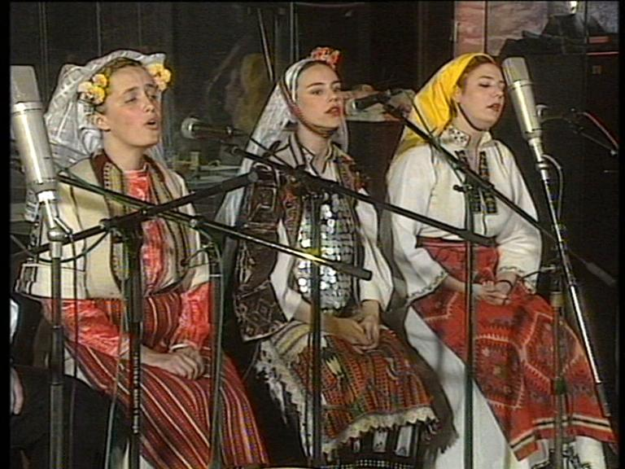
Stage performance of reconstructed traditional songs – Professional State ensemble for songs and dances “TANEC”

c. Rituals and festive events;

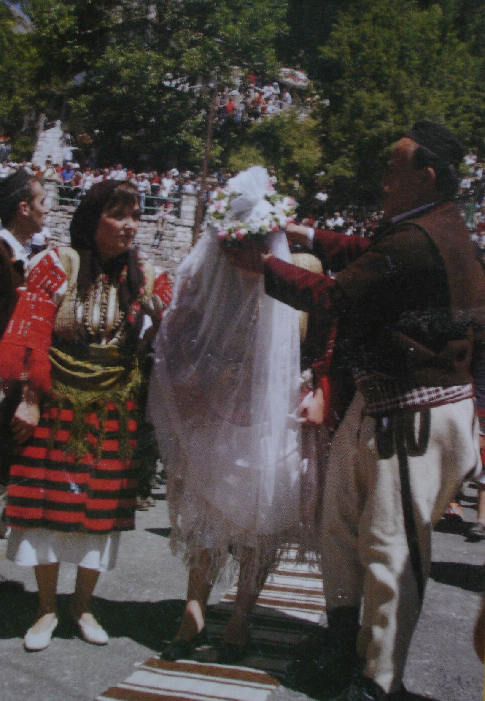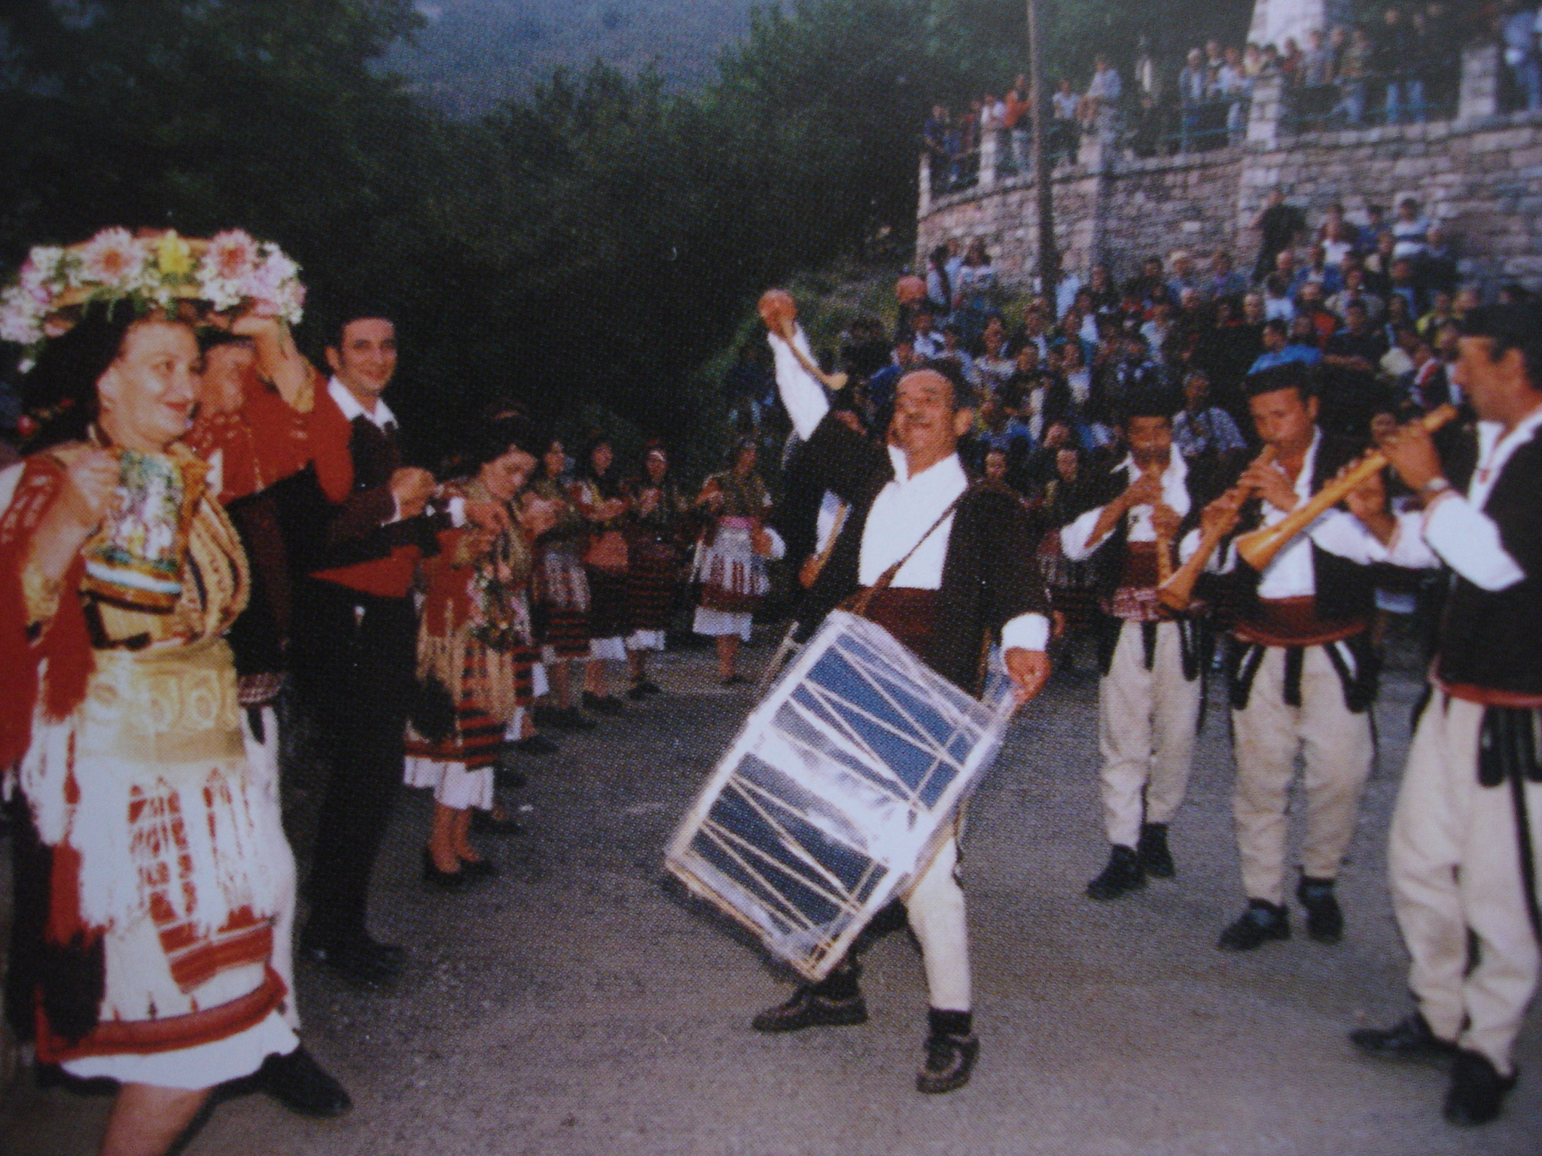
“Galichnik wedding” – institutionalized performance of wedding rituals in Western Macedonia

d. Local and national Festivals of traditional and folk culture;

“Ilindenski denovi” in Bitola;

“Hid -Bah Shen" v.Chalakli, (Festival of the Turkish culture in Macedonia)

“Pece Atanasovski” v.Dolneni;

“Gocevi denovi” in Delchevo, Skopje, v.Podgorci;

“Istibanjsko zdravo zivo” v.Istibanja;

“10 days of Krushevo’s republic”- Krushevo;

“Galichnik Wedding” v. Galichnik;

“Balkanski festival” in Ohrid;

e. Mapping in sphere of Knowledge and practices concerning nature and universe;

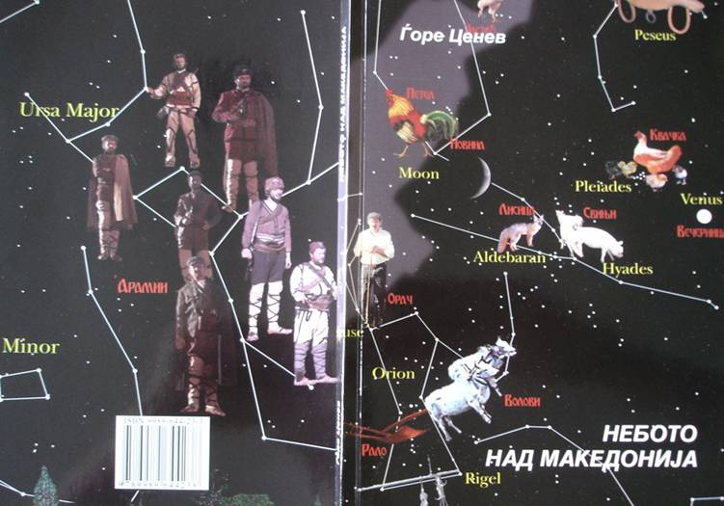
Ethnoastronomy project “The sky over Macedonia” realized by Gjore Cenev from the Macedonian Youth Planetary Centre

f.Traditional Crafmanship Project for protection and revitalization of Old Bazaars in Skopje, Prilep and Kichevo

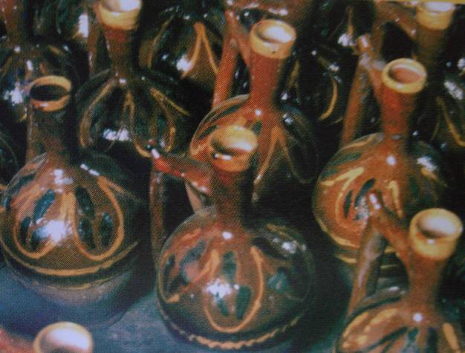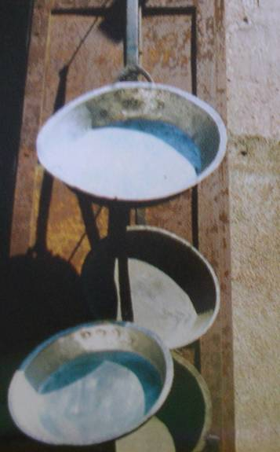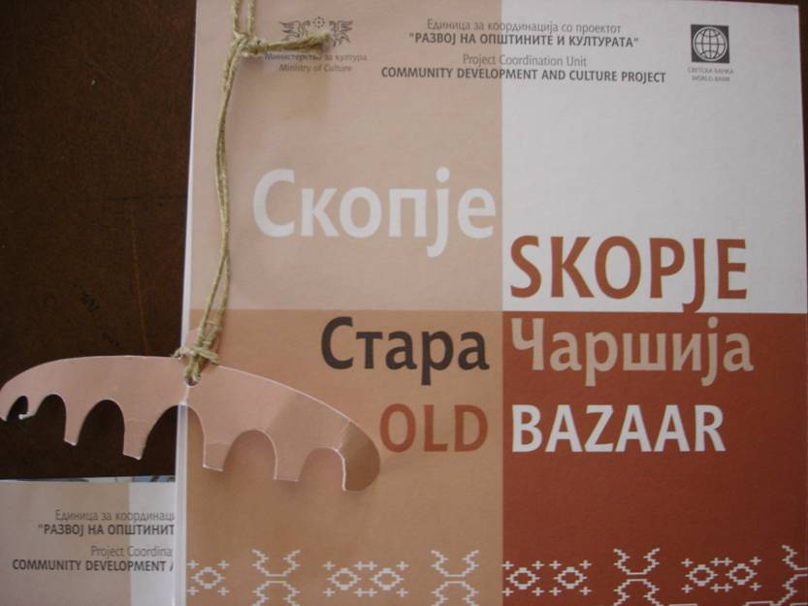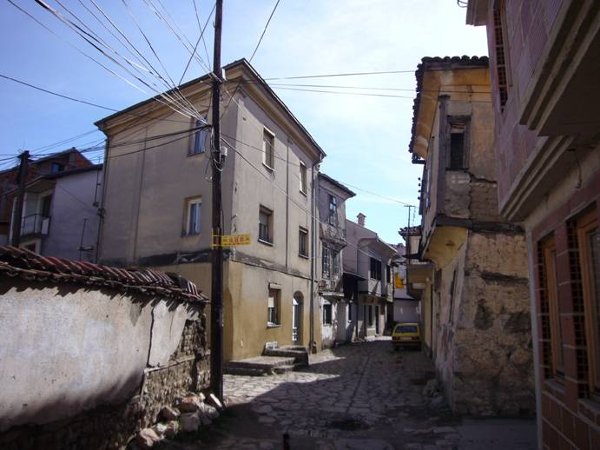

Conclusion

I would like to conclude that after studying the strategic plans and priorities of the Government of the Republic of Macedonia in the Strategic Priorities for the 2009-2011 Period Decree, apart from promoting the cultural identity for the purposes of international recognition of the Republic of Macedonia, the two other priorities of the state are:
- Protecting the cultural heritage and
- Developing tourism.

Cultural heritage Protection Office as an institution specialized in this field, are required to work in several areas at once:

- Expanding the institutional network;
- Improving the human resources situation; (Specified Human Resources);
- Contemporary situation with Archives in Republic of Macedonia;
- Copyrights in sphere of Intangible heritage;
- More active involvement of Macedonia in international activities such as the intergovernmental committee and establishing regional cooperation, and
- Familiarizing the public and the authorities with specific issues in the field.

