E
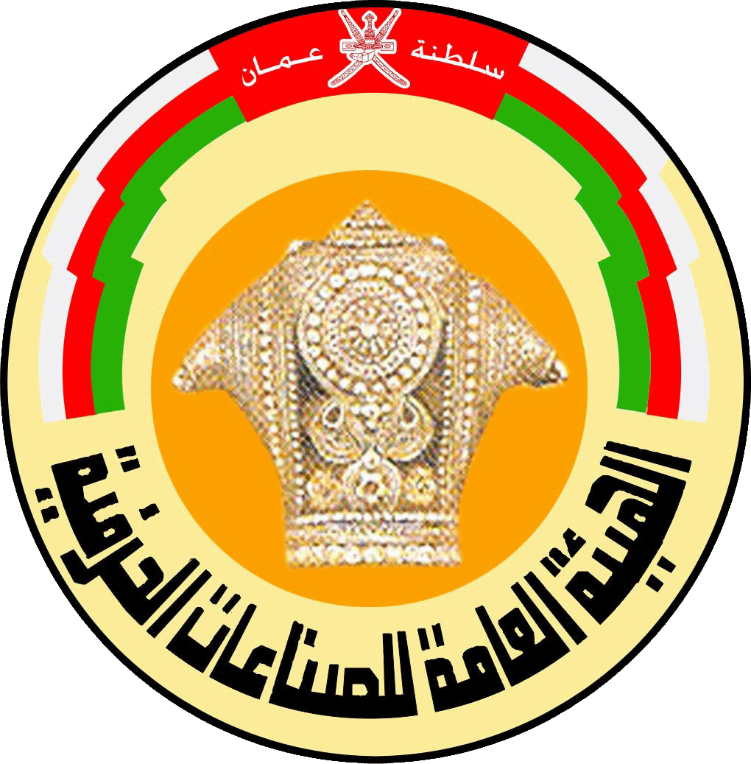
INTERNATIONAL symposium

WIPO/TK/MCT/11/INF/3 Prov. 2
OriGINAL: English
DATE: JUNE 24, 2011
Intellectual Property and Sustainable Development: Documentation and Registration of Traditional Knowledge and Traditional Cultural Expressions

organized by
the World Intellectual Property Organization (WIPO)

and

the Public Authority for Craft Industries (PACI), the Sultanate of Oman

Muscat, Oman, June 26 to 28, 2011

LIST OF PARTICIPANTS

prepared by
the International Bureau of WIPO

LIST OF PARTICIPANTS

I. STATES

ALGERIA
Naima KEBOUR (Ms.), Lawyer, Algerian National Institute of Industrial Property (INAPI), Algiers
Badreddine ALLAL, Head, Legal Department, National Copyright and Neighboring Rights Office, Algiers

BANGLADESH
Mohammed ALI, Regional Director of Archaeology, Dhaka

BULGARIA
Boriana ARGIROVA (Mrs.), Attaché, Ministry of Foreign Affairs, Sofia

CHINA
Zhi Wei CHEN, Deputy Division Director, State Intellectual Property Office of the People’s Republic of China (SIPO), Beijing

ECUADOR
Daniel SANTI, Licenciado, Administración Empresa, Puyo

FIJI
Senileba WAQAINABETE (Ms.), Principal Legal Officer, Office of the Attorney General, Suva

INDONESIA
Muhammad FAUZY, Chief, Directorate General of IPR, Tangerang

IRAN (ISLAMIC REPUBLIC OF)
Nabiollah AZAMI SARDOUEI, Legal Expert, Ministry of Foreign Affairs, Tehran

IRAQ
Mohammed Abdul Razaq RAOOF, Ministry of Culture, Baghdad

JAMAICA
Marcus GOFFE, Legal Advisor, Rastafari Millennium Council, Kingston

KUWAIT
Anwaar ALDHAMER, Translator, Copyright Department, Ministry of Commerce and Industry, Kuwait

KYRGYZSTAN
Azhibai KALMAMATOV, Director, State Intellectual Property Service of the Kyrgyz Republic, Bishkek

LEBANON
Hanna EL AMIL, Head, Cultural Affairs Department, Ministry of Culture, Beirut

MOROCCO
Essaid RACHID, University Manager, Department of Law,,University Hassan 1er, Settat

NIGERIA
Shafiu Yauri ADAMU, Trademarks, Patents and Designs, Abuja

OMAN
Naser Salim Saleh AL-SAWAFI, Ministry of Heritage and Culture
Fathy Abdul AZIZ AL HADAD, Expert, Public Authority for Craft Industries, Muscat
Musalim Bin Ahmed AL KITHIRI, Oman Centre for Traditional Music, Muscat
Nadiya AL-SAADY, The Research Council, Muscat

PAKISTAN
Muhammad ISMAIL, Deputy Director, Intellectual Property Organization (IPO), Islamabad

TOGO
Mnanta Komi LAMATETOU, Chef, Division de la documentation, de l’information et de la sensibilisation, Institute National de la Propriété Industrielle et de la Technologie (INPIT), Lomé

UNITED ARAB EMIRATES
Abdulaziz Abdulrahman AL-MUSALLAM, Ministry of Culture, Youth and Community Development, Abu Dhabi
Khalid Sulaiman AL-HINDASI, Ministry of Culture, Youth and Community Development, Abu Dhabi
Afra Khalifa AL-QUSAIMI (Mrs.), Ministry of Culture, Youth and Community Development, Abu Dhabi
Maryam Rashid AL-ZAABI (Mrs.), Ministry of Culture, Youth and Community Development, Abu Dhabi
UNITED REPUBLIC OF TANZANIA
Frowin Paul NYONI, Chairperson, National Arts Council of Tanzania, Dar-es-Salaam

YEMEN
Mr. Abdu Abdulah ALHUDHAIFI, Director General, Intellectual Property, Ministry of Industry and Trade, Sana’a

NON-GOVERNMENTAL ORGANIZATIONS

Agence Kanak de Development
Saramin BOENGKIH (Director, Noumea, New Caledonia)

Association pour le développement de la société civil angolaise (ADSCA)
Joao Paulo Kahilu DOS MARCOS (Président directeur général, Luanda)
Mununga Chinhama SONHI (Président du Comité d’Audit, Luanda)
Munonga Daniel MUTUCHILLA (Délégué régional, Suarimo)
Alfonsina Capunga LESTOR (Ms) (Huambo)

Centro Educatavi Social Integral de Desarrollo Etnico Indigena (CESIDEI)
Freddy Richard Torrico ZAPATA (Sub-director, Cochabamba, Bolivia) (Plurinational State of)

College of Life Sciences
Justice Osemudiamen AKHUAMHENKHUN (Student, Beijing)

Comunidad Aymara Anconvito
Yanet CHALLAPA (Asesor, Colchane, Chile)

Confederación de Nacionalidades Indígenas del Perú
Luisa Nini Cáceres YUPANQUI (Ms.) (Secretaria de Actas, Lima)

Federation of Environmental and Ecological Diversity for Agricultural Revampment and Human Rights Feedar and HR
Tcharbuahbokengo NFINN (Director General, Kumba, Cameroon)

Ilimaiyo Foundation
Joseph OLESARIOYO (Chairman, Nanyuki, Kenya)

Invest SVG
Angenella YOUNG (Ms.) (Research Assistant, Kingstown, Saint Vincent and the Grenadines)

L’auravetl’an Information and Education Network of Indigenous Peoples (LIENIP)
Gulvayra KUTSENKO (President, Gorno-Altaisk, Russian Federation)

Maasai Experience
Zohra AIT-KACI-ALI (Ms.) (President, Geneva, Switzerland)

Manipur University
Gopal Kumar NIROLA (Imphal, India)

Nama Indigenous Peoples Forum
Pieter CHARLES LEON (Regional Coordinator, Keetmanshoop, Namibia)

Oman Academic Accreditation Authority
Tess GOODLIFFE (Ms.) (Quality Audit Coordinator, Muscat, Oman)

Pacific Islands Museums Association
Tarisi VUNDILO (Secretary General, Auckland, New Zealand)

Rural Women Environmental Protection Association
Rose Ateng MBAH (Mrs.) (General Coordinator, Bamenda, Cameroon)

Sweat Development Programme
Gabriel Marite OLETUKE (Programme Coordinator, Kibaya Kiteto, United Republic of Tanzania)

Tanzania Intellectual Property Rights Network (TIP-NET)
William Ernest KIVUYO (Programme Officer, Lobbying and Advocacy, Arusha, United Republic of Tanzania)

SPEAKERS

Jane ANDERSON (Ms.), Assistant Professor, Center for Heritage and Society, Massachusetts

Fawzia GALAELDIN (Ms.), Executive Director, Sudanese Association for Archiving Knowledge (SUDAAK), Khartoum, Sudan

V.K. GUPTA, Senior Advisor and Director Traditional Knowledge Digital Library, Council of Scientific and Industrial Research, New Delhi

Ahmed MORSI, Counselor, Ministry of Culture, Cairo, Egypt

Manuel RUIZ, Counselor, Lima, Perú

John Ole TINGOI, Project Coordinator, Maasai Cultural Heritage, Nanyuki,
Kenya

OTHER PARTICIPANTS

Tugce ERGENEKON (Ms.), International Trademarks and Design Consultant, Grup Ofis Patents & Trademarks Agency Ltd., Ankara, Turkey
Yeney ACEA VALDÉS, Liciencado en derecho, Universidad de La Habana, Cuba

INTERNATIONAL BUREAU OF THE WORLD INTELLECTUAL PROPERTY ORGANIZATION (WIPO)

Wend WENDLAND, Director, Director, Traditional Knowledge Division
Amgad ABDEL GHAFFAR, Director-Advisor, Office of the Deputy Director General
Brigitte VÉZINA (Ms.), Legal Officer, Traditional Creativity, Cultural Expressions and Cultural Heritage Section, Traditional Knowledge Division

[End of document]

