E
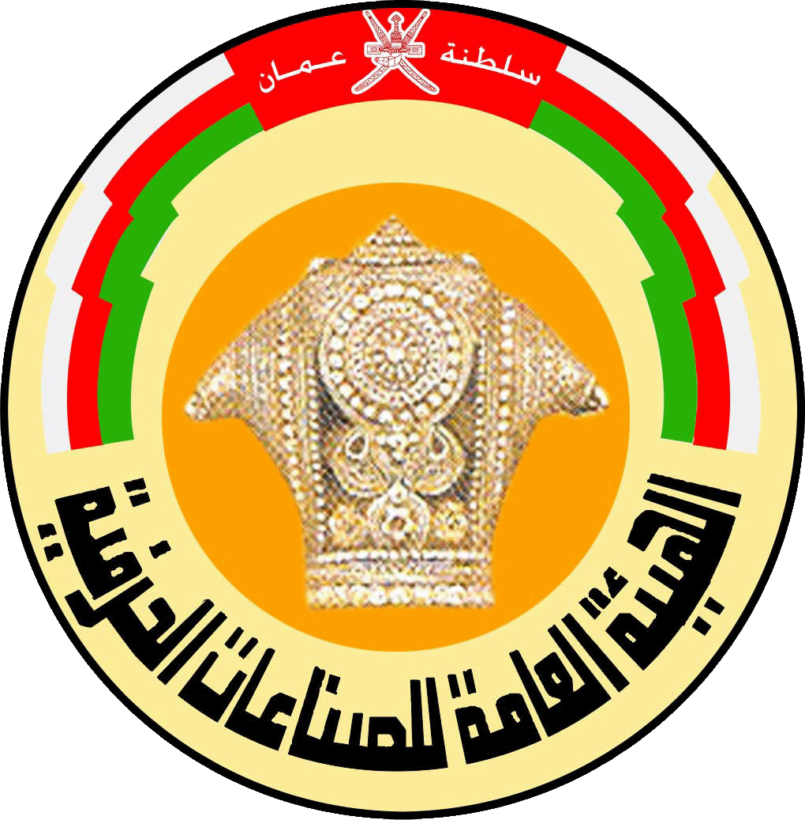

INTERNATIONAL symposium

WIPO/TK/MCT/11/INF/1
OriGINAL: English
DATE: JUNE 26, 2011
Intellectual Property and Sustainable Development: Documentation and Registration of Traditional Knowledge and Traditional Cultural Expressions

organized by
the World Intellectual Property Organization (WIPO)

and

the Public Authority for Craft Industries (PACI), the Sultanate of Oman
Muscat, Oman, June 26 to 28, 2011

PROGRAM

prepared by
The International Bureau of WIPO

Sunday, June 26, 2011

8.30 – 9.30 Registration

9.30 – 10.15 Opening Ceremony
under the patronage of
H.E. Abdul Aziz Bin Mohammed Al-Rawaasi,
Counselor for Cultural Affairs to His Majesty the Sultan, Muscat

10.15 – 10.30 Coffee Break

SESSION I — INTRODUCTION: REGISTRATION AND DOCUMENTATION AND THE PROTECTION OF TRADITIONAL KNOWLEDGE AND TRADITIONAL CULTURAL EXPRESSIONS

Moderator: Mr. Salem Mohammed Al Mahrooki, Undersecretary, Ministry of Heritage and Culture, and Representative of the Public Authority for Craft Industries (PACI), Muscat
Chair: Mr. Abdul Wahab Bin Nasser Al Mandhari, Head, Technical Office, PACI, Muscat

10.30 – 11.15 Issues in Documentation and Registration for the Intellectual Property Protection of Traditional Knowledge and Traditional Cultural Expressions
Speaker: Mr. Wend Wendland, Director, Traditional Knowledge Division, WIPO

11. 15 – 12.00 Documentation of Craft Industries in the Sultanate of Oman: Towards an International Registry for Traditional Knowledge
Speaker: Prof. Dr. Fathy Abdul Aziz Al Hadad

12.00 – 12.45 Panel Discussion: Special Protection for Traditional Knowledge and Traditional Cultural Expressions: What is the Role of Formalities?
Panelists: Mr. Ahmed Morsi, Counselor, Ministry of Culture, Cairo
Mr. Marcus Goffe, Legal Advisor, Rastafari Millennium Council, Kingston
Mr. John Ole Tingoi, Project Coordinator, Maasai Cultural Heritage, Nanyuki, Kenya

SESSION II — REGISTRATION IN EXISTING INTELLECTUAL PROPERTY SYSTEMS
Moderator: Eng. Ahmed Hassen Al Thaib, Undersecretary, Ministry of Trade and Industry, Muscat
Chair: Ms. Amina Salem Al Galania, Director, Intellectual Property Development, Ministry of Trade and Industry, Muscat

12.45 – 13.45 Copyright Registration, Documentation and the WIPO Development Agenda
Registration as a Tool for Facilitating the Diffusion of Creativity in the Digital Environment: The International Music Registry
WIPO Software for Collective Management of Copyright and Related Rights
Video: Director General of WIPO’s talk at MidemNet 2011
Speaker: Ms. Brigitte Vézina, Legal Officer, Traditional Creativity, Cultural Expressions and Cultural Heritage Section, Traditional Knowledge Division, WIPO

13.45 – 14.00 Discussion

14.00 Lunch Break

Monday, June 27, 2011

SESSION III — DEFENSIVE AND POSITIVE PROTECTION: THE ROLE OF DOCUMENTATION
Moderator: Dr. Yahya Bader Al Mawali, Undersecretary, Ministry of Social Development, Muscat
Chair: Mr. Ismail Zadjali, Officer, International Cooperation, PACI

8.00 – 8.40 Traditional Knowledge Documentation and Defensive Protection: An Example from India
Speaker: Dr. V. K. Gupta, Senior Advisor and Director, Traditional Knowledge Digital Library, Council of Scientific and Industrial Research, New Delhi

8.40 – 9.30 Genetic Resources Databases and Intellectual Property Protection
Speaker: Dr. Nadiya Al-Saadi, Researcher, Research Council, Muscat

9.30 – 10.15 Traditional Knowledge Documentation and Positive Protection: An Example from Peru
Speaker: Mr. Manuel Ruiz Muller, Director and Principal Researcher, Biodiversity and International Affairs Program, Peruvian Environmental Law Society (SPDA), Lima

10.15 – 11.00 Discussion

11.00 – 11.15 Coffee Break

Moderator: Dr. Ishaq bin Ahmed Al Ruqishi, Undersecretary, Ministry of Agriculture and Fisheries
Chair: Dr. Fathy Abdul Aziz Al Hadad, PACI

11.15 – 12.00 Traditional Cultural Expressions Documentation and Intellectual Property Protection: National Examples
Speaker: Ms. Brigitte Vézina, WIPO

12.00 – 12.45 Traditional Cultural Expressions Documentation and Positive Protection: An Example from Fiji
Speaker: Ms. Senileba Waqainabete, Principal Legal Officer, Office of the Attorney General, Suva

12.45 – 13.15 Discussion

13.15 – 13.30 Registration and the Right of Prior Informed Consent [short video presentation by Dr. Van Zanten]

13.30 Lunch Break

Tuesday, June 28, 2011

SESSION IV — CULTURAL INSTITUTIONS, PRESERVATION AND INTELLECTUAL PROPERTY
Moderator: Eng. Khalfan Al Nabi, Counselor, Ministry of Sports
Chair: Mr. Salem Gharib Al Rashidi, Director, Legal Department, PACI

8.00 – 8.30 Documentation and Preservation Initiatives: Experience from Oman
Speaker: Mr. Nasser Assawafi, Head, Ministry of Heritage and Culture, Muscat

8.30 – 9.00 Documentation and Preservation Initiatives: Experience from Egypt
Speaker: Mr. Ahmed Morsi, Cairo

9.00 – 9.30 Building Synergies between Preservation, Safeguarding and Intellectual Property Protection
Speaker: Mr. Mussalam Al-Katheeri, Head, Omani Traditional Music Center, Ministry of Information, Oman

9.30 – 10.00 Discussion

10.00 – 10.15 Coffee Break

SESSION V — COMMUNITY-LED CULTURAL DOCUMENTATION
Moderator: Ms. Sameera Ameen, Counselor, Ministry of Education, Muscat
Chair: Mr. Abdul Mohsin Al-Hinai, General Authority of Manuscripts and Documents, Muscat

10.15 – 11.00 Institutional Guidelines, Best Practice and Local Community Management Strategies for the Safeguarding of Traditional Cultural Expressions
Speaker: Dr. Jane Anderson, Assistant Professor, Centre for Heritage and Society, University of Massachusetts, Amherst, United States of America

11.00 – 12.00 Community Documentation of Cultural Heritage: Experiences
Speakers: Mr. John Ole Tingoi, Nanyuki
Ms. Fawzia Galaleldin, Sudanese Association for Archiving Knowledge (SUDAAK), Khartoum

12.00 – 12.30 Panel Discussion: Registration and the WIPO Draft Instruments
Panelists: Mr. Muhammad Ismail, Deputy Director,
Intellectual Property Office-Pakistan Regional Office, Lahore, Pakistan
Mr. Hanna El Amil, Head, Cultural Affairs Department, Ministry of Culture, Beirut
Ms. Senileba Waqainabete, Suva

12.30 – 13.30 Closing Ceremony
under the patronage of H.E. Aisha bint Khalfan Jumail Al Syabia, Chairperson of PACI

[End of document]

