E
WIPO/TK/CEI/00/INF.1
ORIGINAL: English
DATE: November 2000
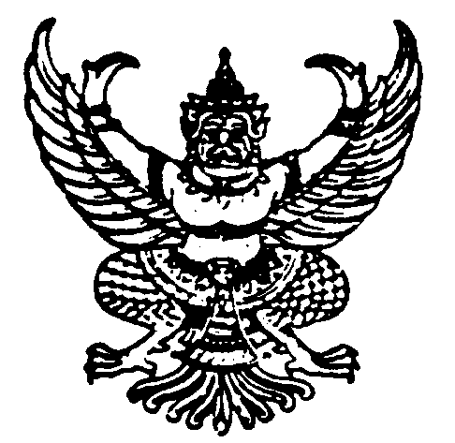 | 
MINISTRY OF COMMERCE  GOVERNMENT OF THAILAND | WORLD INTELLECTUAL  PROPERTY ORGANIZATION
wipo inter-regional meeting on
intellectual property and traditional knowledge
organized by
the World Intellectual Property Organization (WIPO)
and
the Ministry of Commerce,
Government of Thailand
Chiang Rai, Thailand, November 9 to 11, 2000
PROVISIONAL PROGRAM
Document prepared by the International Bureau of WIPO

Thursday, November 9, 2000

8.30 – 9.30 |  | Registration
9.30 –10.30 |  | Opening Ceremony
 |  | Addressed by:
 |  | H.E. Mr. Goanpot Asvinvichit, Deputy Minister, Ministry of Commerce, Government of Thailand
 |  | Mr. Narendra Sabharwal, Director, Cooperation for Development Bureau for Asia and the Pacific, World Intellectual Property Organization (WIPO)
10.30 – 11.00 | Coffee Break
11.00 – 12.00 | Theme I | Intellectual Property and Traditional Knowledge
 |  | What is traditional knowledge? What concepts and terms shall we use? Why should traditional knowledge be protected? For whose benefit should it be protected? What is the relevance of intellectual property to traditional knowledge protection? Recent international, regional and national developments. WIPO’s work on traditional knowledge.
 | Moderator
 | Speakers | Mr. Weerawit Weeraworawit, Deputy Director General, Department of Intellectual Property, Nonthaburi
 |  | Mr. Wend Wendland, Senior Legal Officer, Division of Global Intellectual Property Issues, WIPO
12.00 – 12.30 |  | Discussion
12.30 – 14.00 | Lunch Break

Thursday, November 9, 2000 / continued…

14.00 – 15.00 | Theme II | Intellectual Property Issues in the Field of Traditional Medicines
 |  | The role of traditional medicines and practices in National Health Care Systems. The use of intellectual property for the promotion and protection of traditional medicine. International, regional and national developments.
 | Moderator
 | Speaker | Mr. Zhang Weibo, Deputy Director, Division of Chinese Traditional Medicines, Examination Department I for Chemistry, State Intellectual Property Office, Beijing
15.00 – 15.30 |  | Discussion
15.30 – 16.00 | Coffee Break
16.00 – 17.00 | Theme III | Intellectual Property and Access to and  Benefit-Sharing in Genetic Resources
 |  | What are the intellectual property aspects of access to and benefit-sharing in genetic resources? Recent international, regional and national developments. WIPO’s work on intellectual property and genetic resources.
 | Moderator
 | Speakers | Mrs. Begoña Venero, Member of the Intellectual Property Tribunal, INDECOPI, Lima
 |  | Mr. Zhang Weibo
17.00 – 17.30 |  | Discussion
18.00 – 19.30 |  | WIPO Reception

Friday, November 10, 2000
9.00 – 10.00 | Theme IV | Intellectual Property and Expressions of Folklore
 |  | The nature of folklore, with examples. Concepts and terms. Role of intellectual property in the protection of folklore.
 | Moderator
 | Speakers | Mr. Moses F. Ekpo, Former Director General, Nigerian Copyright Commission (NCC), Abuja
 |  | Mr. Hossam Loufti, Professor of Civil Law, Faculty of Law, Beni Sweif University, Beni Sweif
9.00 – 10.30 |  | Discussion
10.30 – 11.00 | Coffee Break
11.00 – 12.00 | Theme V | Possible Options for the Protection of Traditional Knowledge: Insights from WIPO’s Fact Finding Missions
 | Moderator
 | Speakers | Dr. Hossam Loutfi
 |  | Mr. Wend Wendland
12.00 – 12.30 |  | Discussion
12.30 – 14.00 | Lunch Break
14.00 – 15.00 | Theme VI | The 1999 WIPO/UNESCO Regional Consultations on the Protection of Expressions of Folklore: Future Work
 | Moderator
 | Speakers | Mr. Wend Wendland
 |  | Mr. Moses M. Ekpo

Friday, November 10, 2000 / continued…

15.00 – 15.30 |  | Discussion
15.30 – 16.30 | Coffee Break
16.30 – 17.30 | Theme VII | Intellectual Property and Traditional Knowledge Documentation
 |  | The intellectual property implications and aspects of documentation. Examples of documentation projects. Use of information technology.
 | Moderator
 | Speaker | Mrs. Begoña Venero
17.30 – 18.00 |  | Discussion
Saturday, November 11, 2000
9.00 – 10.30 | Panel Discussion | Intellectual Property and Traditional Knowledge – A Policy and Action Agenda for the Future
 |  | All participants and speakers
10.30 – 11.00 | Coffee Break
11.00 – 12.00 |  | Consideration and Adoption of Meeting Statement
12.00 – 12.30 |  | Closing Ceremony

[End of document]

