E
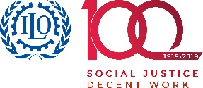 | 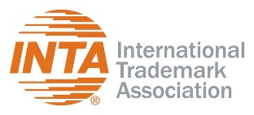 |  | 
WORKSHOP
WIPO/IPTK/GE/3/21/INF/3
ORIGINAL: ENGLISH
DATE: October 20, 2021
Virtual Practical Workshop on Intellectual Property for Women Entrepreneurs from Indigenous Peoples and Local Communities
organized by
the World Intellectual Property Organization (WIPO)
in cooperation with
the International Labour Organization (ILO),
the International Trade Centre (ITC),
and
the International Trademark Association (INTA)
Geneva, Switzerland, October 11 to 22, 2021
SUGGESTED READING LIST
prepared by the International Bureau of WIPO

SUGGESTED READING LIST
A Guide to Intellectual Property Issues in Access and Benefit-sharing Agreements
https://www.wipo.int/publications/en/details.jsp?id=4329
Brief 1 Traditional Knowledge and Intellectual Property
https://www.wipo.int/edocs/pubdocs/en/wipo_pub_tk_1.pdf
Brief 5 Intellectual Property and Traditional Handicrafts
https://www.wipo.int/edocs/pubdocs/en/wipo_pub_tk_5.pdf
Documenting Traditional Knowledge – A Toolkit
https://www.wipo.int/edocs/pubdocs/en/wipo_pub_1049.pdf
Intellectual Property and Arts Festivals
https://www.wipo.int/publications/en/details.jsp?id=4371
Intellectual Property and Genetic Resources, Traditional Knowledge and Traditional Cultural Expressions – An Overview https://www.wipo.int/edocs/pubdocs/en/wipo_pub_933_2020.pdf
Protect and Promote Your Culture: A Practical Guide to Intellectual Property for Indigenous Peoples and Local Communities
https://www.wipo.int/edocs/pubdocs/en/wipo_pub_1048.pdf
Boosting Tourism Development through Intellectual Property
https://www.wipo.int/publications/en/details.jsp?id=4543&plang=EN
9 IP Tips for Indigenous and Local Community Entrepreneurs
https://www.wipo.int/tk/en/entrepreneurship/top-tips/index.html
[End of document]

