 | 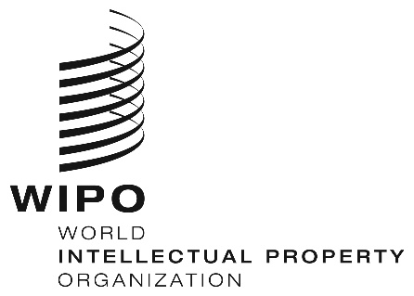 | E
WIPO/GRTKF/IC/37/11
ORIGINAL: ENGLISH
DATE: August 2, 2018

Intergovernmental Committee on Intellectual Property and Genetic Resources, Traditional Knowledge and Folklore

Thirty-Seventh Session
Geneva, August 27 to 31, 2018

EU PROPOSAL FOR A STUDY ON TRADITIONAL CULTURAL EXPRESSIONS

Document submitted by the European Commission, on behalf of the European Union and its Member States

INTRODUCTION

- On July 30, 2018, the International Bureau of the World Intellectual Property Organization (WIPO) received a request from the European Commission, on behalf of the European Union and its Member States, to re-submit a proposal entitled “EU proposal for a study on traditional cultural expressions” to the Thirty-Seventh Session of the Intergovernmental Committee on Intellectual Property and Genetic Resources, Traditional Knowledge and Folklore (IGC), as a working document.

- Pursuant to the request above, the Annex to this document contains the proposal referred to, as received.
3. The Committee is invited to take note of and consider the proposal in the Annex to this document.
[Annex follows]

EU proposal for a study on traditional cultural expressions

Taking into account the evidence based approach mentioned in paragraph (c) of the 2018/2019 mandate for the WIPO Intergovernmental Committee on Intellectual Property and Genetic Resources, Traditional Knowledge and Folklore (IGC), with particular reference to paragraph (d) of that mandate setting out such evidence based approach and expressly mentioning the conducting/updating of studies covering, inter alia, examples of national experiences, including domestic legislation, and in recognition of the commitment of WIPO Members to the Development Agenda Recommendations, the IGC requests the Secretariat to undertake a compilation study of national experiences and domestic legislation and initiatives in relation to the safeguarding of Traditional Cultural Expressions (TCEs).

The study should focus on recently adopted legislation and initiatives on TCEs in general in the Member States of WIPO.

Where possible the study would build upon existing materials and studies already conducted by the Secretariat. Where applicable, the WIPO Chief Economist should be involved.

To inform discussion at the IGC, the study should:

- Set out, in an objective manner, domestic legislation and specific regimes for the safeguarding of TCEs, and provide concrete examples of subject matter covered.
- Take into account the variety of measures that can be taken.

Existing IPR regimes

In particular, the study should, at a minimum, set out those national intellectual property laws, regulations, measures and procedures in relation to the safeguarding of TCEs on the basis of the following:

- Are existing IPR regimes - trademark, design, copyright, trade secrets and geographical indication legislation - used to safeguard TCEs?
- How have key definitions - such as subject matter, scope, beneficiaries, exceptions and duration - been defined?
- Is case law and/or administrative practice available?

Other questions of interest:

- How is use of the existing IPR regimes promoted? Has awareness raising for all stakeholders (including indigenous and local communities) taken place?

Alternative (IPR or other) regimes

In case of specific laws, measures, rules and procedures, the study should, at a minimum, set out those national intellectual property laws, regulations, measures and procedures in relation to the safeguarding of TCEs on the basis of the following:

- The study should identify and summarise the specific regimes in force in WIPO Member States for the safeguarding of TCEs.
- How have the policy objectives been defined?
- How have key definitions such as TCEs/subject matter, “traditional”, misappropriation, scope, duration, exceptions and beneficiaries been defined?
- When a tiered approach is included, how have the different levels been defined, and how can they be distinguished from each other?

- How is legal certainty for different stakeholders ensured?
- Is case law and/or administrative practice available?

Other questions of interest:

- Have/has the instrument(s) proven useful in respect of the policy objectives?
- What has been the economic, social and cultural impact of the instruments(s) on indigenous and local communities?
- What has been the economic, social and cultural impact of the instruments(s) on users, cultural organisations, non - profit organisations such as educational organisations, and society at large?
- Are there examples how the three- tiered approach works out in practice?
- Is there an interplay between IPR regimes and specific regimes on TCEs?
- How has the public domain been safeguarded?

[End of Annex and of document]

