 |  | E
WIPO/GRTKF/IC/30/INF/9
ORIGINAL: ENGLISH
DATE: April 27, 2016

Intergovernmental Committee on Intellectual Property and Genetic Resources, Traditional Knowledge and Folklore

Thirtieth Session
Geneva, May 30 to June 3, 2016

List of references for relevant RESOURCES submitted by member states and observers

Document prepared by the Secretariat

1. At its Twenty-Ninth Session, held from February 15 to 19, 2016, the Intergovernmental Committee on Intellectual Property and Genetic Resources, Traditional Knowledge and Folklore (“the Committee”) decided that “[w]ith regard to resources that Committee participants may wish to use as reference materials in their preparations for Committee sessions: […] Member States and observers are invited to send to the Secretariat by March 31, 2016 references for any other resources that may be relevant for Committee participants as reference materials, and the Secretariat shall communicate a list of such references, as provided, to the Thirtieth Session of the Committee in an information document.”

2. Further to the decision above, the WIPO Secretariat issued a circular to all Committee participants, dated March 7, 2016, recalling the decision and inviting participants to make their submissions before March 31, 2016.

3. Pursuant to the above decision, two Member States (the Republic of Korea and the United States of America) and three observers (Asociación Kunas Unidos por Napguana (KUNA), Phuthadikobo Museum and the United Nations Educational, Scientific and Cultural Organization (UNESCO)) submitted references for resources that may be relevant for Committee participants. These submissions, as provided in the languages in which they were received, are included in this document as an Annex.

4. The Committee is invited to take note of this document and the Annex to it.

[Annex follows]
List of references for relevant RESOURCES submitted by member states and observers

Submissions by Member States

- Republic of Korea

- United States of America

Submissions by observers

- Asociación Kunas Unidos por Napguana (KUNA)

- Phuthadikobo Museum

- United Nations Educational, Scientific and Cultural Organization (UNESCO)

Submission by the Republic of Korea

Introduction of the Korean Traditional Knowledge Portal (KTKP) by Korean Intellectual Property Office
28 March 2016
1. Introduction

Since 2001 the Intergovernmental Committee of the World Intellectual Property Organization (WIPO) has discussed world protection of the traditional knowledge of every country. At the seventh session of the Meeting of International Authorities under the Patent Cooperation Treaty (PCT) in February 2003, it was agreed that traditional knowledge should be included in the "Non-patent Literature" section of the PCT minimum documentation in accordance with specific criteria.

In line with the international protection movement, the Korean Intellectual Property Office (KIPO) decided, in 2004, to formulate an information strategy plan in order to build a database of traditional knowledge. KIPO’s database, which was compiled between 2005 and 2007, is based on traditional Korean medicine. A search service of this database was commenced in December 2007.
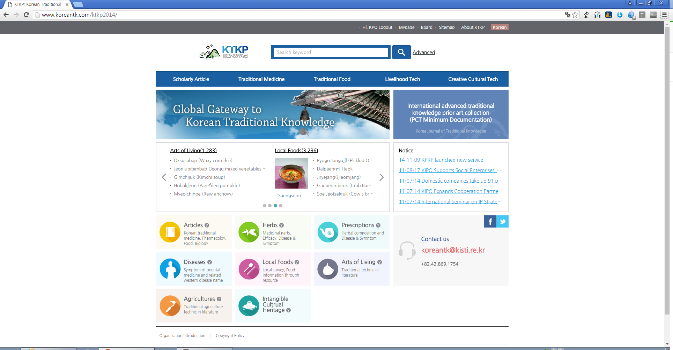
< Figure 1 Main page of the KTKP (http://www.koreantk.com) >

KIPO’s database of traditional knowledge includes a vast amount of knowledge from the documentations of old Korean medicine; it also includes a wide range of articles and patent documents. Thus, it contains traditional knowledge from the past and the present.

This database is presented on-line through the Korean Traditional Knowledge Portal (KTKP, http://www.koreantk.com; hereinafter referred to as the “Database”). The reasons for making KIPO’s database publicly accessible through the KTKP are as follows:

- To lay a foundation for the international protection of Korean traditional knowledge, thereby preventing unauthorized use of patents inside and outside the country;
- To provide an abundance of information on traditional knowledge and related research, thereby expediting the development of related studies and industries; and

- To provide essential information for patent examinations, thereby enhancing the quality of intellectual property applications for traditional knowledge.

The Database can be accessed and utilized by not only the patent examiners of IP Offices, but the general public as well, free of charge. The detailed structure of the Database is shown in Table 1.

< Table 1 Structure of the Database (as of the end of 2015) >

Classifications |  | Contents | No. of items of information
Main database | Articles | Information on excerpts of articles, PDF files of original articles, and articles from scientific journals in the fields of Oriental medicine, pharmacology, sitology, biology, etc. | 34,303
Main database | Herbs | Information on medicinal herbs recorded in old documents of traditional Korean medicine. | 5,500
Main database | Prescriptions | Information on prescriptions recorded in old documents of traditional Korean medicine. | 7,103
Main database | Diseases | Information on diseases (and its treatment) recorded in old documents of traditional Korean medicine and the relation of such treatments to the corresponding treatment in Western medicine. | 12,500
Auxiliaries database | Chemical compounds | Compound ingredients extracted from herbs.  Compounds indexed from articles. | 29,944  137,810
Auxiliaries database | Terminology | Definition of terminology about herbs, prescriptions, and diseases | 54,271
Auxiliaries database | Diseases Mapping | Mapping of disease relevancy between oriental and Western medicine. | 2,630
Total |  |  | 284,061

2. Features and Contents of the DBs

2.1 Scholarly Articles (Korean Journal of Traditional Knowledge) DB

The Database is based on scholarly articles about traditional knowledge. The articles were selected from 47 Korean academic journals of various fields, such as Oriental medicine, pharmacology, sitology and biology. The Database also enables original full-text articles to be accessed, on the condition of an agreement on the right of on-line transmission with each respective institution. The names of herbs and compounds in the articles are linked to the herb and compound databases, where further information can be found on each of the subjects. Table 2 shows the contents of the articles DB. See Annex I for more information on contents of the journal DB.

The KJTK (Korean Journal of Traditional Knowledge) is published in web format, in December, based upon an annual base publication and has an ISSN (1976-6882).

< Table 2 Contents of the articles DB >

Contents | Note
Bibliographic data | ▪ Includes the title of the article, the name of the author, the author’s affiliation, as well as the name of the journal, volume, issue, and page numbers etc.
English abstracts and summaries | ▪ Uses any available English abstract of the author.  ▪ If there is no English abstract of the author, the original text is summarized in English.
Full-text articles | ▪ Uses PDF file format for original articles
International Patent Classification and keywords | ▪ Patent analysis information.

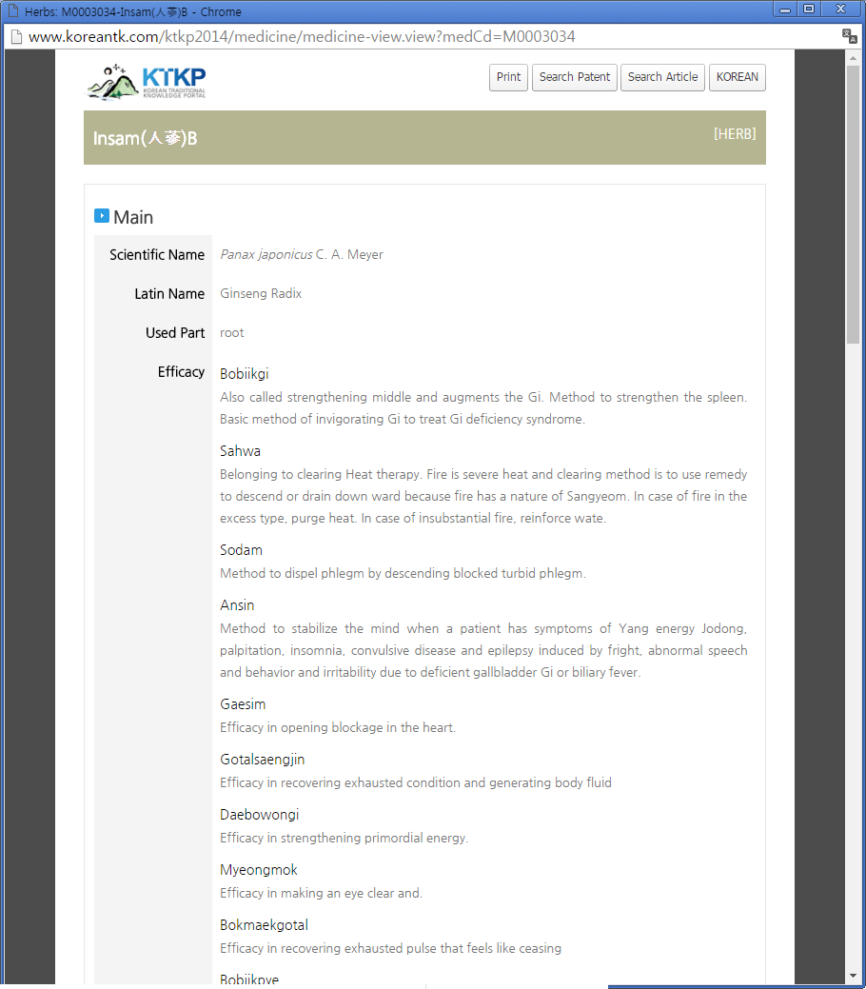
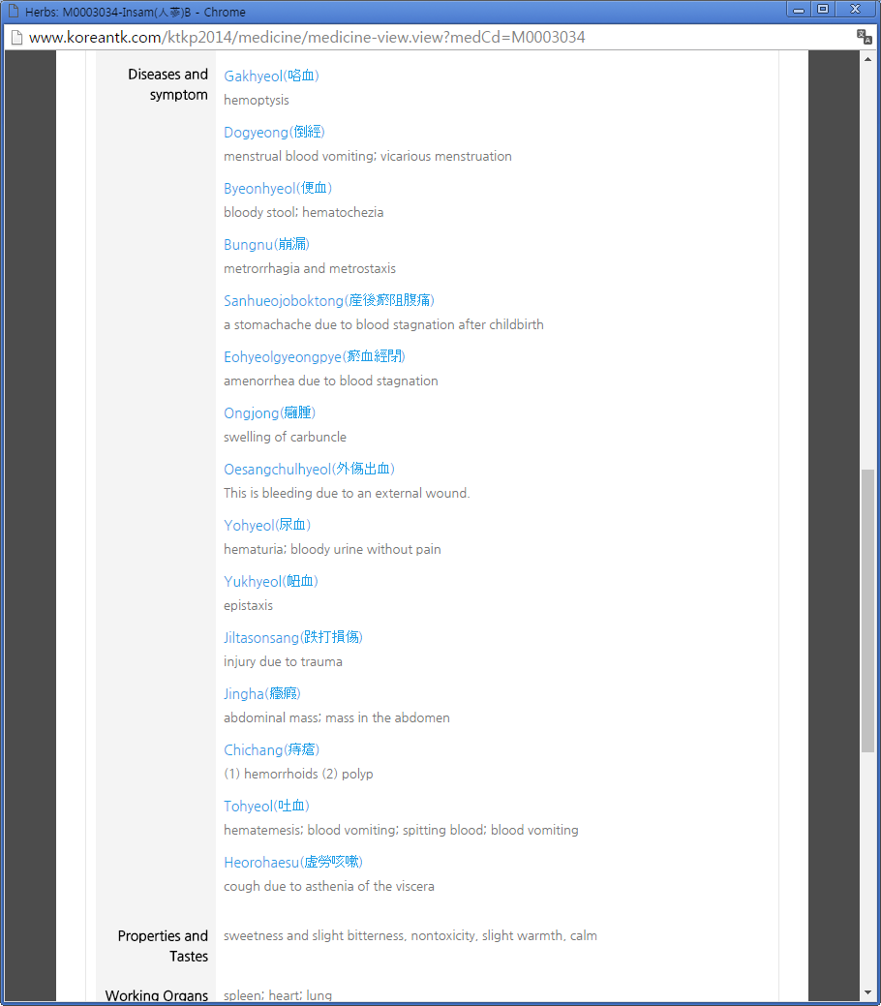
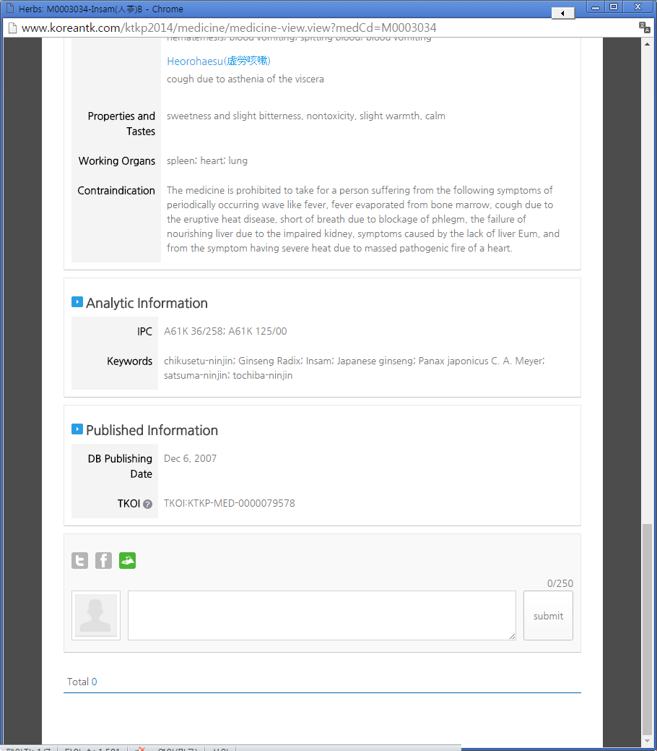
< Figure 2 Example of the contents of a scholarly article through the Database >

2.2 Traditional Medicine DB

(1) Herbs

The Herbs DB has the following features:

- integrated and systematic arrangement of herbal information;
- information from Oriental medicine documentation on the usable parts of herbs and their effects on specific symptoms;
- links between herbs in the database and searchable information on symptoms, diseases and related prescriptions; and
- patent analytical information of the IPC (International Patent Classification) relating to each herb.

This DB contains information such as the scientific name and terms, Latin name, synonyms, etc., medical information (i.e. its efficacy, symptoms, diseases and related prescriptions, etc.), herbal information (i.e, its properties and tastes, working organs, morphology, images, chemical composition, etc.), and patent analytical information of IPC and keywords relating to the herb.

(2) Symptoms and Diseases

This database has the following features:

- integrated and systematic arrangement of symptoms and diseases’ information;
- symptoms and diseases of Oriental medicine based on literatures and the related Western disease name;
- information of herbs and formulas corresponding to diseases and symptoms; and
- patent analytical information of the IPC relating to the symptoms and diseases.

This DB includes medical information, such as definitions and synonyms of symptoms and diseases, etc., old literatures for information of diseases and symptoms, and the disease information related to Western medicine.

(3) Prescriptions

This database has the following features:

- integrated and systematic arrangement of prescriptions data;
- herbal composition, symptoms & diseases and application, etc, of the prescriptions of Oriental medicine based on old literatures;
- links data of diseases and its symptoms to related herbs and prescriptions; and
- patent analytical information of the IPC relating to the prescriptions.

This DB includes information about the resources of prescriptions and herbal composition, medical information (such as the effect of prescriptions, diseases and symptoms, etc.), and information about the application of herbal remedies, along with directions. See Annex II for more information on bibliography of the traditional medicine DB.

2.3 Livelihood Tech (Agriculture and Life Techniques) DB

The books that were published by the Rural Development Administration were about digitalization and reprocessing. To satisfy the standards of the PCT minimum documentation, cover, contents, and copyrights were established along with an issue date. Papers and patent information in relation to the traditional techniques were also provided.

The contents of the DB are as follows:

- PDF and full text for identifying the original articles;
- Bibliographic information of the Agriculture and Living Techniques; and
- Name, methods, notes and evaluation of the development value for the traditional knowledge techniques.

See Annex III for more information on the bibliography of the agriculture and life techniques.

2.4 Auxiliaries DB

The Auxiliaries DB includes chemical compounds, terminology, mapping of diseases and so on, which helps in searching the main DB efficiently. Detailed features and contents of the Auxiliaries DB are as follows:

< Table 3 Features and Contents of each section in the auxiliaries DB >

Section |  | Features | Structured Contents
Patent analysis |  | ▪ useful keywords for searches of the IPC articles. | ▪ main keywords and English keywords related to herbs, prescriptions, diseases and relevant articles.  ▪ information from the IPC (8th edition) and related articles on herbs, prescriptions, and diseases.
Dictionary |  | ▪ description of the Oriental medicine terms used in the traditional knowledge database.  ▪ convenient access to the knowledge database through a ‘tool tip’ option for medical terms | ▪ definitions and synonyms of Oriental medical terms.  ▪ Korean and English definitions of Oriental medical terms.
Mapping of diseases between Oriental and Western medicine |  | ▪ comparison of Oriental and Western medical in terms of specific diseases and symptoms.  ▪ search engine that matches Oriental medical information with the corresponding Western medicine. | ▪ Western medical information that corresponds to Oriental medical information for specific diseases and symptoms.  ▪ Oriental medical information that corresponds to Western medical information for specific diseases and symptoms.
Com-pounds | Compound ingredients of Medicinal herbs | ▪ Compounds ingredients of natural products extracted from medicinal herbs.  ▪ search compounds by name or structure and a link to related herb information.  ▪ link between compounds and related herbs.  ▪ Application to modern scientific studies using traditional medic knowledge. | compound name.  CAS registry No.  molecular formula.  molecular structure (Mol file) of about 12,000 compound substances.
Com-pounds | Index of compounds in articles | ▪ Main compounds were extracted from articles and indexed for compound structure-based searching.  ▪ Provides a relation between articles and medicinal herbs through common compound information.  ▪ Provides new searching method for articles.  ▪ Increases the efficiency of searching by structure-based compound search methods and eliminates the difficulties caused by existence of various synonyms. | ▪ Compound name.  ▪ CAS registry No.  ▪ molecular formula.  ▪ molecular structure (Mol file) of main compounds of articles.  ▪Index information of compound from articles.

Annex I

□ Contents of the Journal DB

No. | Field | Name of institution | Name of academic Journal | No. of Articles
1 | Oriental medicine | Association for Neo Medicine | Journal of Hyungok Academic Society | 14
2 | Oriental medicine | Association for Neo Medicine | Journal of The Association for Neo Medicine | 1
3 | Oriental medicine | Institute of Oriental Kyunghee University | Oriental Pharmacy and Experimental Medicine | 339
4 | Oriental medicine | Korea Institute of Oriental Medicine | Korean Journal of Oriental Medicine | 143
5 | Oriental medicine | Korean Institute of Herbal Acupuncture | Journal of Korean Institute of Herbal Acupuncture | 431
6 | Oriental medicine | Korean Medical Institute of Dermatology & Aesthetics | KOREAN JOURNAL OF KOREAN MEDICAL INSTITUTE OF DERMATOLOGY & AESTHETICS | 7
7 | Oriental medicine | Korean Oriental Association for Study of Obesity | Journal of Korean Oriental Association for Study of Obesity | 80
8 | Oriental medicine | Korean Oriental Medical Society | The Journal of Korean Oriental Medicine | 1,482
9 | Oriental medicine | Kyung Hee University College of Oriental Medicine | Kyung Hee Unicersity Oriental Medical Journal | 454
10 | Oriental medicine | Published by Daejeon University, Institute of korean medicine | The Journal of Daejeon Oriental Medicine | 509
11 | Oriental medicine | Published by Dongguk University, Institute of Oriental Medical | The Journal of DongGuk Oriental Medicine | 98
12 | Oriental medicine | Research Center of Traditional Korean Medicine | The Journal of Traditional Korean Medicine | 62
13 | Oriental medicine | THE KOREAN ACUPUNCTURE & MOXIBUSTION SOCIETY | The JOURNAL OF KOREAN ACUPUNCTURE & MOXIBUSTION SOCIETY | 1,241
14 | Oriental medicine | The Association of Korean Oriental Pediatrics | THE Journal OF KOREAN ORIENTAL PEDIATRICS | 287
15 | Oriental medicine | The KOREAN ORIENTAL ONCOLOGY | Journal of Korean Traditional Oncology | 49
16 | Oriental medicine | The KOREAN ORIENTAL ONCOLOGY | THE JOURNAL OF KOREAN ORIENTAL ONCOLOGY | 64
17 | Oriental medicine | The Korea Association of Herbology | The Korea Journal of Herbology | 1,073
18 | Oriental medicine | The Korea Institute Of Oriental Medical Kiagnodtics | The Journal Of The Korea Institute Of Oriental Medical Kiagnodtics | 90
19 | Oriental medicine | The Korea Institute of Oriental Medical Informatics | The Journal of the Korea institute of oriental medical informatics | 97
20 | Oriental medicine | The Korean Academy of Oriental Medicine Prescription | THE KOREAN JOURNAL OF ORIENTAL MEDICAL PRESCRIPTION | 381
21 | Oriental medicine | The Korean Association of Oriental Medical Physiology | Korean Journal of Oriental Medical Pathology | 226
22 | Oriental medicine | The Korean Association of Oriental Medical Physiology | Korean Journal of Oriental Medical Physiology and Pathology | 196
23 | Oriental medicine | The Korean Association of Oriental Medical Physiology | Korean Journal of Oriental Physiology and Pathology | 1,768
24 | Oriental medicine | The Korean Medical Classics | The Journal of Korean Medical Classics | 39
25 | Oriental medicine | The Korean Oriental Chronic Disease | The Journal of Korean Oriental Chronic Disease | 122
26 | Oriental medicine | The Korean Oriental Internal Medicine | Journal of Korean Oriental Internal Medicine | 979
27 | Oriental medicine | The Korean Oriental Medical Ophthalmology and Otolaryngology and Dermatology Society | The Journal of Oriental Medical Surgery, Ophthalmology and Otolaryngology | 645
28 | Oriental medicine | The Korean Society For Oriental Preventive Medicine | The Korean Journal of Oriental Preventive Medicine | 158
29 | Oriental medicine | The Korean Society of Meridian & Acupoint | The Korean Journal of Meridian & Acupoint | 182
30 | Oriental medicine | The Korean Society of Oriental Neuropsychiatry | Journal of Oriental Neuropsychiatry | 364
31 | Oriental medicine | The Society of Constitutional Medicine | Journal of Sasang Constitutional Medicine | 458
32 | Oriental medicine | The Society of Oriental Obstetrics and Gynecology | The JOURNAL of ORIENTAL OBSTETRICS & GYNECOLOGY | 872
33 | Sitology | Korean Society for Food Science of Animal Resources | Korean Journal for Food Science of Animal Resources | 56
34 | Sitology | Korean Society of Food Science and Technology | Korean journal of food science and technology | 2,649
35 | Sitology | Korean Society of Food and Cookery Science | Korean Journal of Food and Cookery Science | 1,400
36 | Sitology | The Korean Journal of Food and Nutrition | The Korean Journal of Food And Nutrition | 842
37 | Sitology | The Korean Nutrition Society | The Korean Journal of Nutrition | 472
38 | Sitology | The Korean Society of Dietary Culture | Korean Journal of Food Culture | 497
39 | Sitology | The Korean Society of Food Science and Nutrition | Journal of Food Science and Nutrition | 465
40 | Sitology | The Korean Society of Food Science and Nutrition | Journal of the Korean Society of Food Science and Nutrition | 3,868
41 | Pharmacology | The Korean Society of Crop Science | Korean Journal of Crop Science | 191
42 | Pharmacology | The Korean Society of Food Preservation | Korean Journal of Food Preservation | 530
43 | Pharmacology | The Korean Society of Ginseng | Journal of Ginseng Research | 1,059
44 | Pharmacology | The Korean Society of Medicinal Corp Science | Korean Journal of Medicinal Crop Science | 1,164
45 | Pharmacology | The Korean Society of Pharmaceutics | The Journal of Applied Pharmacology | 286
46 | Pharmacology | The Korean Society of Pharmacognosy | Korean Journal of Pharmacognosy | 1,793
47 | Pharmacology | The Korean Society of Pharmacognosy | Natural Product Sciences | 896
48 | Pharmacology | The Pharmaceutical Society of Korea | Archives of Pharmacal Research | 845
49 | Pharmacology | The Pharmaceutical Society of Korea | YAKHAK HOEJI | 865
50 | Biology | Journal of Plant Biotechnology | Journal of Plant Biotechnology | 43
51 | Biology | Korean Society of Life Science | Journal of Life Science | 1,017
52 | Biology | The Korean Society for Applied Microbiology and Biotechnology | Korean Journal of Microbiololgy and Biotechnology | 127
53 | Biology | The Korean Society of Agricutural Chemistry and Biotechnology | Journal of The Korean Society For Applied Biological Chemistry | 1,122
54 | Biology | The Korean Society of Fisheries and Aquatic Science | Korean Journal of Fisheries and Aquatic Sciences | 227
55 | Biology | The Korean Society of Mycology | The Korean Journal of Mycology | 310
56 | Biology | The Plant Resources Society of Korea | Korean Journal of Plant Resources | 636
57 | Biology | The Plant Resources Society of Korea | Plant Resources | 32
Total |  |  |  | 34,303

Annex II

□ Bibliography of the Traditional Medicine DB

1. Herbs
Bibliography | Copyright year | Publisher | Place of publication
Korean Pharmacopoeia, 8th Edition; Korean Herbal Pharmacopoeia | 2002 | Korea Food and Drug Administration | Korea
Donguibangje & Cheobanghaeseol | 2002 | Uiseongdang | Korea
Donguibogam | 1613 |  | Korea
Dongui Yagyong Gwangmulhak | 20 Feb. 2005 | Uiseongdang | Korea
Dongui Yagyong Dongmulhak | 2002 | Uiseongdang | Korea
Bangyakhappyeon | 1884 |  | Korea
Bangjehak | 1989 | Gyechungmunhwasa | Korea
Bonchohak | 20 Mar. 2004 | Yeongnimsa | Korea
Donguisasangsinpyeon | 1929 | Munusa | Korea
Usugyeongheombangjip in Korea | 2004 | Korea Institute of Oriental Medicine | Korea
Ungok Bonchohak | 30 May 2004 | Seorimjae | Korea
Coloured Resources Plants of Korea | 5 Aug. 2003 | Hyangmunsa | Korea
Cheongganguigam | 2001 | Seongbosa | Korea
Illustrated Book of Korean Medicinal Herbs | 20 July 2003 | Gyohaksa | Korea

2. Symptoms and Diseases
Bibliography | Copyright year | Publisher | Place of publication
Donguibogam | 1613 |  | Korea
Bangyakhappyeon | 1884 |  | Korea
Donguisasangsinpyeon | 1929 | Munusa | Korea
Usugyeongheombangjip in Korea | 2004 | Korea Institute of Oriental Medicine | Korea
Cheongganguigam | 2001 | Seongbosa | Korea

3. Prescriptions
Bibliography | Copyright year | Publisher | Place of publication
Donguibangje and Cheobanghaeseol | 2002 | Uiseongdang | Korea
Donguibogam | 1613 |  | Korea
Dongui Yagyong Gwangmulhak | 20 Feb. 2005 | Uiseongdang | Korea
Bangyakhappyeon | 1884 |  | Korea
Bangjehak | 1989 | Gyechungmunhwasa | Korea
Donguisasangsinpyeon | 1929 | Munusa | Korea
Usugyeongheombangjip in Korea | 2004 | Korea Institute of Oriental Medicine | Korea
Cheongganguigam | 2001 | Seongbosa | Korea
www.tradimed.co.kr |  |  | Korea

Annex III

□ Bibliography of the Agriculture and Life Techniques

Bibliography | Year of Published | Publisher | Country
Traditional Knowledge Collection books – Living culture | 1997 | Rural Development Administration | Korea
Traditional Knowledge Collection books – Production use technique | 1997 | Rural Development Administration | Korea
Traditional Knowledge Collection books –Medicinal crop utilization | 1997 | Rural Development Administration | Korea
Traditional Knowledge Collection books – Hereditary resourcesⅠ- Animals, mulberry trees, microorganisms | 1997 | Rural Development Administration | Korea
Traditional Knowledge Collection books Hereditary resourcesⅡ- Planting seed | 1997 | Rural Development Administration | Korea
Traditional Knowledge Resource Practical Usage Report | 2003 | Rural Development Administration | Korea
Gyuhapchongseo - Traditional life skills | 2003 | Rural Development Administration | Korea
Traditional 2004 and Technology for Green Agriculture Collection Books – Food Crops | 2004 | Rural Development Administration | Korea
Traditional Knowledge and Technology for Environment-friendly Agriculture Collection Books – Garden Products | 2004 | Rural Development Administration | Korea
Traditional Knowledge and Technology for Environment-friendly Agriculture Collection Books - Livestock Products | 2004 | Rural Development Administration | Korea
Rural Area’s Traditional Oral Transmission Research and Practical Use | 2007 | Rural Development Administration | Korea
Ancient Agriculture Book for Modern Application Ongoijisin Vol. 1 | 2008 | Rural Development Administration | Korea
Ancient Agriculture Book for Modern Application Ongoijisin Vol. 2 | 2008 | Rural Development Administration | Korea
Ancient Agriculture Book for Modern Application Ongoijisin Vol. 3 | 2008 | Rural Development Administration | Korea
Ancient Agriculture Book for Modern Application Ongoijisin Vol. 4 | 2008 | Rural Development Administration | Korea
Promising Industrialization Resources of Rural Areas | - | Rural Development Administration | Korea
Ancient Agriculture Book Korean Translated Collection Books 1 - Saekgyeong | 2001 | Rural Development Administration | Korea
Ancient Agriculture Book Korean Translated Collection Books2 - Nongjeongsinpyeon | 2002 | Rural Development Administration | Korea
Ancient Agriculture Book Korean Translated Collection Books3 – Nongjeongseo | 2002 | Rural Development Administration | Korea
Ancient Agriculture Book Korean Translated Collection Books4 - JeungbosallimgyeongjeⅠ | 2003 | Rural Development Administration | Korea
Ancient Agriculture Book Korean Translated Collection Books5 – Jeungbosallimgyeongje Ⅱ | 2003 | Rural Development Administration | Korea
Ancient Agriculture Book Korean Translated Collection Books6 - Jeungbosallimgyeongje Ⅲ | 2004 | Rural Development Administration | Korea
Ancient Agriculture Book Korean Translated Collection Books 7 – Nonggaseol/Wibinmyeongnonggi/Nonggawillyeong/Nonggajipseong | 2004 | Rural Development Administration | Korea
Ancient Agriculture Book Korean Translated Collection Books 8 - Sangayorok | 2004 | Rural Development Administration | Korea
Ancient Agriculture Book Korean Translated Collection Books 9 - Singnyochannyo | 2004 | Rural Development Administration | Korea
Ancient Agriculture Book Korean Translated Collection Books 10 - NongjeonghoeyoⅠ | 2005 | Rural Development Administration | Korea
Ancient Agriculture Book Korean Translated Collection Books 11 - NongjeonghoeyoⅡ | 2006 | Rural Development Administration | Korea
Ancient Agriculture Book Korean Translated Collection Books 12 – Nongjeonghoeyo Ⅲ | 2007 | Rural Development Administration | Korea
Ancient Agriculture Book Korean Translated Collection Books 13 - HaedongnongseoⅠ | 2008 | Rural Development Administration | Korea
Ancient Agriculture Book Korean Translated Collection Books 14 - HaedongnongseoⅡ | 2008 | Rural Development Administration | Korea

Submission by the United States of America

The following list of resources related to traditional knowledge and genetic resources is used by US patent examiners. This list is regularly updated. The patent examiners find that the most useful resources are:
- India’s TKDL
- Dictionary of Natural Products
- iChinese Herbs
- Korean Traditional Knowledge Portal
- Dr. Duke’s
- Henriette’s Classic Herbal Texts

Submission by Asociación Kunas Unidos por Napguana (KUNA)

Decisión del Punto 7 del orden del día
RECURSOS GENÉTICOS.

Cuando el Comité pide a la Secretaría, anticipadamente antes de la trigésima sesión del Comité, que consoliden todos los recursos existentes, sobre experiencias regionales, nacionales, locales y comunitarias.

La Asociación Kunas Unidos por Napguana (KUNA), quiere compartir las experiencias del Pueblo indígena Kuna en Panamá, con los Protocolos Comunitarios que hemos venido desarrollando en nuestras comunidades, para proteger, salvaguardar los saberes ancestrales.

Los trabajos concluidos con el aval de máxima autoridad del pueblo kuna, el Congreso General Kuna tenemos:

- Protocolo de Investigación en materia de medicina tradicional kuna y la biodiversidad. Instituto de investigación y desarrollo de Kuna Yala. Panamá, 2000.
- Conocimiento kuna, Biodiversidad y Propiedad intelectual. Congreso General kuna, Congreso General de la cultura kuna, Fundación Dobbo Yala. Panamá, Octubre 2006.
- Protocolo indígena de acceso a recursos genéticos y distribución equitativa de los beneficios. Congreso General Kuna, Fundación para la promoción del conocimiento indígena (FPC). Panamá, 2008-2011
- Protocolo regional indígena sobre acceso a recursos genéticos y conocimiento tradicional. Fundación para la promoción del conocimiento indígena.(FPCI), Panamá 2011.
- Ley General de Ambiente y Pueblos Indígenas. CEALP

Nota: Adjunto breve presentación de los trabajos que están ejecución en territorio de los indígenas kunas de Panamá.

Tengo trabajos terminados que se puede compartir con los demás miembros.

Sin más por el momento, me despido de usted, y espero que este aporte sea tomado en cuenta, cómo los indígenas kunas en Panamá, estamos protegiendo nuestros conocimientos ancestrales, tanto estudio, investigación a recursos genéticos y otros saberes ancestrales. Con mucho gusto puedo seguir contribuyendo, cuando reciban estos trabajos, por favor avíseme, y acabo de recibir la nota de invitación para 30º Sesión.

Atentamente,

Nelson De León Kantule
Asociación Kunas Unidos por Napguana (KUNA)

Submission by the Phuthadikobo Museum

Ethiopia: Challenges to Biodiversity Conservation AllAfrica.com

Kenya launches biodiversity and climate change strategy SciDev.Net-24 Feb 2016

Biopiracy: When corporations steal indigenous practices and patent ... The World Weekly-03 Mar 2016

Genetic Resources, Chromosome Engineering, and Crop ... - Page 38 https://books.google.co.bw/books?isbn=1420073842 Ram J. Singh - 2011

Animal genetic resources and sustainable livelihoods S Anderson - Ecological Economics, 2003 – Elsevier

Shifts in African crop climates by 2050, and the implications for crop improvement and genetic resources conservation MB Burke, DB Lobell, L Guarino - Global Environmental Change, 2009 – Elsevier

Genetic diversity of oil palm (Elaeis guineensis Jacq.) germplasm collections from Africa: implications for improvement and conservation of genetic resources A Hayati, R Wickneswari, I Maizura… - … and Applied Genetics, 2004 – Springer

SD Tanksley, SR McCouch - Science, 1997 - science.sciencemag.org

The wild relatives of rice: a genetic resources handbook DA Vaughan - 1994 - books.google.com

Plant genetic resources: What can they contribute toward increased crop productivity?
D Hoisington, M Khairallah, T Reeves… - Proceedings of the …, 1999 - National Acad Sciences

Hotspots: Earth's biologically richest and most endangered terrestrial ecoregions. RA Mittermeier, N Myers, CG Mittermeier, P Robles Gil - 1999 - cabdirect.org

The regime complex for plant genetic resources. K Raustiala, DG Victor - International organization, 2004 - Cambridge Univ Press

Animal genetic resources and sustainable livelihoods. S Anderson - Ecological Economics, 2003 – Elsevier

Molecular tools in plant genetic resources conservation: a guide to the technologies. A Karp - 1997 - books.google.com

Genetic diversity and conservation and utilization of plant genetic resources. VR Rao, T Hodgkin - Plant cell, tissue and organ culture, 2002 – Springer

Potential genetic resources in tomato species: clues from observations in native habitats. CM Rick - Genes, enzymes, and populations, 1973 – Springer

Legume genetic resources with novel “value added” industrial and pharmaceutical use. JB Morris - Perspectives on new crops and new uses, 1999 - hort.purdue.edu

Core collections of plant genetic resources. TJL van Hintum, AHD Brown, C Spillane, T Hodkin - 2000 - books.google.com

Grain legumes: evolution and genetic resources. J Smartt - 1990 - books.google.com

Valuing animal genetic resources: a choice modeling application to indigenous cattle in Kenya E Ruto, G Garrod, R Scarpa - Agricultural Economics, 2008 - Wiley Online Library

A mini core subset for capturing diversity and promoting utilization of chickpea genetic resources in crop improvement HD Upadhyaya, R Ortiz - Theoretical and Applied Genetics, 2001 – Springer

Shifts in African crop climates by 2050, and the implications for crop improvement and genetic resources conservation MB Burke, DB Lobell, L Guarino - Global Environmental Change, 2009 – Elsevier

Food, industrial, nutraceutical, and pharmaceutical uses of sesame genetic resources JB Morris - Trends in new crops and new uses, 2002 - byeways.net

Valuing crop biodiversity: on-farm genetic resources and economic change M Smale - 2005 - books.google.com

Selected guidelines for ethnobotanical research: a field manual.MN Alexiades, JW Sheldon - 1996 - cabdirect.org

36 Geographic Information Systems (GIS) and the Conservation and Use of Plant Genetic Resources L Guarino, A Jarvis, RJ Hijmans… - Managing plant genetic …, 2002 - books.google.com

Metagenomics for mining new genetic resources of microbial communities M Ferrer, A Beloqui, KN Timmis… - Journal of molecular …, 2009 - karger.com

Plant genetic resources: advancing conservation and use through biotechnology. NK Rao - African Journal of biotechnology, 2004 - ajol.info

Farmers' valuation and conservation of crop genetic resources. B St B, E Meng - Genetic resources and crop evolution, 1998 – Springer

In situ conservation of genetic resources: determinants of minimum area requirements. BA Wilcox - National parks, conservation and development: the …, 1984 - researchgate.net

Evolution of wild emmer and wheat improvement: population genetics, genetic resources, and genome organization of wheat's progenitor, Triticum … E Nevo, AB Korol, A Beiles, T Fahima - 2013 - books.google.com

Plant genetic resources conservation and utilization P Gepts - Crop Science, 2006 - dl.sciencesocieties.org

Climate change and the characterization, breeding and conservation of animal genetic resources I Hoffmann - Animal genetics, 2010 - Wiley Online Library

Use and exchange of genetic resources in molluscan aquaculture X Guo - Reviews in Aquaculture, 2009 - Wiley Online Library

Crop genetic resources: an economic appraisal KA Day-Rubenstein, PW Heisey, RA Shoemaker… - 2005 - ideas.repec.org

Maize and sorghum: genetic resources for bioenergy grasses NC Carpita, MC McCann - Trends in plant science, 2008 - Elsevier

Submission by the United Nations Educational, Scientific and Cultural Organization (UNESCO)

The UNESCO recommends that the IGC takes into consideration:

- the Ethical Principles for Safeguarding Intangible Cultural Heritage, endorsed at the tenth session of the Intergovernmental Committee for the Safeguarding of the Intangible Cultural Heritage (http://www.unesco.org/culture/ich/en/Decisions/10.COM/15.a), which provide overarching aspirational orientations for governments, organizations and individuals directly or indirectly affecting the viability of intangible cultural heritage, including traditional knowledge; and

- the draft Operational Directives on ‘Safeguarding intangible cultural heritage and sustainable development at the national level’ – which specifically refers to genetic resources – will be proposed for adoption at the sixth session of the General Assembly of States Parties to the 2003 Convention in 2016.

[End of Annex and of document]

Note from the Secretariat: Hyperlinks to other websites are provided as received from Member States and observers, and imply neither responsibility for, nor approval of, the information contained in those other websites on the part of WIPO. The Secretariat makes no warranty, either express or implied, as to the accuracy, availability, reliability or content of such information, text, graphics and hyperlinks.

