
E

WIPO/GRTKF/IC/16/INF/5(c)
OriGINAL: English
DATE : May 3, 2010
INTERGOVERNMENTAL COMMITTEE ON INTELLECTUAL PROPERTY AND GENETIC RESOURCES TRADITIONAL KNOWLEDGE AND FOLKLORE
Sixteenth Session
Geneva, May 3-7, 2010
WIpo indigenous panel ON free, prior and informed consent: EXPERIENCES IN THE FIELDS OF GENETIC RESOURCES, TRADITIONAL KNOWLEDGE AND TRADITIONAL CULTURAL EXPRESSIONS: EXPERIENCES FROM CAMEROON
Document prepared by
Ms Haman Hajara
African Indigenous Women`s Organisation,
Central African Network, Cameroon

FREE PRIOR INFORMED CONSENT

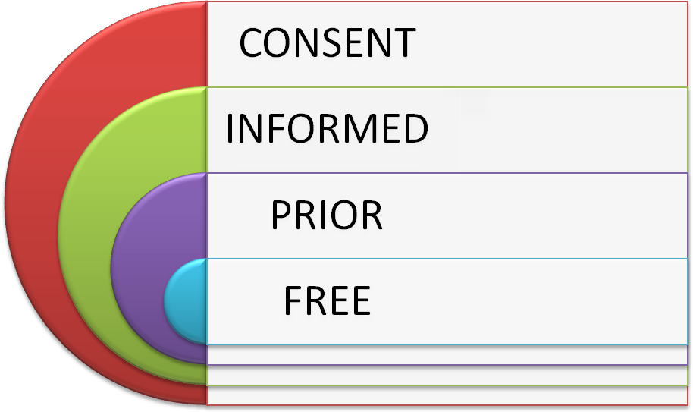
Definition
FREE: NO Pressure
PRIOR: In advance (how much in advance) this will depend on the group and the subject. How much influence does this have in their lives.
- Genetic resources, hydroelectric dams, logging, mining, etc
- traditional knowledge and their traditional cultural expressions
- Current Technologies and innovations for their daily life.

INFORMED:
- I am conscious
Or
- I know about
Or
- I Heard about
But in all is for those concerned to be conscious of both negatives and positives and be able to choose or make a choice

CONSENT:
The right to say no or yes by the target group, the right to form an in dependant opinion after being well informed.
There is also a way to cheat on this concept by going to the authorities and to impose it by the government. Instead of respecting communities as human beings which is a moral choice FPIC they choose power and money strategies which is the most used nowadays in our communities, By companies, States, researchers etc for they don’t think that they are able to convince communities.
In these strategies of power and money people in communities are considered obstacles to development, what kind of development.
- money and power development
Or
- Life and dignity of the communities.
Free prior Inform Consent within my community, we have carried out lots of awareness Meetings within this communities starting from our Traditional institutions which are the Lamidads to the lawans or Ardos, to Juros, Men heads of families, Women and the Youths, together we are developing our community

protocols but a wider one 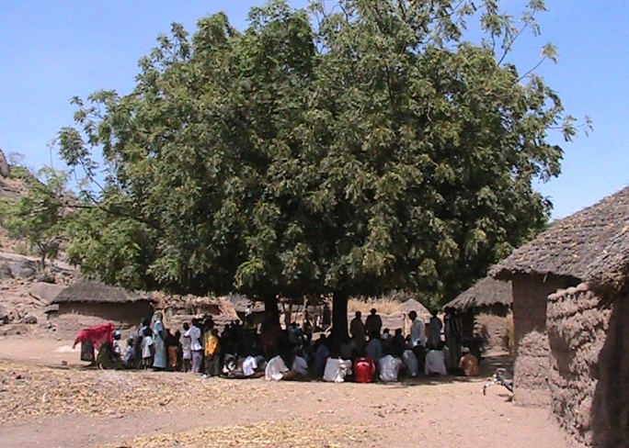

We have developed within our communities for those wishing to use a particular knowledge of one or more communities must previously request its authorization. In order to ensure PIC the indigenous communities should have enough information as to the purposes, risks and implications of the activity that is to be carried out.
We have also created Traditional knowledge centres where we regenerate our lost traditional knowledge, cultures and cultural expressions, promote, preserve and protect our knowledge. We have people who are in charge of those centres and whoever wants to access them most have an authorisation.
Now to get into our communities and get access to our Traditional knowledge, genetic resources and folklore you must pass through our Traditional institutions which are the Lamidads to the lawans or Ardos, to Juros, Men heads of families, Women and the Youths.
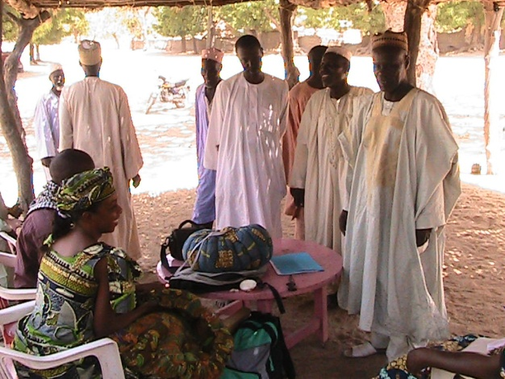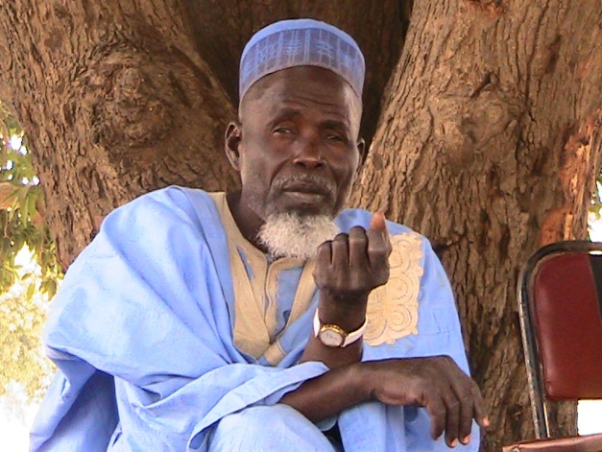
We have also created sanction for those who break our customary laws.

As for researchers copies of their research picture documentaries or films must be left to the communities and the intention of what the research is going to be used for most be known in advance.

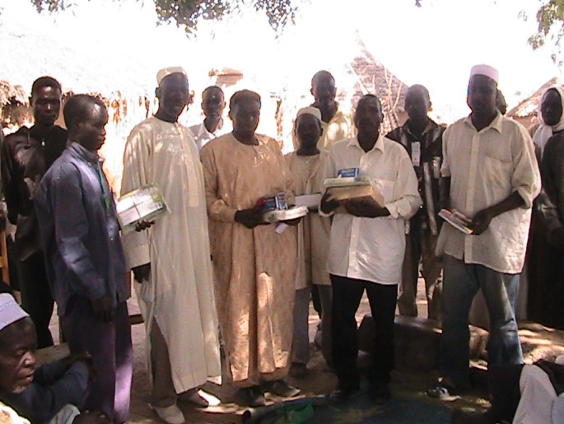

If the Product gotten from our community is to be used for commercial purposed then the benefit sharing is an eventuality which has to be discussed and be part of a formal contract.
In Cameroon, with our government, most of the discussion so far, the involvement of the community is not clearly defined. At what point will they participate? Often there are requirements for prior informed consent, but it is not clear how communities can participate.
Our communities face a number of obstacles in Cameroon with regard to exerting their rights over their traditional medicinal knowledge and granting access to their biological resources:
- Communities are usually not recognized as parties to the agreement or contract by the state
- Often, community knowledge is not eligible for IPR protection
- There are no institutional mechanisms via which a community can assert rights over its knowledge nationally
- There are no mandatory schemes for benefit sharing at the national level
- Prior informed consent consultations do not take place or lack effective community participation

Community Protocols has been devised in order to address some of these issues. It is an expression of customary law on matters related to access to genetic resources and/or traditional knowledge. It provides for a practical way to allow communities to participate in discussions on access and benefit-sharing and to provide input to those who seek access, especially when bioprospecting activities are about to be implemented in the area.
The Community Protocol will enable our communities to assert their own customary law before granting access to collectors or researchers. Collectors will have to undergo the procedures that are provided for in the Community Protocol. One of the positive points of the Community Protocol is that it is actually being implemented. Several communities’ protocols have been developed. We the Mbororos we are found in more than 12 countries in Africa divided by international borders will developed a wider community’s protocol which will be used by Mbororos everywhere before COP 10 with the help of Natural Justice Which is an organization that has helped the others developed theirs
Our Universe
Our spiritual universe is linked to our livestock breeding and our ethnicity is inextricable intertwined with our breeds and way of life e.g. JAFUNS with the red horn cattle, AKUS white zebus, the WODABE the dark ox blood cattle . We have always considered ourselves a distinct indigenous community. You can identify us with some special traits and we can also identify each other no matter the country by merely looking at hair, nose, height, and they way we walk.
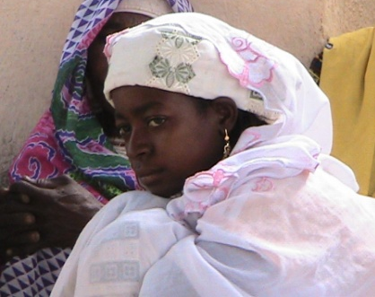
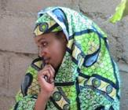


Our Traditions and livelihood
We the Mbororos have rich indigenous traditional knowledge and are good preservers of Biodiversity and our life and culture is attached to our environment and therefore losing our lands means totally losing our indigenous knowledge. We got also a distinct language from the main stream communities.
Very efficient medicinal, ethno vet and food plants, traditional dressing, hairstyles, rituals and folklore, our community has what we call PULAAKU which is a code of conduct within the community, this entails having qualities, like patience, endurance, respect, honesty, trust, the list goes on and on, we are brought up with it and with this you have to know how to behave depending where and which age group you find yourself.

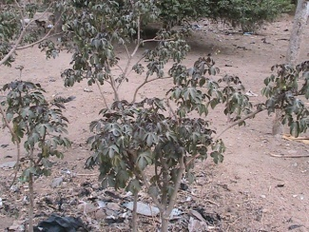
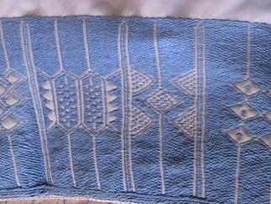
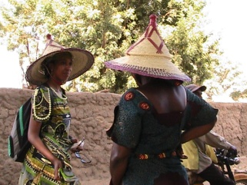

We are indigenous nomadic pastoralist who have developed a variety of livestock breeds using our traditional knowledge and have customarily grazed our animals on our communal lands, when I talk of communal lands since we are nomads I mean even across international borders we do have areas where we have leaved and left part of the family there or those lands are our ancestral lands. This means that our livelihood, our survival and the survival of our breeds are based on the access to our communal lands.

From our selection of breeds for generation we have created are particularly strong hardy animals that can withstand harsh conditions, Dry environments, diseases resistant and can walk long distances, all these qualities which the exotic breeds from the developed world don’t have. The animal genetic diversity, traits and our traditional knowledge enables us to respond to changes in the natural environment, climate and food security.
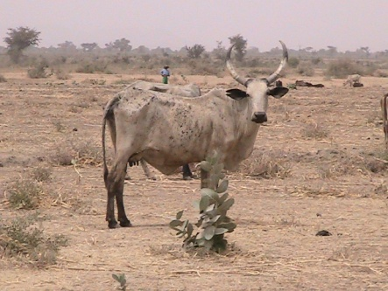
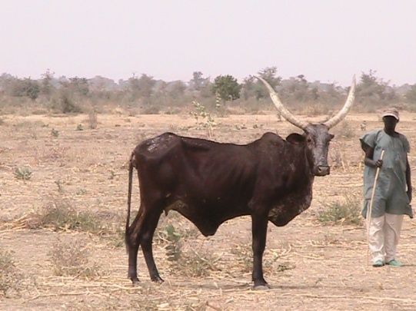
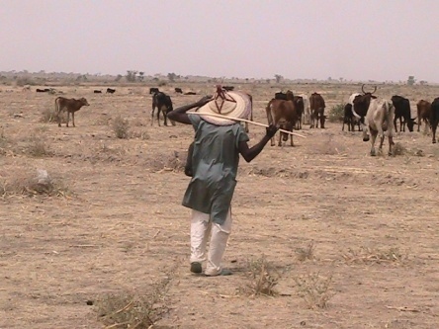

Our indigenous cosmology and worldwide regard knowledge as a gift from nature, from our creator and great spirits, from our ancestors. Knowledge is created collectively, by creation, and inter-generationally and not just by individuals.
Our traditional knowledge is held by both women and men. We also share medicinal and ethno–veterinary knowledge with other communities since most of the communities are inaccessible and lack all the social amenities. Spiritual understandings of our breeds or our animals are just more than just livelihood. These animals form an integral part of our social fabric and are interwoven with spiritual meaning. A number of important rituals involve our animals and the sacred ties between our livestock, the environment and our traditional knowledge.
Our Difficulties as Mbororos
Since we are nomads and the culture of being nomadic is our way of life we are looked upon even within the countries where are born as strangers. There is also the aspect of denigration where we are called primitive and bush people because of our way of life.
There is no political recognition of the Mbororos by states government not to talk of recognition, protection and promotion of their traditional knowledge; Mbororos have no access to the basic amenities. Nigeria and the nomadic education commission which is doing something credible but still has so much to do and other governments needs to emulate that example.
State governments do not recognise land ownership of most indigenous communities especially who are nomadic people in Africa, but encourage and also participate in the process of dispossession of these lands in favour of ambitious development projects which are destructive to the environment and its biodiversity and therefore to the reach indigenous knowledge .
This state of affairs comforted the newly independent African states whose policy is that of national integration and assimilation rather than promoting cultural diversity which they saw as a treat to their fragile states. There was no reason to promote, protect traditional knowledge, Indigenous knowledge in general not to talk of the Mbororo traditional knowledge.
Non Indigenous people in the name of researchers have appropriated this knowledge and have succeeded to patents it as an invention as there are no laws at national or international level which recognises indigenous traditional knowledge. A great example is my father and researchers.
Indigenous communities are refused these collective protection rights of their traditional knowledge on the pretext that it’s not an invention.
Knowledge sharing was based on trust, but the introduction of capitalism has eroded this practice and resource ownership has tended to shift from communal to private.
The debate on whether or not Indigenous traditional knowledge should be protected by this world body is on for some years now, Indigenous people are activating and mobilising for recognition and protection of their traditional knowledge. How far has the debate gone in favour of us the indigenous people are a question?
In the last decades even where indigenous communities like mine (Mbororo) leave on their ancestral lands most of the youths from the indigenous and local communities are fast abandoning this valuable knowledge in favour of the modern knowledge.
Traditional knowledge and customary laws are threatened by similar pressures, a shift towards western life styles, weakening of customary institutions and customary authorities that are made auxiliaries of the state governments.
In Cameroon at national level customary laws are subordinate to the written law, and only apply as a guide, the courts are not bound to apply it. The Mbororos communities face threats to their knowledge and resource right including cases of biopiracy.
Recommendations
For the free prior and informed consent and the community protocols to work effectively in Cameroon, we need our customary institutions to be recognised, institutionalised, empowered and the customary laws should be fully integrated in to all states legal systems capacity building for the customary institutions and communities. We, the Indigenous people are asking for full and effective participation at all levels of the processes in relation to our traditional knowledge genetic resources and cultural expressions. We have to ensure the viability and preservation, safeguarding and protection of our heritage through continues use, by transmitting it to the next generation and through sustained revitalization. We are asking the international community and national governments to recognize and support our ways of safe guarding and protecting our heritage and traditional knowledge. We the indigenous people and nations should put powerful networks at international level and at national level for special measures to be taken towards protecting our indigenous traditional knowledge. We the indigenous people should preserve promote and especially protect our traditional knowledge from any misuse that can cause harm to the custodians of the knowledge or to the entire tribe or nation, any misuse and misappropriation is the violation of the right of the knowledge holders. We indigenous peoples have our own philosophies, customary laws, values and norms and relationship to the land, resources and knowledge which have been used for centuries up till now. This should be acknowledging as valid and relevant. IPO should promote traditional knowledge and genetic resources based on the customary laws of the indigenous peoples.

[End of document]

